Introduction to Electrical Faults
Electrical networks, machines and equipments are often subjected to various types of faults while they are in operation. When a fault occurs, the characteristic values (such as impedance) of the machines may change from existing values to different values till the fault is cleared.
There may be lot of probabilities of faults to appear in the power system network, including lighting, wind, tree falling on lines, apparatus failure, etc.
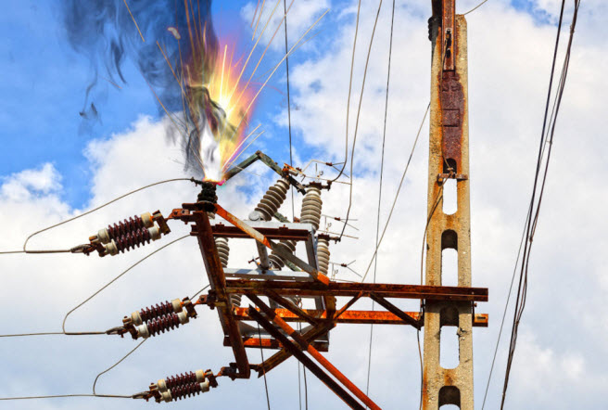
Electrical Faults
A fault in an electric power system can be defined as , any abnormal condition of the system that involves the electrical failure of the equipment, such as , transformers, generators, busbars, etc.
The fault inception also involves in insulation failures and conducting path failures which results short circuit and open circuit of conductors.
Under normal or safe operating conditions, the electric equipments in a power system network operate at normal voltage and current ratings. Once the fault takes place in a circuit or device, voltage and current values deviates from their nominal ranges.
The faults in power system causes over current, under voltage, unbalance of the phases, reversed power and high voltage surges. This results in the interruption of the normal operation of the network, failure of equipments, electrical fires, etc.
Usually power system networks are protected with switchgear protection equipments such as circuit breakers and relays in order to limit the loss of service due to the electrical failures.

Types of Faults
Electrical faults in three-phase power system mainly classified into two types, namely open and short circuit faults. Further, these faults can be symmetrical or unsymmetrical faults. Let us discuss these faults in detail.

Open Circuit Faults
These faults occur due to the failure of one or more conductors. The figure below illustrates the open circuit faults for single, two and three phases (or conductors) open condition.
The most common causes of these faults include joint failures of cables and overhead lines, and failure of one or more phase of circuit breaker and also due to melting of a fuse or conductor in one or more phases.
Open circuit faults are also called as series faults. These are unsymmetrical or unbalanced type of faults except three phase open fault.
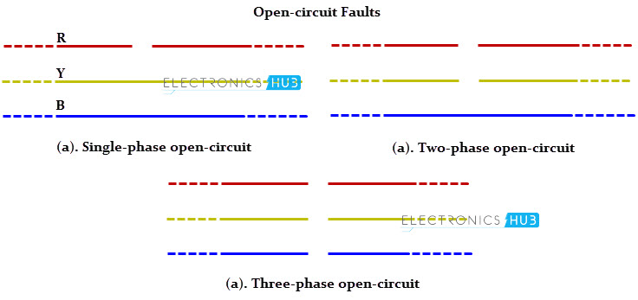

Consider that a transmission line is working with a balanced load before the occurrence of open circuit fault. If one of the phase gets melted, the actual loading of the alternator is reduced and this cause to raise the acceleration of the alternator, thereby it runs at a speed slightly greater than synchronous speed. This over speed causes over voltages in other transmission lines.
Thus, single and two phase open conditions can produce the unbalance of the power system voltages and currents that causes great damage to the equipments.

Causes
Broken conductor and malfunctioning of circuit breaker in one or more phases.

Effects
- Abnormal operation of the system
- Danger to the personnel as well as animals
- Exceeding the voltages beyond normal values in certain parts of the network, which further leads to insulation failures and developing of short circuit faults.
Although open circuit faults can be tolerated for longer periods than short circuit faults, these must be removed as early as possible to reduce the greater damage.

Short Circuit Faults
A short circuit can be defined as an abnormal connection of very low impedance between two points of different potential, whether made intentionally or accidentally.
These are the most common and severe kind of faults, resulting in the flow of abnormal high currents through the equipment or transmission lines. If these faults are allowed to persist even for a short period, it leads to the extensive damage to the equipment.
Short circuit faults are also called as shunt faults. These faults are caused due to the insulation failure between phase conductors or between earth and phase conductors or both.
The various possible short circuit fault conditions include three phase to earth, three phase clear of earth, phase to phase, single phase to earth, two phase to earth and phase to phase plus single phase to earth as shown in figure.
The three phase fault clear of earth and three phase fault to earth are balanced or symmetrical short circuit faults while other remaining faults are unsymmetrical faults.

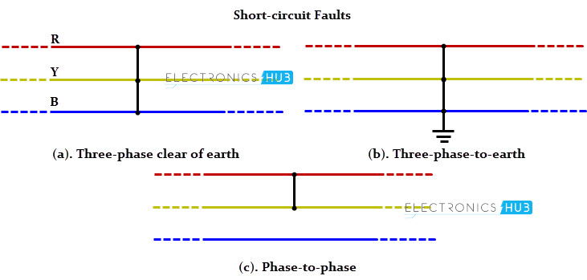

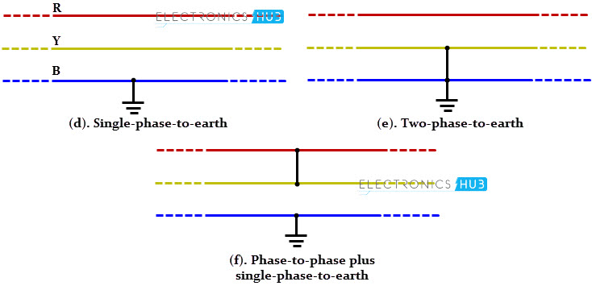

Causes
These may be due to internal or external effects
- Internal effects include breakdown of transmission lines or equipment, aging of insulation, deterioration of insulation in generator, transformer and other electrical equipments, improper installations and inadequate design.
- External effects include overloading of equipments, insulation failure due to lighting surges and mechanical damage by public.

Effects
- Arcing faults can lead to fire and explosion in equipments such as transformers and circuit breakers.
- Abnormal currents cause the equipments to get overheated, which further leads to reduction of life span of their insulation.
- The operating voltages of the system can go below or above their acceptance values that creates harmful effect to the service rendered by the power system.
- The power flow is severely restricted or even completely blocked as long as the short circuit fault persists.

Symmetrical and Unsymmetrical Faults
As discussed above that faults are mainly classified into open and short circuit faults and again these can be symmetrical or unsymmetrical faults.

Symmetrical Faults
A symmetrical fault gives rise to symmetrical fault currents that are displaced with 1200 each other. Symmetrical fault is also called as balanced fault. This fault occurs when all the three phases are simultaneously short circuited.
These faults rarely occur in practice as compared with unsymmetrical faults. Two kinds of symmetrical faults include line to line to line (L-L-L) and line to line to line to ground (L-L-L-G) as shown in figure below.
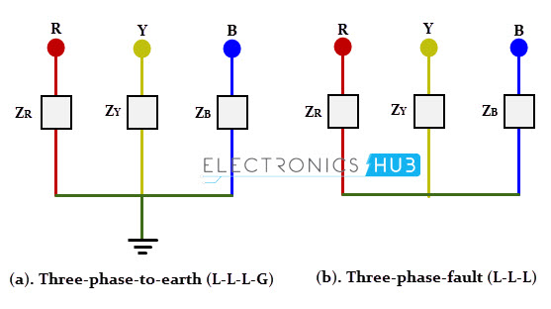
A rough occurrence of symmetrical faults is in the range of 2 to 5% of the total system faults. However, if these faults occur, they cause a very severe damage to the equipments even though the system remains in balanced condition.
The analysis of these faults is required for selecting the rupturing capacity of the circuit breakers, choosing set-phase relays and other protective switchgear. These faults are analyzed on per phase basis using bus impedance matrix or Thevenins’s theorem.

Unsymmetrical Faults
The most common faults that occur in the power system network are unsymmetrical faults. This kind of fault gives rise to unsymmetrical fault currents (having different magnitudes with unequal phase displacement). These faults are also called as unbalanced faults as it causes unbalanced currents in the system.
Up to the above discussion, unsymmetrical faults include both open circuit faults (single and two phase open condition) and short circuit faults (excluding L-L-L-G and L-L-L).
The figure below shows the three types of symmetrical faults occurred due to the short circuit conditions, namely phase or line to ground (L-G) fault, phase to phase (L-L) fault and double line to ground (L-L-G) fault.
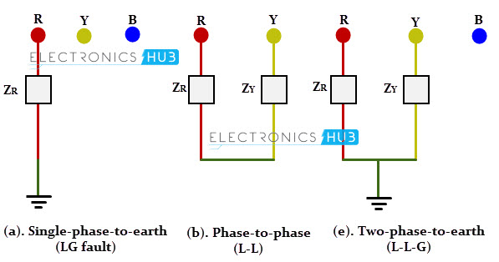
A single line-to-ground (LG) fault is one of the most common faults and experiences show that 70-80 percent of the faults that occur in power system are of this type. This forms a short circuit path between the line and ground. These are very less severe faults compared to other faults.
A line to line fault occur when a live conductor get in contact with other live conductor. Heavy winds are the major cause for this fault during which swinging of overhead conductors may touch together. These are less severe faults and its occurrence range may be between 15-20%.
In double line to ground faults, two lines come into the contact with each other as well as with ground. These are severe faults and the occurrence these faults is about 10% when compared with total system faults.
Unsymmetrical faults are analyzed using methods of unsymmetrical components in order to determine the voltage and currents in all parts of the system. The analysis of these faults is more difficult compared to symmetrical faults.
This analysis is necessary for determining the size of a circuit breaker for largest short circuit current. The greater current usually occurs for either L-G or L-L fault.

Murray Loop Test
This test is used to find the fault location in an underground cable by making one Wheatstone Bridge in it and by comparing the resistance we shall find out the fault location. But we should use the known length of the cables in this experiment. The necessary connection of the Murray loop test is shown in figure 2 and 3. The figure 2 shows that the circuit connection for finding the fault location when the ground fault occurs and the figure 3 shows that the circuit connections for finding the fault location when the short circuit fault occurs.

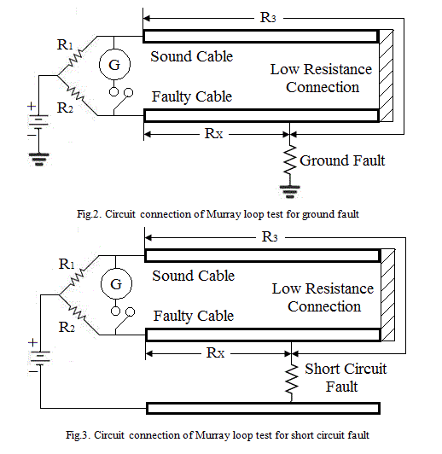
In this test, the faulty cable is connected with sound cable by a low resistance wire, because that resistance should not affect the total resistance of the cable and it should be able to circulate the loop current to the bridge circuits without loss.
The variable resistors R₁ and R₂ are forming the ratio arms. Balance of the bridge is achieved by adjusting the variable resistors. G is the galvanometer to indicate the balance. [R₃ + R_{X}] is the total loop resistance formed by the sound cable and the faulty cable. At the balance condition,

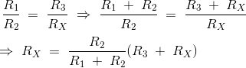
When the cross section area of the both sound cable and faulty cable are equal, then the resistance of the conductors are directly proportional to their lengths. So, if L_{X} represents the length between test end to the fault end of the faulty cable.

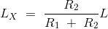
The above test is only valid when the lengths of the cables are known. In Murray Loop Test, the fault resistance is fixed and it may not be varied. Also it is difficult to set the bridge as balance. Thus, the determination of the fault position is not accurate. Then the current circulation through the cable would cause temperature rises due to high voltage or high current. If the resistance varies according to the temperature, then the balance collapses. So, we need to apply less voltage or less current to this circuit.

Varley Loop Test
This test is used to find the fault location in an underground cable by making one Wheatstone Bridge in it and by comparing the resistance we shall find out the fault location instead of calculating it from the known lengths of the cable. The necessary connection of the Varley loop test is shown in figure 4 and 5. The figure 4 shows that the circuit connection for finding the fault location when the ground fault occurs and the figure 5 shows that the circuit connections
forfinding the fault location when the short circuit fault occurs.

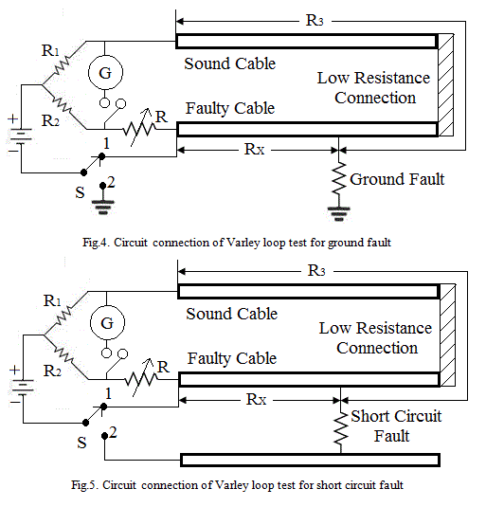
In this test, the faulty cable is connected with sound cable by a low resistance wire, because that resistance should not affect the total resistance of the cable and it should be able to circulate the loop current to the bridge circuits without loss. A single pole double through switch ‘S’ is used in this circuit. There would be a variable resistor ’ which is used to balance the bridge circuit during the working period.
If the switch S is in position 1, then we need to adjust the variable resistance R to balance the circuit. Let us assume that the present R value as R_{S1}. At this position, the expressions are as follows;
This expression gives the value of [R₃ + R_{X}], if the value of R₁, R₂ and R_{S1} are known.
If the switch S is in position 2, then again we need to adjust the variable resistance R to balance the bridge circuit. Let us assume that the new R value as R_{S2}. At this position, the expressions are as follows;

By solving the equation (1) and (2),

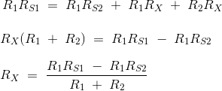
Therefore, the unknown resistance R_{X} is,

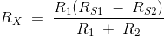
Varley Loop Test is valid only when the cable sections are uniform throughout the loop. The current flowing through the cable would cause the temperature effect. Due to this temperature effect, the resistance of the cable would change. Thus, we need to apply less current to this circuit to carry out the experiment.

Introduction of circuit breaker
A circuit breaker is an automatically switching device which is designed to protect an electrical circuit from damage caused by overload or short circuit. It can be operated manually. Its major function is to detect a fault condition and interrupt current flow during the operation of circuit breaker.
Therefore we can define it as a mechanical switching device which is capable of switching, breaking and carrying current under normal conditions and under some specific time period.
Power system deals with huge power network and huge numbers of associated electrical equipment. At the time of short circuit fault or any other types of electrical fault the power network may release a high stress of fault current in the equipment which may damage both the equipment and networks permanently. Only solution for saving the equipments and the power networks is that the fault current should be cleared as soon as possible from the system. Once the fault is cleared, the system will recover its normal working condition and gets ready for supplying reliable quality power to the receiving ends.
There are different switching operations needed for proper controlling of power systems. For the protection and control of power system network some special type of switching devices are introduced which can be operated safely under huge current carrying conditions During the flow of huge current, there may be large arcing in between switching contacts, so it should be taken care to quench these arcs in circuit breaker in safe manner.

Basic Design of Circuit Breaker
Major components of a circuit breaker are
- Frame ( cases made of metal or electrical insulation types)
- Contacts (Electrical)
- Arc (Arc extinguishing assembly)
- Operating mechanism
- Trip unit (having thermal element or magnetic)

Restriking voltage and recovery voltage:

Restriking Voltage:

As the arcing current crosses zero, a high frequency transient voltage appears across the contacts of the Circuit Breaker. This Transient voltage is known as Restriking Voltage. Now, two question should strike in your smart brain. First, why voltage shoots up when arcing current crosses zero?

Second, why high frequency voltage during transient period?
First, as the power system has appreciable amount of inductance, thus the fault current must lag behind the system voltage by 90°. Therefore, when the arcing current crosses zero, the voltage across the contacts of Circuit Breaker shoots up to its peak value.
Second, as the voltage reaches its peak, it restrikes the arc and try to maintain the arc. Due to this the arcing current will increase from its zero and correspondingly the voltage must also decrease. The combined effect of increasing current and decreasing voltage across the contact will bring the voltage back to its normal value within few mili seconds as shown in figure below. Thus we see that voltage has very few mili seconds to come back to its normal waveform from its peak, and hence voltage will do the thing faster and therefore it will be of high frequency as shown in figure below.

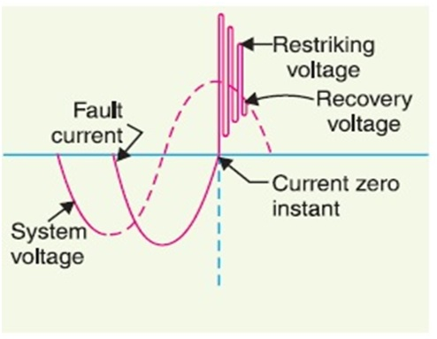
Restriking Voltage has a very important role in the arc extinction process. If the Restriking Voltage rises more rapidly than the dielectric strength of the medium between the contacts of the Circuit Breaker, the arc will persists for next half cycle and after next half cycle, arcing current will again reach to its zero and we will again get a chance. If this time the rate of rise of dielectric strength of medium between the contacts is more than rate of rise of Restriking Voltage then arc will extinguish.
Therefore, for arc extinction
Rate of Rise of Restriking Voltage < Rate of Rise of Dielectric Strength of Medium
So finally arc extinguished. So the voltage across the contacts of the Circuit Breaker will be normal 50 Hz / 60 Hz system voltage.

Recovery Voltage :
it is the rms voltage after final arc extinction. (normal frequency 50 or 60 Hz).both voltages appear between circuit breaker poles.
· A circuit breaker is a piece of equipment which can Make or break a circuit either manually or by remote control under normal conditions.
· Break a circuit automatically under fault condition
· Make a circuit either manually or by remote under fault condition
· Circuit Breaker consists of fixed and moving contacts called electrodes
· Under normal operating condition these contacts remain closed and will not open automatically unless the system becomes faulty .These contacts can be opened manually or by remote control.
· When a fault occurs in a circuit the trip coils of the circuit breaker get energized and the moving contacts are pulled apart by some mechanism,thus opening the circuit.

Difference Between Isolator and Circuit Breaker
The major difference between the isolator and the circuit breaker is that the isolator disconnects the circuit at offload condition whereas the circuit breaker disconnects the circuit at on load condition. The Difference Between Isolatorand Circuit Breaker are explained in the comparison chart by considering the factors like the type of device and its action. The operation of the Isolator and Circuit breaker, their functions and the withstand capability.
Difference Between Isolator and Circuit Breaker are given below in the tabulated form.
Comparison Chart
BASIS | ISOLATOR | CIRCUIT BREAKER
Type of device | Isolator is an off load device | Circuit Breaker is an On load device.
Operation | It is operated manually. | It is operated Automatically.
Action of device | It is a Mechanical device which acts as a switch. | It is an Electronic device made by using MOSFET or BJT.
Function | Isolator cut out a portion of a substation when a fault occurred. The other devices operate without any interruption. | The Circuit breaker is a device such as ACB or MCB, which trips the entire system if there is any fault.
Withstand Capability | They have the low withstand capacity as compared to Circuit Breaker. | They have the high withstand capability at the on load condition.

An insulator is a disconnecting switch which operates under off load condition. It isolates the part of the circuit in which the fault takes place from the main supply. It is used in high voltage devices such as transformers, etc. Isolators block the DC signals and allow the AC signals to pass.
Circuit Breaker is a protecting device which acts as a switch. It opens and closes the contact of the circuit at the normal as well as when the faulty condition occurs in the system. It automatically disconnects the circuit when an overload current or short circuit takes place.

Rating of Circuit Breaker | Short Circuit Breaking Making Current:
The rating of a circuit breaker includes,
- Rated short circuit breaking current.
- Rated short circuit making current.
- Rated operating sequence of circuit breaker.
- Rated short time current.

Short Circuit Breaking Current of Circuit Breaker
This is the maximum short circuit current which a circuit breaker can withstand before it, finally cleared by opening its contacts.
When a short circuit flows through a circuit breaker, there would be thermal and mechanical stresses in the current carrying parts of the breaker. If the contact area and cross-section of the conducting parts of the circuit breaker are not sufficiently large, there may be a chance of permanent damage in insulation as well as conducting parts of the CB. As per Joule’s law of heating, the rising temperature is directly proportional to square of short circuit current, contact resistance and duration of short circuit current. The short circuit current continuous to flow through circuit breaker until the short circuit is cleared by opening operation of the circuit breaker. As the thermal stress in the circuit breaker is proportional to the period of short circuit, the breaking capacity of electrical circuit breaker, depends upon the operating time.
At 160ºC aluminum becomes soft and losses its mechanical strength, this temperature may be taken as limit of temperature rise of breaker contacts during short circuit.
Hence short circuit breaking capacity or short circuit breaking current of circuit breakeris defined as maximum current can flow through the breaker from time of occurring short circuit to the time of clearing the short circuit without any permanent damage in the CB.
The value of short circuit breaking current is expressed in RMS. During short circuit, the CB is not only subjected to thermal stress, it also suffers seriously from mechanical stresses. So during determining short circuit capacity, the mechanical strength of the CB is also considered. So for choosing suitable circuit breaker it is obvious to determine the fault level at that point of the
system where CB to be installed.
Once the fault level of any part of electrical transmission is determined it is easy to choose the correct rated circuit breaker for this part of network.

Rated Short Circuit Making Capacity
The short circuit making capacity of circuit breaker is expressed in peak value
not in rms value like breaking capacity.
Theoretically at the instant of fault occurrence in a system, the fault current can rise to twice of its symmetrical fault level. At the instant of switching on a circuit breaker in faulty condition, of system, the short circuit portion of the system connected to the source. The first cycle of the current during a circuit is closed by circuit breaker, has maximum amplitude. This is about twice of the amplitude of symmetrical fault current waveform.
The breaker’s contacts have to withstand this highest value of current during the first cycle of waveform when breaker is closed under fault.
On the basis of this above mentioned phenomenon, a selected breaker should be rated with short circuit making capacity.
As the rated short circuit making current of circuit breaker is expressed in maximum peak value, it is always more than rated short circuit breaking current of circuit breaker. Normally value of short circuit making current is 2.5 times more than short circuit breaking current.

Rated Operating Sequence or Duty Cycle of Circuit Breaker
This is mechanical duty requirement of circuit breaker operating mechanism. The sequence of rated operating duty of a circuit breaker has been specified as
Where, O indicates opening operation of CB.
CO represents closing operation time which is immediately followed by an opening operation without any intentional time delay. t’ is time between two operations which is necessary to restore the initial conditions and/or to prevent undue heating of conducting parts of circuit breaker. t = 0.3 sec for circuit breaker intended for first auto re closing duty, if not otherwise specified.
Suppose rated duty circle of a circuit breaker is
This means, an opening operation of circuit breaker is followed by a closing operation after a time interval of 0.3 sec, and then the circuit breaker again opens without any intentional time delay. After this opening operation the CB is again closed after 3 minutes and then instantly trips without any intentional time delay.

Rated Short Time Current
This is the current limit which a circuit breaker can carry safely for certain specific time without any damage in it. The circuit breakers do not clear the short circuit current as soon as any fault occurs in the system. There always some intentional and an intentional time delays present between the instant of occurrence of fault and instant of clearing the fault by CB. This delay is because of time of operation of protection relays, time of operation of circuit breaker and also there may be some intentional time delay imposed in relay for proper coordination of power system protection. Even a circuit breaker fails to trip, the fault will be cleared by next higher positioned circuit breaker. In this case the fault clearing time is longer. Hence, after fault, a circuit breaker has to carry the short circuit for certain time. The summation of all time delays should not be more than 3 seconds; hence a circuit breaker should be capable of carrying a maximum faulty current for at least this short period of time.
The short circuit current may have two major affects inside a circuit breaker.
- Because of the high electric current, there may be high thermal stress in the insulation and conducting parts of CB.
- The high short circuit current, produces significant mechanical stresses in different current carrying parts of the circuit breaker.
A circuit breaker is designed to withstand these stresses. But no circuit breaker has to carry a short circuit current not more than current for a specified short period. The rated short time current of a circuit breaker is at least equal to rated short circuit breaking current of the circuit breaker.

Rated Voltage of Circuit Breaker
Rated voltage of circuit breaker depends upon its insulation system. For below 400 KV systems, the circuit breaker is designed to withstand 10% above the normal system voltage. For above or equal 400 KV system the insulation of circuit breaker should be capable of withstanding 5% above the normal system voltage. That means, rated voltage of circuit breaker corresponds to the highest system voltage. This is because during no load or small load condition the voltage level of power system is allowed rise up to highest voltage rating of the system.
A circuit breaker is also subject to two other high voltage conditions.
- Sudden disconnection of huge load for any other cause, the voltage imposed on the CB and also between the contacts when the CB is open, may be very high compared to higher system voltage. This voltage may be of power frequency but does not stay for very long period as this high voltage situation must be cleared by protective switchgear.
But a circuit breaker may have to withstand this power frequency over voltage, during its normal life span.
The Circuit Breaker must be rated for power frequency withstands voltage for a specific time only. Generally the time is 60 seconds. Making power frequency withstand capacity, more than 60 second is not economical and not practically desired as all the abnormal situations of electrical power system are definitely cleared within much smaller period than 60 seconds.
- Like other apparatuses connected to power system, a circuit breaker may have also to face lighting impulse and switching impulses during its life span.
The insulation system of CB and contact gap of an open CB have to withstand these impulse voltage waveform amplitude of this disturbance is very very high but extremely transient in nature. So a circuit breaker is designed to withstand this impulse peaky voltage for microsecond range only.

Nominal System Voltage | Highest System Voltage | Power Frequency Withstand Voltage | Impulse Voltage Level
11 KV | 12 KV | – | –
33 KV | 36 KV | 70 KV | 170 KV
132 KV | 145 KV | 275 KV | 650 KV
220 KV | 245 KV | 460 KV | 1050 KV
400 KV | 420 KV | – | –

Oil Circuit Breaker :
Oil circuit breaker is such type of circuit breaker which used oil as a dielectric or insulating medium for arc extinction. In oil circuit breaker the contacts of the breaker are made to separate within an insulating oil. When the fault occurs in the system the contacts of the circuit breaker are open under the insulating oil, and an arc is developed between them and the heat of the arc is evaporated in the surrounding oil. The oil circuit breaker is divided into two categories
- Bulk Oil Circuit Breaker
- Low Oil Circuit Breaker

Construction of Oil Circuit Breaker
Oil circuit breaker is very easy in construction. It consists of current carrying contacts enclosed in a strong, weather-tight earth metal tank and the tank is filled with transformer oil. The oil is both acts as an arc extinguishing medium and as an insulator between the live part and earth.
At the top of the oil, air is filled in the tank which acts as a cushion to control the displaced oil on the formation of gas around the arc and also to absorb the mechanical shock of the upward movement of oil. The breaker tank is securely bolted for carrying out the vibration caused on interrupting very high current. Oil circuit breaker consists gas outlet which is fitted in the tank cover for the removal of the gases.
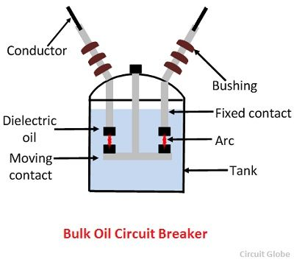

Working Principle of Oil Circuit Breaker
During the normal operating conditions, the contact of the oil circuit breaker is closed and carry the current. When the fault occurs in the system, the contacts of the breaker are moving apart, and an arc is struck between the contacts.
Due to this arc, a large amount of heat is liberated, and a very high temperature is reached which vaporises the surrounding oil into gas. The gas, thus liberated surrounds the arc and its explosive growth around it displace the oil violently. The arc is extinguished when the distance between the fixed and moving contact reaches a certain critical value, depends on the arc current and recovery voltage.
The oil circuit breaker is very reliable in operation, and it is very cheap. The most important feature of oil circuit breaker is that no special devices are used for controlling the arc caused by moving contact.
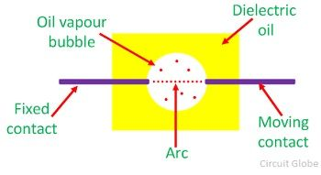

Advantages of Oil as an Arc Quenching
- The oil has a high dielectric strength and provides insulation between the contact after the arc has been extinguished.
- The oil used in circuit breaker provides a small clearance between the conductors and the earth components.
- The hydrogen gas is formed in the tank which has a high diffusion rate and good cooling properties.

Disadvantages of Oil as an Arc Quenching
- The oil used in oil circuit breaker is inflammable and hence, cause a fire hazard.
- There is a risk of formation of explosive mixture with air.
- Due to decomposition of oil in the arc, the carbon particles is generated which polluted the oil and hence the dielectric strength of the oil decreases.

Self Blast Oil Circuit Breaker

In case of plain break oil circuit breaker, the arc is controlled only by increasing the length of the arc.
However, it is required that final arc extinction should occur at small contact gap too. For this purpose, some arc control is to be provided in the circuit breaker. The circuit breakers provided with arc control is known as arc control circuit breakers. These are of two types, namely:
- Self Blast Oil Circuit Breaker
- Forced Blast Oil Circuit Breaker

Self Blast Oil Circuit Breaker
In such circuit breakers, movement of the oil into contact space is increased by the use of pressure developed by arc itself.
The high pressure produced by the arc causes an immediate flow of oil into space between contacts after the arc current goes to zero.
This is obtained by surrounding the contacts by a pressure chamber or pot. The pressure developed by the oil depends upon the value of current to be interrupted. Such circuit breakers have the following advantages:
- the pressure chamber is relatively cheap to make
- length for critical gap is reduced
- arcing time is reduced
- the breaking capacity of circuit breaker is increased
The design of pressure chamber or pot should be such that:
- pressure developed in it should be enough to quench the arc even at low values of current
- it should not be too high to break the pot on heavy current
This has led to the manufacture of a different variety of pots, description of some is as below:
PlainExplosionPot
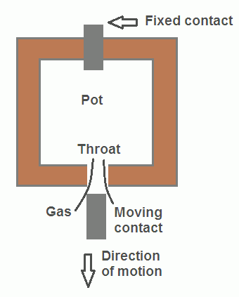
It is a rigid cylinder of insulating material which surrounds the fixed and moving contacts, closed at the top but with a narrow opening, known as the throat, at the bottom.
The moving contact is a cylindrical rod passing through the throat. When a fault occurs, the contacts separate, an arc is struck between them and oil is decomposed into a gas (mostly Hydrogen) at a very high pressure in the pot, due to the heat of arc. The high pressure forces the oil and gas around the arc to extinguish it.
This type of pot cannot be used either for very low or very high currents. On low fault currents, the pressure developed is small which increases the arcing time.
On the other hand, on large fault currents, the gas is produced so violently that pot may burst due to high pressure. Thus the breaking capacity of this type of pot is limited.
Cross-Jet Explosion Pot

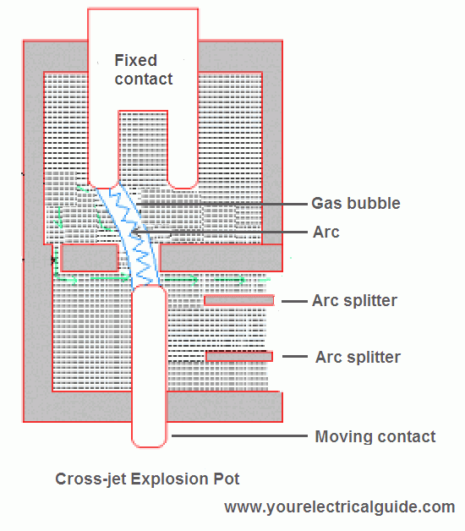
This pot is just a modification of plain explosion pot and shown in the figure. It is made of insulating material and has channels on one side which acts as arc splitters.

These arc splitters lengthen the arc and also provide cutting edges across which arc is weakened and finally interrupted. When the contacts of the pot are ejected, oil movement is checked by arc pressure itself until arc current goes to zero.
When a fault occurs, the moving contact of breaker separates, and due to this separation of contacts, the arc is initially struck in the top of the pot. The gas produced by the arc exerts pressure on the oil.
When the moving contact uncovers the arc splitters ducts fresh oil is forced across the arc path. Thus the arc is driven sideways into the arc splitters which increase the arc length, causing arc extinction.
The cross-jet explosion pot is very suitable when heavy fault currents are to be interrupted. But gas pressure developed is small on low fault currents and consequently, pot operation is not satisfactory.
Therefore, cross-jet explosion pot based self-blast oil circuit breaker is suitable for interrupting heavy currents at high voltage (66 kV).
SelfCompensated Explosion Pot

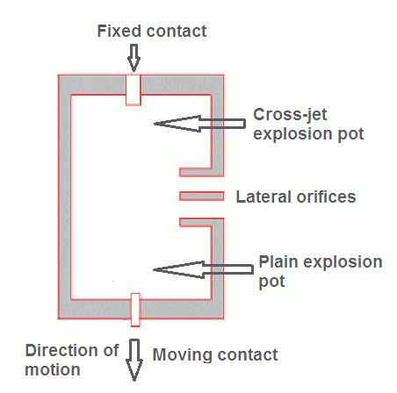
Such a pot is shown in the figure. It consists of two chambers. The upper chamber is cross-jet explosion pot with two lateral orifices while the lower is plain explosion pot.
As it is a combination of the plain explosion pot and the cross-jet explosion pot. Therefore, it operates very well at heavy currents and low currents.

Forced Blast Oil Circuit Breaker

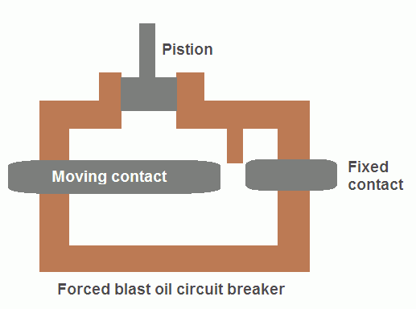
The major drawback of the self-blast oil circuit breaker is that:
- its arcing time is long
- poor performance with fault currents considerably less than rated current.
It is due to reduced generation of gas at low fault currents. This problem is eliminated in forced blast oil circuit breakers in which pressure is developed by the external mechanical system.
In these circuit breakers pressure developed is independent of the fault currents to be interrupted.
In forced blast oil circuit breaker, the oil pressure is created mechanically by the piston-cylinder arrangement. The movement of the piston is mechanically coupled to the moving contact. Thus when circuit breaker operates, oil pressure is generated automatically and the arc is interrupted at high speed.
At low currents, the performance of such breaker is more consistent than self-blast oil circuit breaker since oil pressure is independent of fault current.
One more advantage of this design over the self-blast oil circuit breaker is that the quantity of oil required is reduced to one-quarter.

Minimum Oil Circuit Breaker
In this type of circuit breaker minimum oil is used as an arc quenching medium and it is mounted on a porcelain insulator to insulate it from the earth. The arc chamber of such type of circuit breaker is enclosed in a bakelised paper. The lower portion of this breaker is supported by the porcelain and the upper porcelain enclosed the contacts.
This circuit breaker is of the single breaker type in which a moving contact tube moves in a vertical line to make or break contact with the upper fixed contacts mounted within the arc control devices.
A lower ring of fixed contacts is in permanent contact with the moving arm to provide the other terminal of the phase unit. Within the moving contact, the tube is a fixed piston. When the moving contact moves downwards, it forces the insulating oil to enter into the arc control devices . Thus, the arc gets extinguished.
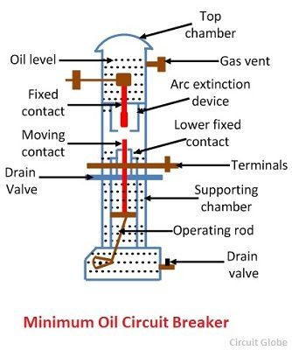
Minimum oil circuit breaker requires less space as compared to bulk oil circuit breaker which is an important feature in large installations. But it is less suitable in places where the frequent operation is required because the degree of carbonisation produced in the small volume of oil is far more dangerous than in the conventional bulk oil circuit breakers and this also decreases the dielectric strength of the material.
The low oil circuit breakers have the advantages of a requirement of the lesser quantity of oil, smaller space requirement, smaller tank size, smaller weight, low cost, reduced risk of fire and reduced maintenance problems. Minimum oil circuit breaker suffers from the following drawbacks when compared with the bulk oil circuit breakers
- Increased degree of carbonisation due to a smaller quantity of oil.
- The dielectric strength of oil decreases due to a high degree of carbonisation.
- Difficulty in removal of gases from the contact space-time

Air Circuit Breaker Air Blast Circuit Breaker :

This type of circuit breakers, is those kind of circuit breaker which operates in air at atmospheric pressure. After development of oil circuit breaker, the medium voltageair circuit breaker (ACB) is replaced completely by oil circuit breaker in different countries. But in countries like France and Italy, ACBs are still preferable choice up to voltage 15 KV. It is also good choice to avoid the risk of oil fire, in case of oil circuit breaker. In America ACBs were exclusively used for the system up to 15 KV until the development of new vacuum and SF₆ circuit breakers.

Working Principle of Air Circuit Breaker
The working principle of this breaker is rather different from those in any other types of circuit breakers. The main aim of all kind of circuit breaker is to prevent the reestablishment of arcing after current zero by creating a situation where in the contact gap will withstand the system recovery voltage. The air circuit breaker does the same but in different manner. For interrupting arc it creates an arc voltage in excess of the supply voltage. Arc voltage is defined as the minimum voltage required maintaining the arc. This circuit breaker increases the arc voltage by mainly three different ways,
- It may increase the arc voltage by cooling the arc plasma. As the temperature of arc plasma is decreased, the mobility of the particle in arc plasma is reduced; hence more voltage gradient is required to maintain the arc.
- It may increase the arc voltage by lengthening the arc path. As the length of arc path is increased, the resistance of the path is increased, and hence to maintain the same arc current more voltage is required to be applied across the arc path. That means arc voltage is increased.
- Splitting up the arc into a number of series arcs also increases the arc voltage.

Types of ACB
There are mainly two types of ACB are available.
- Plain air circuit breaker.
- Air blast Circuit Breaker.

Operation of ACB
- The first objective is usually achieved by forcing the arc into contact with as large an area as possible of insulating material. Every air circuit breaker is fitted with a chamber surrounding the contact. This chamber is called ‘arc chute’. The arc is driven into it. If inside of the arc chute is suitably shaped, and if the arc can be made conform to the shape, the arc chute wall will help to achieve cooling. This type of arc chute should be made from some kind of refractory material. High temperature plastics reinforced with glass fiber and ceramics are preferable materials for making arc chute.
- The second objective that is lengthening the arc path, is achieved concurrently with fist objective. If the inner walls of the arc chute is shaped in such a way that the arcis not only forced into close proximity with it but also driven into a serpentine channel projected on the arc chute wall. The lengthening of the arc path increases the arc resistance.
- The third technique is achieved by using metal arc slitter inside the arc chute. The main arc chute is divided into numbers of small compartments by using metallic separation plates. These metallic separation plates are actually the arc splitters and each of the small compartments behaves as individual mini arc chute. In this system the initial arc is split into a number of series arcs, each of which will have its own mini arc chute. So each of the split arcs has its own cooling and lengthening effect due to its own mini arc chute and hence individual split arc voltage becomes high. These collectively, make the overall arc voltage, much higher than the system voltage.
This was working principle of air circuit breaker now we will discuss in details the operation of ACB in practice.
The air circuit breaker, operated within the voltage level 1 KV, does not require any arc control device. Mainly for heavy fault current on low voltages (low voltage level above 1 KV) ABCs with appropriate arc control device, are good choice. These breakers normally have two pairs of contacts. The main pair of contacts carries the current at normal load and these contacts are made of copper. The additional pair is the arcing contact and is made of carbon. When circuit breaker is being opened, the main contacts open first and during opening of main contacts the arcing contacts are still in touch with each other. As the current gets, a parallel low resistive path through the arcing contact during opening of main contacts, there will not be any arcing in the main contact. The arcing is only initiated when finally the arcing contacts are separated. The each of the arc contacts is fitted with an arc runner which helps, the arc discharge to move upward due to both thermal and electromagnetic effects as shown in the figure. As the arc is driven upward it enters in the arc chute, consisting of splitters. The arc in chute will become colder, lengthen and split hence arc voltage becomes much larger than system voltage at the time of operation of air circuit breaker, and therefore the arc is quenched finally during the current zero.
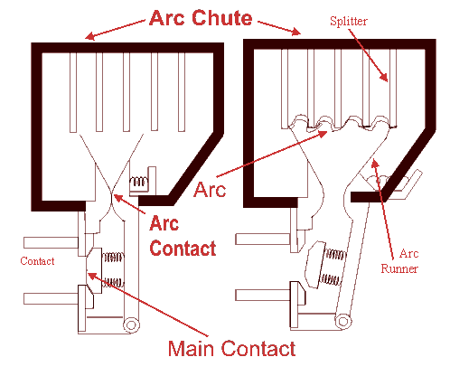
Although these types of circuit breakers have become obsolete for medium voltage application, but they are still preferable choice for high current rating in low voltage application.

Air Blast Circuit Breaker
These types of air circuit breaker were used for the system voltage of 245 KV, 420 KV and even more, especially where faster breaker operation was required. Air blast circuit breaker has some specific advantages over oil circuit breaker which are listed as follows,
- There is no chance of fire hazard caused by oil.
- The breaking speed of circuit breaker is much higher during operation of air blast circuit breaker.
- Arc quenching is much faster during operation of air blast circuit breaker.
- The duration of arc is same for all values of small as well as high currents interruptions.
- As the duration of arc is smaller, so lesser amount of heat realized from arc to current carrying contacts hence the service life of the contacts becomes longer.
- The stability of the system can be well maintained as it depends on the speed of operation of circuit breaker.
- Requires much less maintenance compared to oil circuit breaker.
There are also some disadvantages of air blast circuit breakers–
- In order to have frequent operations, it is necessary to have sufficiently high capacity air compressor.
- Frequent maintenance of compressor, associated air pipes and automatic control equipments is also required.
- Due to high speed current interruption there is always a chance of high rate of rise of re-striking voltage and current chopping.
- There also a chance of air pressure leakage from air pipes junctions.
As we said earlier that there are mainly two types of ACB, plain air circuit breaker and air blast circuit breaker. But the later can be sub divided further into three different categories.
- Axial Blast ACB.
- Axial Blast ACB with side moving contact.
- Cross Blast ACB.

Axial Blast Air Circuit Breaker

In axial blast ACB the moving contact is in contact with fixed contact with the help of a spring pressure as shown in the figure. There is a nozzle orifice in the fixed contact which is blocked by tip of the moving contact at normal closed condition of the breaker. When fault occurs, the high pressure air is introduced into the arcing chamber. The air pressure will counter the spring pressure and deforms the spring hence the moving contact is withdrawn from the fixed contact and nozzle hole becomes open. At the same time the high pressure air starts flowing along the arc through the fixed contact nozzle orifice. This axial flow of air along the arc through the nozzle orifice will make the arc lengthen and colder hence arc voltage become much higher than system voltage that means system voltage is insufficient to sustain the arc consequently the arc is quenched.

Axial Blast ACB with Side Moving Contact

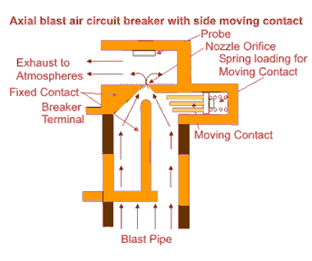

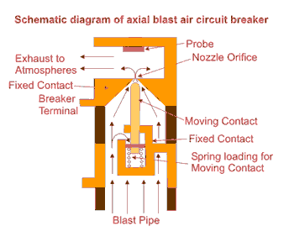
In this type of axial blast air circuit breaker the moving contact is fitted over a piston supported over a spring. In order to open the circuit breaker the air is admitted into the arcing chamber when pressure reaches to a predetermined value, it presses down the moving contact; an arc is drawn between the fixed and moving contacts. The air blast immediately transfers the arc to the arcing electrode and is consequently quenched by the axial flow of air.

Cross Blast Air Circuit Breaker

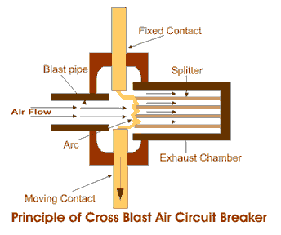
The working principle of cross blast air circuit breaker is quite simple. In this system of air blast circuit breaker the blast pipe is fixed in perpendicular to the movement of moving contact in the arcing chamber and on the opposite side of the arcing chamber one exhaust chamber is also fitted at the same alignment of blast pipe, so that the air comes from blast pipe can straightly enter into exhaust chamber through the contact gap of the breaker. The exhaust chamber is spit with arc splitters. When moving contact is withdrawn from fixed contact, an arc is established in between the contact, and at the same time high pressure air coming from blast pipe will pass through the contact gap and will forcefully take the arc into exhaust chamber where the arc is split with the help of arc splitters and ultimately arc is quenched.

Sulphur Hexafluoride (SF6) Circuit Breaker :

A circuit breaker in which SF₆ under pressure gas is used to extinguish the arc is called SF₆ circuit breaker. SF₆ (sulphur hexafluoride) gas has excellent dielectric, arc quenching, chemical and other physical properties which have proved its superiority over other arc quenching mediums such as oil or air. The SF₆ circuit breaker is mainly divided into three types

- Non-puffer piston circuit breaker
- Single- puffer piston circuit breaker.
- Double-puffer piston circuit breaker.

The circuit breaker which used air and oil as an insulating medium, their arc extinguishing force builds up was relatively slow after the movement of contact separation. In the case of high voltage circuit breakers quick arc extinction properties are used which require less time for quick recovery, voltage builds up. SF₆ circuit breakers have good properties in this regards compared to oil or air circuit breakers. So in high voltage up to 760 kV, SF₆ circuit breakers is used.

Properties of Sulphur hexafluoride Circuit Breaker

Sulphur hexafluoride possesses very good insulating and arc quenching properties. These properties are
- It is colourless, odourless, non-toxic, and non-inflammable gas.
- SF₆ gas is extremely stable and inert, and its density is five times that of air.
- It has high thermal conductivity better than that of air and assists in better cooling current carrying parts.
- SF₆ gas is strongly electronegative, which means the free electrons are easily removed from discharge by the formation of negative ions.
- It has a unique property of fast recombination after the source energising spark is removed. It is 100 times more effective as compared to arc quenching medium.
- Its dielectric strength is 2.5 times than that of air and 30% less than that of the dielectric oil. At high pressure the dielectric strength of the gas increases.
- Moisture is very harmful to SF₆ circuit breaker. Due to a combination of humidity and SF₆ gas, hydrogen fluoride is formed (when the arc is interrupted) which can attack the parts of the circuit breakers.

Construction of SF₆ Circuit Breakers

SF₆ circuit breakers mainly consist of two parts, namely (a) the interrupter unit and (b) the gas system.
Interrupter Unit – This unit consists of moving and fixed contacts comprising a set of current-carrying parts and an arcing probe. It is connected to the SF₆gas reservoir. This unit consists slide vents in the moving contacts which permit the high-pressure gas into the main tank.
Gas System – The closed circuit gas system is employed in SF₆ circuit breakers. The SF₆ gas is costly, so it is reclaimed after each operation. This unit consists low and high-pressure chambers with a low-pressure alarm along with warning switches. When the pressure of the gas is very low due to which the dielectric strength of gases decrease and an arc quenching ability of the breakers is endangered, then this system gives the warning alarm.
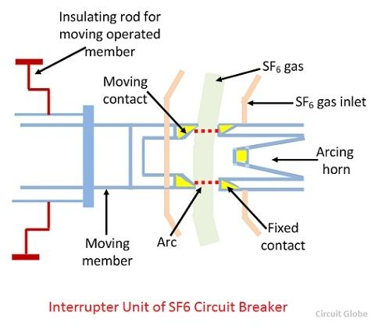

Working Principle of SF₆ Circuit Breaker
In the normal operating conditions, the contacts of the breaker are closed. When the fault occurs in the system, the contacts are pulled apart, and an arc is struck between them. The displacement of the moving contacts is synchronised with the valve which enters the high-pressure SF₆ gas in the arc interrupting chamber at a pressure of about 16kg/cm^2.
The SF₆ gas absorbs the free electrons in the arc path and forms ions which do not act as a charge carrier. These ions increase the dielectric strength of the gas and hence the arc is extinguished. This process reduces the pressure of the SF₆ gas up to 3kg/cm^2 thus; it is stored in the low-pressure reservoir. This low-pressure gas is pulled back to the high-pressure reservoir for re-use.
Now a day puffer piston pressure is used for generating arc quenching pressure during an opening operation by mean of a piston attached to the moving contacts.

Advantage of SF₆ circuit breaker

SF₆ circuit breakers have the following advantages over conventional breaker
- SF₆ gas has excellent insulating, arc extinguishing and many other properties which are the greatest advantages of SF₆ circuit breakers.
- The gas is non-inflammable and chemically stable. Their decomposition products are non-explosive and hence there is no risk of fire or explosion.
- Electric clearance is very much reduced because of the high dielectric strength of SF₆.
- Its performance is not affected due to variations in atmospheric condition.
- It gives noiseless operation, and there is no over voltage problem because the arc is extinguished at natural current zero.
- There is no reduction in dielectric strength because no carbon particles are formed during arcing.
- It requires less maintenance and no costly compressed air system is required.
- SF₆ performs various duties like clearing short-line faults, switching, opening unloaded transmission lines, and transformer reactor, etc. without any problem.

Disadvantages of SF₆ circuit breakers

- SF₆ gas is suffocating to some extent. In the case of leakage in the breaker tank, the SF₆ gas being heavier than air and hence SF₆ are settled in the surroundings and lead to the suffocation of the operating personnel.
- The entrance of moisture in the SF₆ breaker tank is very harmful to the breaker, and it causes several failures.
- The internal parts need cleaning during periodic maintenance under clean and dry environment.
- The special facility requires for transportation and maintenance of quality of gas.

Miniature circuit breaker (MCB):
A miniature circuit breaker automatically switches off electrical circuit during an abnormal condition of the network means in overload condition as well as faulty condition. Nowadays we use an MCB in low voltage electrical network instead of fuse. The fuse may not sense it but the miniature circuit breaker does it in a more reliable way. MCB is much more sensitive to overcurrent than fuse.
Handling an MCB is electrically safer than a fuse. Quick restoration of supply is possible in case of fuse as because fuses must be re-wirable or replaced for restoring the supply. Restoration is easily possible by just switching it ON. Let’s look at the working of the miniature circuit breaker.
Inside an MCB
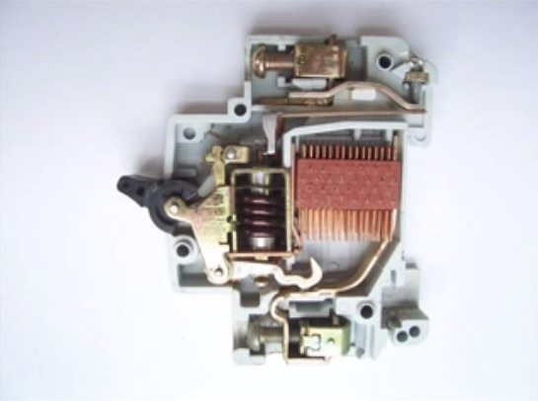

Working principle of MCB
Whenever continuous over current flows through MCB, the bimetallic strip is heated and deflects by bending. This deflection of bimetallic strip releases mechanical latch. As this mechanical latch is attached with operating mechanism, it causes to open the miniature circuit breaker contacts, and the MCB turns off thereby stopping the current to flow in the circuit. To restart the flow of current the MCB must be manually turned ON. This mechanism protects from the faults arising due to over current or over load.
But during short circuit condition, the current rises suddenly, causing electromechanical displacement of plunger associated with a tripping coil or solenoid. The plunger strikes the trip lever causing immediate release of latch mechanism consequently open the circuit breaker contacts. This was a simple explanation of miniature circuit breaker working principle.
Advertisement
An MCB is very simple, easy to use and is not generally repaired. It is just easier to replace. The trip unit is the main part, responsible for its proper working. There are two main types of trip mechanism. A bi-metal provides protection against overload current and an electromagnet provides protection against short-circuit current.

MCB operation
If the circuit is overloaded for a long time, the bi-metallic strip becomes overheated and deformed. This deformation of Bi-metallic strip causes, displacement of latch point. The moving contact of the MCB is arranged by means of spring pressure, with this latch point, that a little displacement of latch causes, release of spring and makes the moving contact to move for opening the MCB.
The current coil or trip coil is placed so that during short circuit fault the magneto-motive force (mmf) of the coil causes its plunger to hit the same latch point and make the latch to be displaced. Again, when operating lever of the miniature circuit breaker is operated by hand, that means when MCB goes off position manually, the same latch point is displaced as a result moving contact separated from fixed contact in the same manner.
It may be due to deformation of a bi-metallic strip, or increased mmf of trip coil or maybe a manual operation, the same latch point is displaced and same deformed spring is released, which ultimately responsible for movement of the moving contact. When the moving contact separated from fixed contact, there may be a high chance of arc. This arc then goes up through the arc runner and enters arc splitters and is finally quenched. When we switch it on, we reset the displaced operating latch to its previous on position and the MCB is ready for another switch off or trip operation.
MCCB has a higher capacity than an MCB, both are classified under low voltage circuit breakers and should, therefore, respond to standards set by the IEC 947. For convenience’s sake, some MCCB units have electrical motor operators, which means they can be tripped using only a remote control. For industrial or commercial use, they may be utilized as standby power that runs on an automatic transfer switch.
Both are installed in special niches on the wall that make it easy to install or uninstall without interrupting the whole system or damaging the switchgear. Both are also specially made to handle direct current, and are usually laid out in tiers for space efficiency.

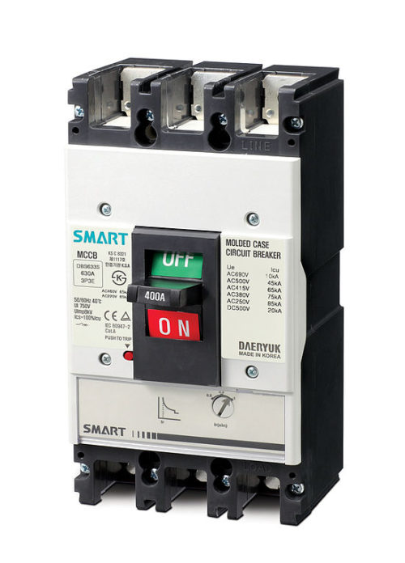
Molded Case Circuit Breaker (MCCB):

Circuit breakers are usually reset after they have been “tripped.” Both MCB and MCCB are highly durable and can last for years, depending on the manufacturer.
When choosing between an MCB and an MCCB, it is important to consider the amount of power that will be coursing through the device. As mentioned above, MCCB is more suited for higher energy due to its better capacity. Of course, when it comes to home use, the MCB is usually the circuit breaker of choice. For heavier power requirements that go beyond the 2,500 amps ceiling of the MCCB, medium or high-voltage circuit breakers are the next best choice.
Circuit breakers are installed in any structure that requires power for safety reasons. They are made to ensure that fire hazards or electrical problems will not occur in a home by cutting off electricity flow. This is usually done when the system experiences a “short circuit”, or an “overload.”
For this reason, MCB or MCCB should both be installed by professionals. This minimizes the chance of problems occurring with use. At the same time, choosing the right MCB or MCCB brand to install in a building is necessary as some brands are actually better than others. Ideally, the location of circuit breakers should provide easy access and be known to all individuals residing in the building.
Summary:
1.An MCB has less than 100 amps, while an MCCB goes as high as 2,500 amps.
2.The interrupting rating for an MCB is 18,000 amps, and up to 200,000 amps for an MCCB.
3.MCBs are mostly installed for home use, while an MCCB is generally utilized for commercial or industrial purposes.
4.Both are low-voltage circuit breakers created to meet IEC 947 standards.
5.Some MCCB units are specially made to respond to remote control signals, usually as standby power.
6.Circuit breakers are installed for safety reasons.
7.The location of circuit breakers in every structure should be known to the people who reside in it

Working Principle Of Earth Leakage Circuit Breaker(ELCB) And Its Advantage and Disadvantages :

- ELECTRICAL 10 COMMENTS
Early earth leakage circuit breakers are voltage detecting devices, which are now switched by current sensing devices (RCD/RCCB). Generally, the current sensing devices termed as RCCB and voltage detecting devices named as Earth Leakage Circuit Breaker (ELCB). Forty years ago, the first current ECLBs were introduced and about sixty years ago the first voltage ECLB was introduced. For several years, both the voltage and current operated ELCBs were both referred to as ELCBs due to its simple name to remember. But the applications of these two devices gave growth to the significant mix-up in the electrical industry.The manufacture of ECLB includes Fuji Electric, Major Tech, Siemens, ABB, Avera T&D, Telemecanique, Camsco, Crabtree, Orion Italia, Terasaki, MEM, and V guard.

What is an Earth Leakage Circuit Breaker (ELCB)
An ECLB is one kind of safety device used for installing an electrical device with high earth impedance to avoid shock. These devices identify small stray voltages of the electrical device on the metal enclosures and intrude the circuit if a dangerous voltage is identified. The main purpose of Earth leakage circuit breaker (ECLB) is to stop damage to humans & animals due to electric shock.
An ELCB is a specific type of latching relay that has a structure’s incoming mains power associated through its switching contacts so that the circuit breaker detaches the power in an unsafe condition.The ELCB notices fault currents of human or animal to the earth wire in the connection it guards. If ample voltage seems across the ELCB’s sense coil, it will turn off the power, and remain off until manually rearrange. A voltage sensing ELCB doesn’t detect fault currents from human or animal to the earth.

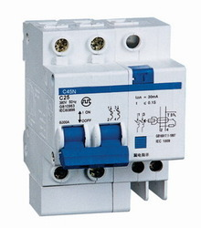
Earth Leakage Circuit Breaker
The ELCB notices fault currents of human or animal to the earth wire in the connection it guards. If ample voltage seems across the ELCB’s sense coil, it will turn off the power, and remain off until manually rearrange. A voltage sensing ELCB doesn’t detect fault currents from human or animal to the earth .

How to Connect Earth Leakage Circuit Breaker

The earth circuit is adapted when an ELCB is used; the connection to the earth rod is accepted through the earth leakage circuit breaker by linking to its two earth terminals. One goes to the fitting earth circuit protective conductor (CPC), and the other to the earth rod or another kind of earth connection. Thus the earth circuit permits through the ELCB’s sense coil.
Earth Leakage Circuit Breaker

Types of Earth Leakage Circuit Breaker (ELCB)
There are two types of Earth Leakage Circuit Breaker (ELCB)
- Voltage Operated ELCB
- Current Operated ELCB

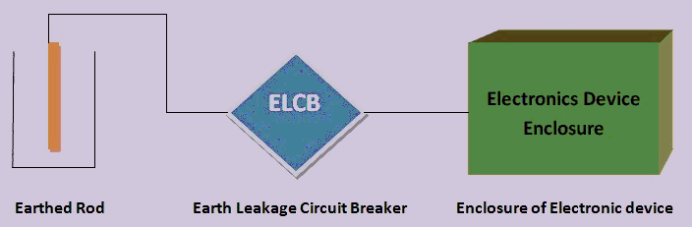

Voltage Operated ELCB
Voltage-operated ELCB device is used to detect a voltage to choose the Earth leakage. A single-phase voltage ELCB includes 6-terminals namely line in, line out, neutral in, neutral out, Earth and fault. The metal body of the load is associated with the fault terminal of the Earth Leakage Circuit Breaker (ELCB) & Earth terminal is associated with the ground. For usual working, the voltage across the trip coil is ‘0’, as the Load’s body is isolated from the supply line. When an Earth fault happens on the load due to the interaction of line wire to the metal body, a current will run through fault to the ground. The flow of current will set up a voltage across the trip coil, which is associated between E & F. The energized trip coil will tour the circuit to guard the load device & the user.
Voltage Operated ELCB
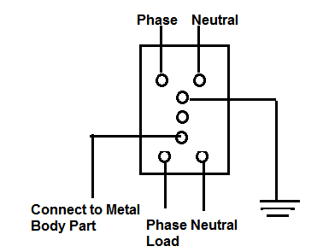
A voltage-operated ELCB detects a growth in potential between the threatened consistent metalwork and a distant isolated Earth reference electrode. They work as a sensed potential of around 50V to open the main breaker & separate the supply from the threatened premises.A voltage-operated ELCB includes a second terminal for linking to the remote reference Earth connection.
The Earth circuit is improved when an ELCB is utilized; the link to the Earth rod is delivered through the ELCB by linking to its two Earth terminals. One terminal energy to the installation Earth circuit protective conductor, aka Earth wire (CPC), and the other to the Earth rod or some type of earth connection.

Advantages of Voltage Operated ELCB

- ELCBs are less sensitive to fault conditions and have few nuisance trips.
- While current and voltage on the ground line generally fault current from a live wire, this is not continuously the case, therefore there are conditions in which an ELCB can annoyance trip.
- When an installation of the electrical instrument has two contacts to earth, a near high current lightning attack will root a voltage gradient in the earth, offering the ELCB sense coil with sufficient voltage to source it to a trip.
- If either of the soil wires become detached from the ELCB, it will no longer install will frequently no longer be correctly earthed.
- These ELCBs are the necessity for a second connection and the opportunity that any extra connection to ground on the threatened system can inactivate the detector.

Disadvantages of Voltage Operated ELCB
- They do not sense errors that don’t permit current through the CPC to the ground rod.
- They do not permit an only building system to be simply divided into many sections with independent error protection because earthing systems are typically used mutual earth, Rod.
- They may be skipped by outside voltages from something associated with the earthing system like as metal pipes, a TN-C-S or a TN-S earth mutual neutral and earth.
- As electrical leaky utilizations like washing machines, some water heaters and cookers might source the ELCB to trip.
- ELCBs present an extra resistance & an extra point of failure in the earthing system.

Current Operated ELCB
RCCB is the generally used ELCB and it comprises of a three winding transformer, that has two primary windings and also one secondary winding. Neutral & line wires work as the two main windings. A wire wound coil is the minor winding. The flow of current through the minor winding is “0” in the stable condition. In this condition, the flux owed to the current over the phase wire will be deactivated by the current through the neutral wire, meanwhile the current, that flows from the phase will be refunded to the neutral.
When an error occurs, a slight current will run into the ground also. This creates a confuse between line and neutral current and that makes an unstable magnetic field. This encourages a current flow through the minor winding, which is associated with the sensing circuit. This will detect the outflow and direct signal to tripping system.
Current Operated ELCB
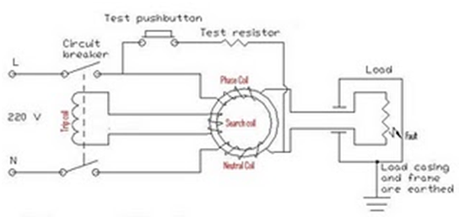
Thus, this is all about Earth Leakage Circuit Breaker (ELCB), types of ELCB and its working.We hope that you have got a better understanding of this concept. Furthermore, any doubts regarding this concept or to implement any electrical and electronic projects, please give your feedback by commenting in the comment section below. Here is a question for you, what is the function of ELCB?

