E-Notes

EIM

By – Bhupinder Kr.

Lecturer in ECE

Measurement

Methods of Measurements
The measurement is the result of the comparison of standard and the unknown quantity. The result of the measured quantity is generally expressed in numeric forms. In other words, the measurement is the process through which the physical parameters like heat, displacement, force etc. is converted into the easily readable numeric value.

The different methods of measurement are explained below in details.

Direct Method of Measurement – In this method of measurement, the unknown quantity is directly compared with the standard quantity. The result of the quantity is expressed in number. It is the most common method of measuring the physical quantities like length, temperature, pressure, etc.

Example: The physical balance directly measures the weight of the matter.

Indirect Method of Measurement – The direct measurement gives the inaccurate results in most of the cases. Hence, the direct method is rarely preferred for measurement. In indirect method of measurement, the physical parameters of the quantity are measured by the direct method, and then the numerical value of the quantity is determined by the mathematical relationship.

Example: The length, breadth and height of the substance is measured by the direct method and then by the help of the given relation the weight of the substance is known.

Weight = Length X Breadth X Height X Density

Method of Measurement without Contact – The sensor remains untouched with the object whose characters need to be measured.

Method of Combination measurement closed series – The result of the direct or indirect method of measurement are used for solving the equations.

Instrument Types
-Active and Passive Instruments
Passive: instrument output is produced entirely by the quantity being measured

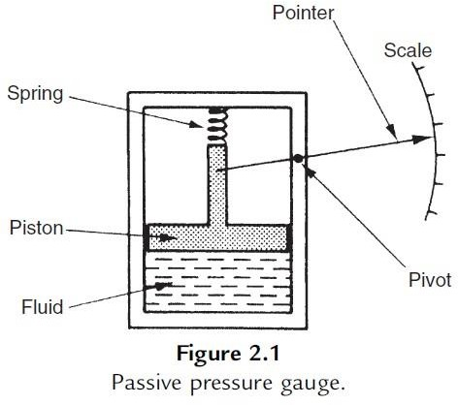

Active: the quantity being measured simply modulates the magnitude of some external power source
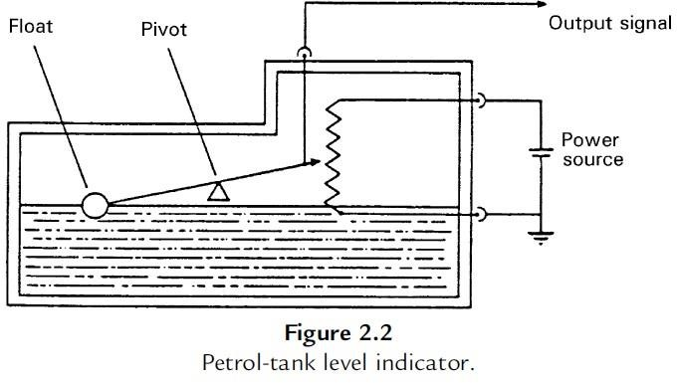

-Null-Type and Deflection-Type Instruments

Deflection type: the value of the quantity being measured is displayed in terms of the amount of movement of a pointer (like the pressure gauge)
An alternative type of pressure gauge is the dead-weight gauge shown in Figure, which is a null- type instrument. Here, weights are put on top of the piston until the downward force balances the fluid

pressure. Weights are added until the piston reaches a datum level, known as the null point. Pressure measurement is made in terms of the value of the weights needed to reach this null position. A general rule that null-type instruments are more accurate than deflection types
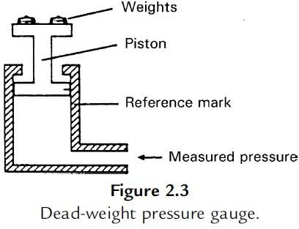

-Analogue and Digital Instruments
Analogue: gives an output that varies continuously as the quantity being measured changes. The output can have an infinite number of values within the range that the instrument is designed to measure (the deflection-type of pressure gauge)
Digital: has an output that varies in discrete steps and so can only have a finite number of values
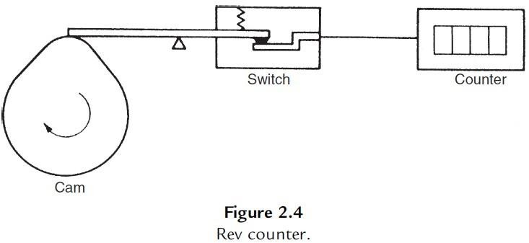
Analogue instruments must be interfaced to the microcomputer by an analogue-to- digital (A/D) converter, which converts the analogue output signal from the instrument into an equivalent digital quantity that can be read into the computer.

-Indicating Instruments and Instruments with a Signal Output
Indicating: merely give an audio or visual indication of the magnitude of the physical quantity measured (normally includes all null-type instruments and most passive ones. Indicators can also be further divided into those that have an analogue output and those that have a digital display. A common analogue indicator is the liquid-in-glass thermometer)
With a Signal Output: give an output in the form of a measurement signal whose magnitude is proportional to the measured quantity (commonly as part of automatic control systems)

-Smart and Non-smart Instruments

The advent of the microprocessor has created a new division in instruments between those that do incorporate a microprocessor (smart) and those that don’t

A) Static Characteristics of Instruments

If we have a thermometer in a room and its reading shows a temperature of 20oC, then it does not really matter whether the true temperature of the room is 19.5 or 20.5oC. Such small variations around 20oC are too small to affect whether we feel warm enough or not. Our bodies cannot discriminate between such close levels of temperature and therefore a thermometer with an inaccuracy of ±0.5oC is perfectly adequate. If we had to measure the temperature of certain chemical processes, however, a variation of
oC might have a significant effect on the rate of reaction or even the products of a process. A measurement inaccuracy much less than ±0.5oC is therefore clearly required.

Accuracy of measurement is thus one consideration in the choice of instrument for a particular application. Other parameters, such as sensitivity, linearity, and the reaction to ambient temperature changes, are further considerations. These attributes are collectively known as the static characteristics of instruments and are given in the data sheet for a particular instrument. It is important to note that values quoted for instrument characteristics in such a data sheet only apply when the instrument is used under specified standard calibration conditions.

    - Accuracy and Inaccuracy (Measurement Uncertainty)

The accuracy of an instrument is a measure of how close the output reading of the instrument is to the correct value. In practice, it is more usual to quote the inaccuracy or measurement uncertainty value rather than the accuracy value for an instrument. Inaccuracy or measurement uncertainty is the extent to which a reading might be wrong and is often quoted as a percentage of the full-scale (f.s.) reading of an instrument.
The aforementioned example carries a very important message. Because the maximum measurement error in an instrument is usually related to the full-scale reading of the instrument, measuring quantities that are substantially less than the full-scale reading means that the possible measurement error is amplified.

Example
A pressure gauge with a measurement range of 0–10 bar has a quoted inaccuracy of ±1.0% f.s. (±1% of full-scale reading). (a) What is the maximum measurement error expected for this instrument? (b) What is the likely measurement error expressed as a percentage of the output reading if this pressure gauge is measuring a pressure of 1 bar?

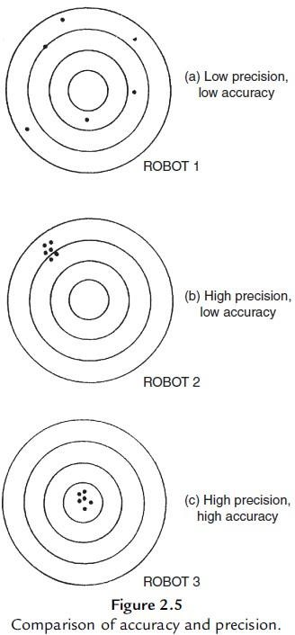
    - Precision/Repeatability/Reproducibility

Precision is a term that describes an instrument’s degree of freedom from random errors. If a large number of readings are taken of the same quantity by a high- precision instrument, then the spread of readings will be very small. Precision is often, although incorrectly, confused with accuracy. High precision does not imply anything about measurement accuracy. A high-precision instrument may have a low accuracy. Low accuracy measurements from a high-precision instrument are normally caused by a bias in the measurements, which is removable by recalibration.

    - Tolerance

Tolerance is a term that is closely related to accuracy and defines the maximum error that is to be expected in some value. While it is not, strictly speaking, a static characteristic of measuring instruments, it is mentioned here because the accuracy of some instruments is sometimes quoted as a tolerance value. When used correctly, tolerance describes the maximum deviation of a manufactured component from some specified value.

    - Range or Span

The range or span of an instrument defines the minimum and maximum values of a quantity that the instrument is designed to measure.

    - Linearity

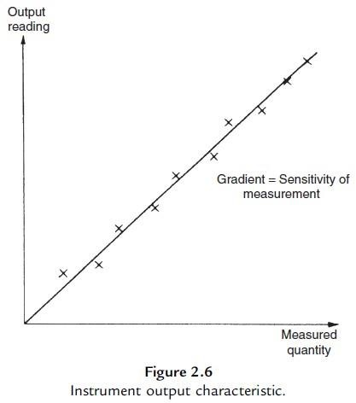
It is normally desirable that the output reading of an instrument is linearly proportional to the quantity being measured. The Xs marked on Figure 2.6 show a plot of typical output readings of an instrument when a sequence of input quantities are applied to it. Normal procedure is to draw a good fit straight line through the Xs, as shown in Figure 2.6.

Nonlinearity is then defined as the maximum deviation of any of the output readings marked X from this straight line.

    - Sensitivity of Measurement

The sensitivity of measurement is a measure of the change in instrument output that occurs when the quantity being measured changes by a given amount. Thus, sensitivity is the ratio:
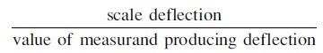

The sensitivity of measurement is therefore the slope of the straight line drawn on Figure 2.6.
    - Threshold

If the input to an instrument is increased gradually from zero, the input will have to reach a certain minimum level before the change in the instrument output reading is of a large enough magnitude to be detectable. This minimum level of input is known as the threshold of the instrument.
Manufacturers
vary in the way that they specify threshold for instruments. Some quote absolute values, whereas others quote threshold as a percentage of full-scale readings.
    - Resolution
When an instrument is showing a particular output reading, there is a lower limit on the magnitude of the change in the input measured quantity that produces an observable change in the instrument

output. Like threshold, resolution is sometimes specified as an absolute value and sometimes as a percentage of f.s. deflection. One of the major factors influencing the resolution of an instrument is how finely its output scale is divided into subdivisions.

    - Sensitivity to Disturbance

All calibrations and specifications of an instrument are only valid under controlled conditions of temperature, pressure, and so on. These standard ambient conditions are usually defined in the instrument specification. As variations occur in the ambient temperature, certain static instrument characteristics change, and the sensitivity to disturbance is a measure of the magnitude of this change. Figure 2.7

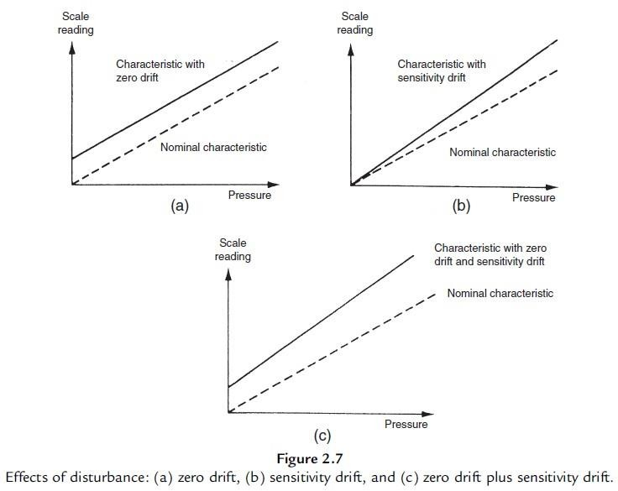
ERROR
The static error of a measuring instrument is the numerical difference between the true value of a quantity and its value as obtained by measurement, i.e. repeated measurement of the same quantity give different indications.
Static errors are categorized as gross errors or human errors, systematic errors and Random errors.
Gross Errors

This error is mainly due to human mistakes in reading or in using instruments or errors in recording observations. Errors may also occur due to incorrect adjustments of instruments and computational mistakes. These errors cannot be treated mathematically. The complete elimination of gross errors is not possible, but one can minimize them. Some errors are

easily detected while others may be elusive. One of the basic gross errors that occur frequently is the improper use of an Instrument the error can be minimized by taking proper care in reading and recording the measurement parameter. In general, indicating instruments change ambient conditions to some extent when connected into a complete circuit.

Systematic Errors
These errors occur due to shortcomings of, the instrument, such as defective or worn parts, or ageing or effects of the environment on the instrument. These errors are sometimes referred to as bias, and they influence all measurements of a quantity alike. A constant uniform deviation of the operation of an instrument is known as a systematic error.
There are basically three types of systematic errors (i) Instrumental, (ii) Environmental, and (iii)
Observational
    - Instrumental Errors
Instrumental errors are inherent in measuring instruments, because of their mechanical structure. For example, in the D'Arsonval movement friction in the bearings of various moving components, irregular spring tensions, stretching of the spring or reduction in tension due to improper handling or over loading of the instrument.
Instrumental errors can be avoided by
- Selecting a suitable instrument for the particular measurement applications.
- Applying correction factors after determining the amount of instrumental error. (c) Calibrating the instrument against a standard.

    - Environmental Errors
Environmental errors are due to conditions external to the measuring device, including conditions in the area surrounding the instrument, such as the effects of change in temperature, humidity, barometric pressure or of magnetic or electrostatic fields.

These errors can also be avoided by (i) air conditioning, (ii) hermetically sealing certain components in the instruments, and (iii) using magnetic shields.

    - Observational Errors
Observational errors are errors introduced by the observer. The most common error is the parallax error introduced in reading a meter scale, and the error of estimation when obtaining a reading from a meter scale These errors are caused by the habits of individual observers. For example, an observer may always introduce an error by consistently holding his head too far to the left while reading a needle and scale reading. In general, systematic errors can also be subdivided into static and dynamic errors.
Static errors are caused by limitations of the measuring device or the physical laws governing its behavior. Dynamic errors are caused by the instrument not responding fast enough to follow the changes in a measured variable

ERROR IN MEASUREMENT
Measurement is the process of comparing an unknown quantity with an accepted standard quantity. It involves connecting a measuring instrument into the system under consideration and observing the resulting response on the instrument. The measurement thus obtained is a quantitative measure of the so-called "true value" (since it is very difficult to define the true value, the term "expected value" is used). Any measurement is affected by many variables; therefore the results rarely reflect the expected value. For example, connecting a measuring instrument into the circuit under consideration always disturbs (changes) the circuit, causing the measurement to differ from the expected value. Some factors that affect the measurements are related to the measuring instruments themselves.
Other factors are related to the person using the instrument. The degree to which a measurement nears the expected value is expressed in terms of the error of measurement. Error may be

expressed either as absolute or as percentage of error. Absolute error may be defined as the difference between the expected value of the variable and the measured value of the variable, or
e = Y n - X n Where, e=absolute errors; Yn=expected value;
Xn=measured value;

Random (indeterminate) errors:
Those due to causes that cannot be directly established because of random variations in the parameter or the system of measurement. Hence, we have no control over them. Their random nature causes both high and low values to average out. Multiple trials help to minimize their effects. We deal with them using statistics.

Statistical analysis of errors
A statistical analysis of measurement data is common practice because it allows an analytical determination of the uncertainty of the final test result. The outcome of a certain measurement method may be predicted on the basis of sample data without having detailed information on all the disturbing factors. To make statistical methods and interpretations meaningful, a large number of measurements are usually required. Also, systematic errors should be small compared with residual or random errors, because statistical treatment of data cannot remove a fixed bias contained in all the measurements

ERROR
The static error of a measuring instrument is the numerical difference between the true value of a quantity and its value as obtained by measurement, i.e. repeated measurement of the same quantity give different indications.
Static errors are categorized as gross errors or human errors, systematic errors and Random errors.

Gross Errors

This error is mainly due to human mistakes in reading or in using instruments or errors in recording observations. Errors may also occur due to incorrect adjustments of instruments and computational mistakes. These errors cannot be treated mathematically. The complete elimination of gross errors is not possible, but one can minimize them. Some errors are easily detected while others may be elusive. One of the basic gross errors that occur frequently is the improper use of an Instrument the error can be minimized by taking proper care in reading and recording the measurement parameter. In general, indicating instruments change ambient conditions to some extent when connected into a complete circuit.

Systematic Errors
These errors occur due to shortcomings of, the instrument, such as defective or worn parts, or ageing or effects of the environment on the instrument. These errors are sometimes referred to as bias, and they influence all measurements of a quantity alike. A constant uniform deviation of the operation of an instrument is known as a systematic error.
There are basically three types of systematic errors (i) Instrumental, (ii) Environmental, and (iii)
Observational
- Instrumental Errors
Instrumental errors are inherent in measuring instruments, because of their mechanical structure. For example, in the D'Arsonval movement friction in the bearings of various moving components, irregular spring tensions, stretching of the

spring or reduction in tension due to improper handling or over loading of the instrument.
Instrumental errors can be avoided by
  - Selecting a suitable instrument for the particular measurement applications.
  - Applying correction factors after determining the amount of instrumental error. (c) Calibrating the instrument against a standard.

- Environmental Errors
Environmental errors are due to conditions external to the measuring device, including conditions in the area surrounding the instrument, such as the effects of change in temperature, humidity, barometric pressure or of magnetic or electrostatic fields.

These errors can also be avoided by (i) air conditioning, (ii) hermetically sealing certain components in the instruments, and (iii) using magnetic shields.

- Observational Errors
Observational errors are errors introduced by the observer. The most common error is the parallax error introduced in reading a meter scale, and the error of estimation when obtaining a reading from a meter scale These errors are caused by the habits of individual observers. For example, an observer may always introduce an error by consistently holding his head too far to the left while reading a needle and scale reading. In general, systematic errors can also be subdivided into static and dynamic errors.
Static errors are caused by limitations of the measuring device or the physical laws governing its behavior. Dynamic errors are caused by the instrument not responding fast enough to follow the changes in a measured variable

ERROR IN MEASUREMENT
Measurement is the process of comparing an unknown quantity with an accepted standard quantity. It involves connecting a measuring instrument into the system under consideration and observing the resulting response on the instrument. The measurement thus obtained is a quantitative measure of the so-called "true value" (since it is very difficult to define the true value, the term "expected value" is used). Any measurement is affected by many variables; therefore the results rarely reflect the expected value. For example, connecting a measuring instrument into the circuit under consideration always disturbs (changes) the circuit, causing the measurement to differ from the expected value. Some factors that affect the measurements are related to the measuring instruments themselves.
Other factors are related to the person using the instrument. The degree to which a measurement nears the expected value is expressed in terms of the error of measurement. Error may be expressed either as absolute or as percentage of error. Absolute error may be defined as the difference between the expected value of the variable and the measured value of the variable, or
e = Y n - X n Where, e=absolute errors; Yn=expected value;
Xn=measured value;

Random (indeterminate) errors:
Those due to causes that cannot be directly established because of random variations in the parameter or the system of measurement. Hence, we have no control over them. Their random nature causes both high and low values to average out. Multiple trials help to minimize their effects. We deal with them using statistics.

Statistical analysis of errors
A statistical analysis of measurement data is common practice because it allows an analytical determination of the uncertainty of the final test result. The outcome of a certain measurement method may be predicted on the basis of sample data without having detailed information on all the disturbing factors. To make statistical methods and interpretations meaningful, a large number of measurements are usually required. Also, systematic errors should be small compared with residual or random errors, because statistical treatment of data cannot remove a fixed bias contained in all the measurements

Equation involved

The interaction between the induced field and the field produced by the permanent magnet causes a deflecting torque, which results in the rotation.

The three important torque involved in this instrument are:

Deflecting torque:

The force F which will be perpendicular to both the direction of the current flow and the direction of magnetic field as per Fleming’s left hand rule can be written as

F = NBIL

where N: turns of wire on the coil B: flux density in the air gap
I: current in the movable coil L: vertical length of the coil
Theoretically, the torque (here electro-magnetical torque) is equal to the multiplication of force with distance to the point of suspension.

Hence Torque on left side of the cylinder TL = NBIL x W/2 and torque on right side of the cylinder TR = NBIL x W/2

Therefore the total torque will be = TL + TR

T = NBILW or NBIA where A is effective area (A= LxW)

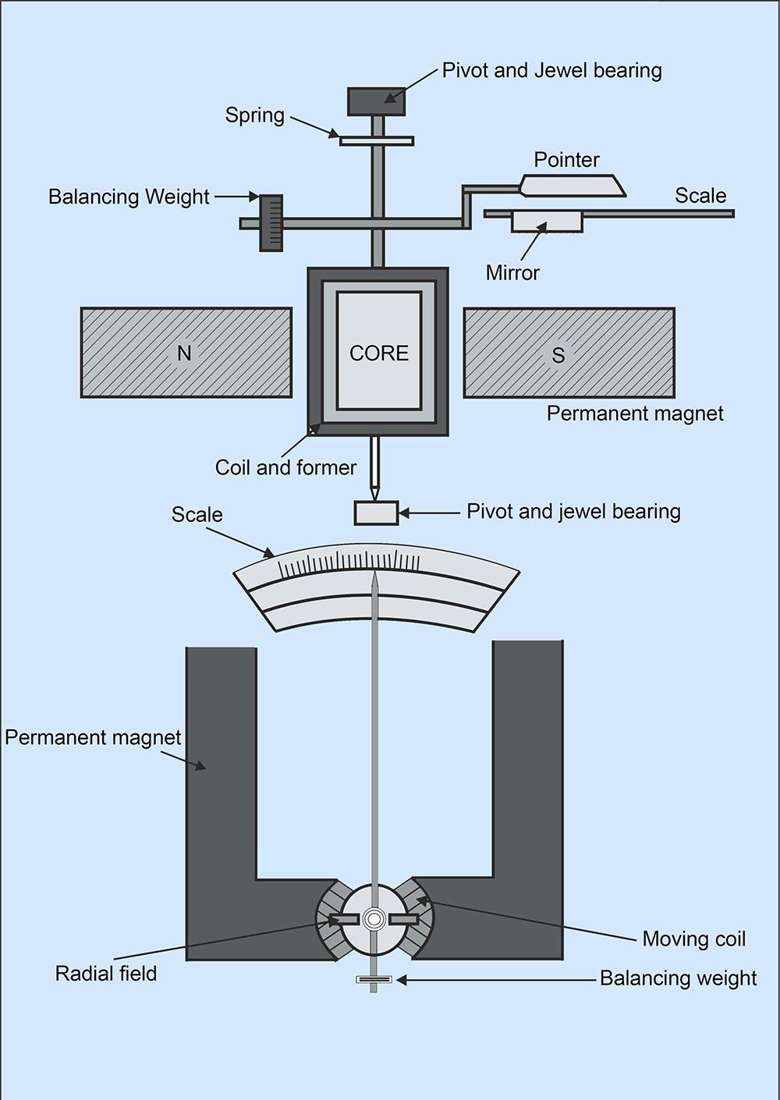

Controlling Torque

This torque is produced by the spring action and opposes the deflection torque so as the pointer can come to rest at the point where these two torques are equal (Electromagnetic torque = control spring torque). The value of control torque depends on the mechanical design of spiral springs and strip suspensions.

The controlling torque is directly proportional to the angle of deflection of the coil.

Control torque Ct =Cθ where, θ = deflection angle in radians and C = spring constant Nm /rad .

Damping torque

This torque ensures the pointer comes to an equilibrium position i.e. at rest in the scale without oscillating to give an accurate reading. In PMMC as the coil moves in the magnetic field, eddy current sets up in a metal former or core on which the coil is wound or in the circuit of the coil itself which opposes the motion of the coil resulting in the slow swing of a pointer and then come to rest quickly with very little oscillation.

Construction

A coil of thin wire is mounted on an aluminum frame (spindle) positioned between the poles of a U shaped permanent magnet which is made up of magnetic alloys like alnico.

The coil is pivoted on the jeweled bearing and thus the coil is free to rotate. The current is fed to the coil through spiral springs which are two in numbers. The coil which carries a current, which is to be measured, moves in a strong magnetic field produced by a permanent magnet and a pointer is attached to the spindle which shows the measured value.

Working

When a current flow through the coil, it generates a magnetic field which is proportional to the current in case of an ammeter. The deflecting torque is produced by the electromagnetic action of the current in the coil and the magnetic field.

When the torques are balanced the moving coil will stop and its angular deflection represents the amount of electrical current to be measured against a fixed reference, called a scale. If the permanent magnet field is uniform and the spring linear, then the pointer deflection is also linear.

The controlling torque is provided by two phosphorous bronze flat coiled helical springs. These springs serve as a flexible connection to the coil conductors.

Damping is caused by the eddy current set up in the aluminum coil which prevents the oscillation of the coil.

Applications

The PMMC has a variety of uses onboard ship. It can be used as:

Ammeter:

When PMMC is used as an ammeter, except for a very small current range, the moving coil is connected across a suitable low resistance shunt, so that only small part of the main current flows through the coil.

The shunt consists of a number of thin plates made up of alloy metal, which is usually magnetic and has a low-temperature coefficient of resistance, fixed between two massive blocks of copper. A resistor of the same alloy is also placed in series with the coil to reduce errors due to temperature variation.

Voltmeter:

When PMMC is used as a voltmeter, the coil is connected in series with a high resistance. Rest of the function is same as above. The same moving coil can be used as an ammeter or voltmeter with an interchange of above arrangement

Galvanometer:

The galvanometer is used to measure a small value of current along with its direction and strength. It is mainly used onboard to detect and compare different circuits in a system.

Ohm Meter:

The ohm meter is used to measure the resistance of the electric circuit by applying a voltage to a resistance with the help of battery. A galvanometer is used to determine the flow of current through the resistance. The galvanometer scale is marked in ohms and as the resistance varies since the voltage is fixed, the current through the meter will also vary.

Advantages

  - The PMMC consumes less power and has great accuracy.
  - It has a uniformly divided scale and can cover an arc of 270 degrees.
  - The PMMC has a high torque to weight ratio.
  - It can be modified as ammeter or voltmeter with suitable resistance.
  - It has efficient damping characteristics and is not affected by stray magnetic field.
  - It produces no losses due to hysteresis.

Disadvantage

  - The moving coil instrument can only be used on D.C supply as the reversal of current produces a reversal of torque on the coil.
  - It’s very delicate and sometimes uses AC circuit with a rectifier.
  - It’s costly as compared to moving coil iron instruments.

  - It may show an error due to loss of magnetism of permanent magnet.

What are the different reasons that cause an error in PMMC?

- Temperature effect: Error in the reading of the PMMC may cause due to change in the temperature which will affect the resistance of the moving coil. The temperature coefficients of the value of the coefficient of copper wire in moving coil are 0.04 per degree Celsius rise in temperature. Since the coil has a lower temperature coefficient, it will have a faster rate of temperature rises which will result in increase in the resistance causing an error

- Spring material and age: The other factor which may lead to error in the PMMC reading is the quality and contortion of the spring. Old aging spring will not allow the pointer to show the correct reading making an error.

- Ageing of Magnet: Along with the age, the effect of heat and vibration will reduce the magnetic effect of the permanent magnet which will produce an error in the reading.

Can PMMC be used to measure AC?

If the frequency is low enough, the PMMC with the addition to a rectifier can be used to measure AC which converts the measured quantity into a dc current typically less than 1mA. Add an appropriate scale and you have a meter.

What will happen if I use it with high-frequency AC?

If frequency of ac is high, the meter just vibrates in and around the zero value (preferable to verify with a center zero meter), and finally stops responding to ac

What are permanent magnets made of?

Permanent magnets are made of special alloys such as :

- Aluminum-Nickel-Cobalt (Alnicos)
- Strontium-Iron
- Neodymium-Iron-Boron
- Samarium-Cobalt.

