E-content

CSE

2ndSemester

AdvancedIT(AIT)

Unit1:HTMLFundamentals

HTML provides basic and advanced concepts of HTML. If you are new in learning HTML, then you can learn HTML from basic to a professional level and after learning HTML with CSS and JavaScript you will be able to create your own interactive and dynamic website. But Now We will focus on HTML only from unit 1 to unit 4 and in unit 5 will cover JavaScript.
ThemajorpointsorcharacteristicsofHTMLaregivenbelow:

- HTMLstandsforHypertextMarkupLanguage.
- HTMLisusedtocreatewebpagesandwebapplications.
- HTMLiswidelyusedlanguageontheweb.
- WecancreateastaticwebsitebyHTMLonly.
- Technically,HTML isaMarkuplanguageratherthanaprogramminglanguage.

Whatis HTML
HTML is an acronym which stands for Hyper Text Markup Language which is used for creating web pages and web applications. Let's see what is meant by Hypertext Markup Language, and Web page.
Hyper Text: HyperText simply means "Text within Text." A text has a link within it, is a hypertext. Whenever you click on a link which brings you to a new webpage, you have clicked ona hypertext. HyperText is awaytolink twoor more webpages (HTML documents)witheach other.
Markup language: A markup language is a computer language that is used to apply layout and formatting conventions to a text document. Markup language makes text more interactive and dynamic. It can turn text into images, tables, links, etc.
Web Page:A web page is a document which is commonly written in HTML and translated by a webbrowser.Aweb pagecan be identified byenteringan URL. A Web pagecan be ofthe static or dynamic type. With the help of HTML only, we can create static web pages.
Hence, HTML is a markup language which is used for creating attractive web pages with the helpofstyling,andwhichlooks ina nice format ona webbrowser. AnHTML document is made of many HTML tags and each HTML tag contains different content.

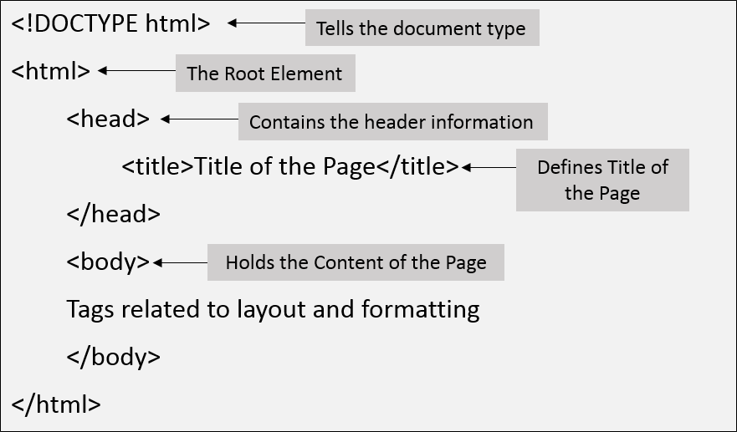

Note:Inside<body>tagwrite<h1>and<p>tags

DescriptionofHTMLExample
<!DOCTYPE>:Itdefinesthedocumenttypeoritinstructthebrowserabouttheversionof HTML.
<html >:This tag informs the browser that it is an HTML document. Text between html tag describesthewebdocument.ItisacontainerforallotherelementsofHTMLexcept
<!DOCTYPE>
<head>: It should be the first element inside the <html> element, which contains the metadata(information about the document). It must be closed before the body tag opens.
<title>:As its name suggested, it is used to add title of that HTML page which appears at thetop of the browser window. It must be placed inside the head tag and should closeimmediately. (Optional)
<body>: Text between body tag describes the body content of the page that is visible to the end user. This tag contains the main content of the HTML document.
<h1>:Textbetween<h1>tagdescribesthefirstlevelheadingofthewebpage.
<p>:Textbetween<p>tagdescribestheparagraphofthewebpage.

BriefHistoryofHTML
In the late 1980's , a physicist, Tim Berners-Lee who was a contractor at CERN, proposed a system forCERN researchers. In1989, he wrote a memoproposing an internet basedhypertext system.
Tim Berners-Leeis known as the father of HTML. The first available description of HTML was a document called "HTML Tags" proposed by Tim in late 1991. The latest version of HTML is HTML5, which we will learn later in this tutorial.

HTMLVersions
Since the time HTML was invented there are lots of HTML versions in market, the brief introduction about the HTML version is given below:
HTML 1.0:The first version of HTML was 1.0, which was the barebones version of HTML language, and it was released in1991.
HTML 2.0:This was the next version which was released in 1995, and it was standard language versionforwebsitedesign. HTML2.0was abletosupport extrafeatures such as form-basedfile upload, form elements such as text box, option button, etc.
HTML 3.2:HTML 3.2 version was published by W3C in early 1997. This version was capable of creating tables and providing support for extra options for form elements. It can also support a webpagewithcomplexmathematicalequations. Itbecameanofficialstandardforany browser till January 1997. Today it is practically supported by most of the browsers.
HTML 4.01:HTML 4.01 version was released on December 1999, and it is a very stable version of HTML language. This version is the current official standard, and it provides added support for stylesheets (CSS) and scripting ability for various multimedia elements.
HTML5 :HTML5 is the newest version of HyperText Markup language. The first draft of this version was announced in January 2008. There are two major organizations one is W3C (World Wide Web Consortium), and another one is WHATWG( Web Hypertext Application Technology Working Group) which are involved in the development of HTML 5 version, and still, it is under development.

Featuresorcharacteristics ofHTML
- Itisaveryeasyandsimplelanguage.Itcanbeeasilyunderstoodand modified.

- ItisveryeasytomakeaneffectivepresentationwithHTML becauseit hasalotofformatting tags.
- Itisamarkuplanguage,soitprovidesaflexiblewaytodesignwebpagesalongwith the text.
- Itfacilitatesprogrammerstoadda linkonthewebpages(byhtmlanchortag),soit enhances the interest of browsing of the user.
- It isplatform-independentbecause it can be displayed on any platform like Windows, Linux, and Macintosh, etc.
- Itfacilitatestheprogrammer to add Graphics,Videos,andSound to thewebpageswhich makes it more attractive and interactive.
- HTMLisacase-insensitivelanguage,whichmeanswecanuse tagseitherinlower-caseor upper-case.
NOTE:Itisrecommendedtowritealltagsinlower-caseforconsistency,readability, etc.

HTMLtextEditors:
  - AnHTMLfileisatextfile,sotocreatean HTMLfilewecanuseanytext editors.
  - Text editors are theprograms whichallow editing in awritten text, hence tocreate aweb page we need to write our code in some text editor.
  - There are various types of text editors available which you can directly download, butfor a beginner, the best text editor is Notepad (Windows) or TextEdit (Mac).
  - Afterlearningthebasics,youcaneasilyuseotherprofessionaltexteditorswhichare, Notepad++, Sublime Text, Vim, etc.
  - In our tutorial, we will useNotepad and sublimetext editor. Following are someeasyways to create your first web page with Notepad, and sublime text.
A.HTMLcodewithNotepad.(RecommendedforBeginners)
NotepadisasimpletexteditorandsuitableforbeginnerstolearnHTML.Itisavailableinall versions of Windows, from where you easily access it.
Step1:OpenNotepad (Windows)

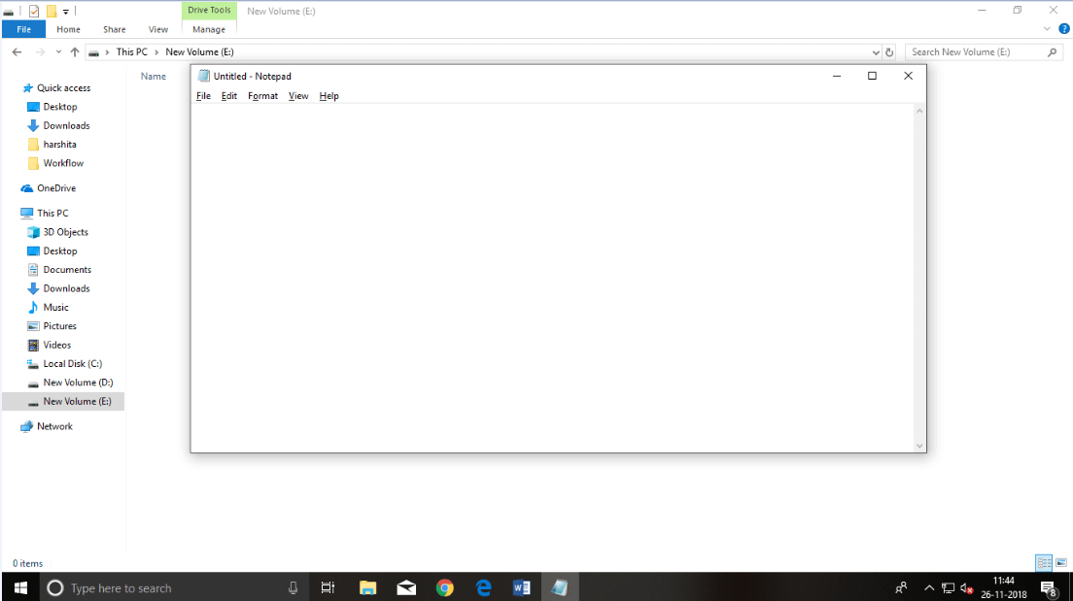

Step2:WritecodeinHTML
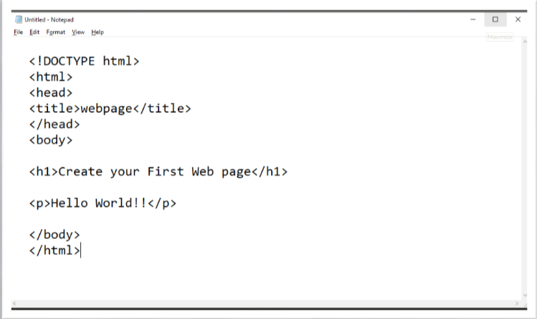

Step3:SavetheHTMLfilewith.htmor.htmlextension.

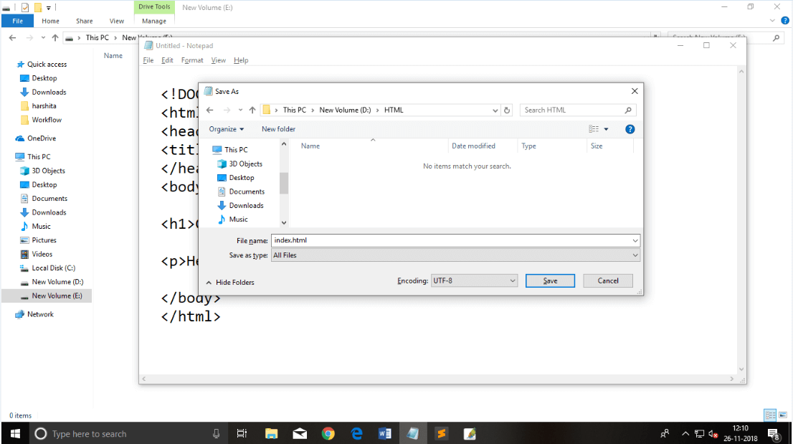
Step4:OpentheHTMLpageinyourwebbrowser.
To run the HTMLpage, you need to openthe file location, where you have saved the file andthen either double-click on file or click on open with option
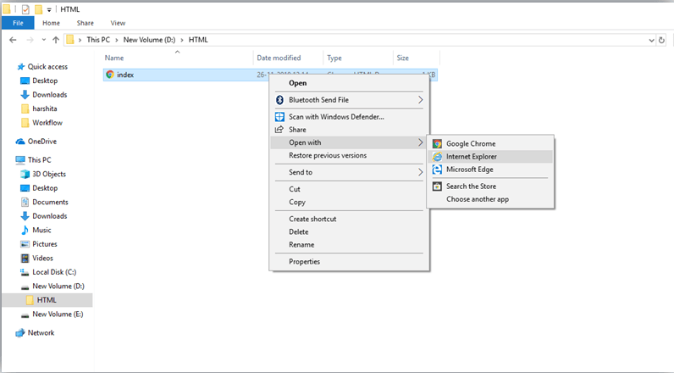

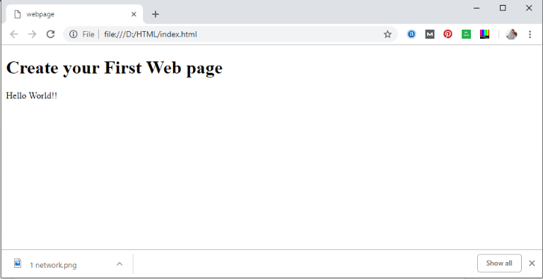

Note:YoucanexecuteHTMLfileinanybrowser,buttherearesometagswhicharenotsupported by Some Web browser.

Commonlyusedwebbrowsers:
Web Browsers are software installed on your PC. To access the Web, you need a web browser, such as Netscape Navigator, Microsoft Internet Explorer or Mozilla Firefox.
Currently you must be using any sort of Web browserwhile youare navigating through our site tutorialspoint.com. On the Web, when you navigate through pages of information, this is commonly known as web browsing or web surfing.
There are four leading web browsers − Explorer, Firefox, Netscape, and Safari, but there are many others browsers available. You might be interested in knowing Complete Browser Statistics. Now we will see these browsers in bit more detail.
While developing a site, we should try to make it compatible to as many browsers as possible. Especially sites should be compatible to major browsers like Explorer, Firefox, Chrome, Netscape, Opera, and Safari.

InternetExplorer
Internet Explorer (IE) is a product from software giant Microsoft. This is the most commonly usedbrowserintheuniverse.Thiswas introducedin 1995along withWindows 95launchand it has passed Netscape popularity in 1998.
You can download a latest version of this browser by clicking here → Download InternetExplorer

GoogleChrome
This web browser is developed by Google and its beta version was first released on September 2, 2008 for Microsoft Windows. Today, chrome is known to be one of the most popular web browser with its global share of more than 50%.
You can download a latest version of this browser by clicking here → Download GoogleChrome
Mozilla Firefox
Firefox is a new browserderived from Mozilla. It was released in 2004and has grown to be the second most popular browser on the Internet.
Youcandownloadalatestversionofthisbrowserbyclickinghere→DownloadFirefox
Safari
Safari is a web browser developed by Apple Inc. and included in Mac OS X. It was first released as a public beta in January 2003. Safari has very good support for latest technologies like XHTML, CSS2 etc.
Youcandownloadalatestversionofthisbrowserbyclickinghere→DownloadSafari

Opera
Opera is smaller and faster than most other browsers,yet it is full- featured. Fast,user-friendly, with keyboard interface, multiple windows, zoom functions, and more. Java and non Java- enabled versions available. Ideal for newcomers to the Internet, school children, handicap and as a front-end for CD-Rom and kiosks.
Youcandownloadalatestversionofthisbrowserbyclickinghere→DownloadOpera

BuildingblocksofHTML
AnHTMLdocumentconsistofitsbasicbuildingblockswhichare:

- Tags:An HTMLtagsurroundsthecontentandapplymeaningtoit.Itiswrittenbetween
<and> brackets.
- Attribute:An attribute in HTML provides extra information about the element, and it is applied within the start tag. An HTML attribute contains two fields: name & value.
Syntax

- <tagnameattribute_name="attr_value">content</tagname>
  - Elements:AnHTMLelementisanindividualcomponentofanHTMLfile.InanHTML file, everything written within tags are termed as HTML elements.

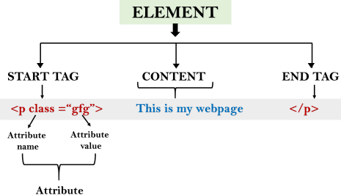

Example:

<!DOCTYPEhtml>

<html>
<head>
<title>ThebasicbuildingblocksofHTML</title>

</head>
<body>
<h2>Thebuildingblocks</h2>
<p>Thisisa paragraphtag</p>
<pstyle="color:red">Thestyleisattributeofparagraphtag</p>
<span>Theelementcontainstag,attributeandcontent</span>

</body>
</html>Output:

Thebuildingblocks
Thisisa paragraphtag
Thestyleisattributeofparagraphtag
Theelementcontainstag,attributeand content

HTMLTags
HTML tags are like keywords which define that how web browser will format and display the content. With the help of tags, a web browser can distinguish between an HTML content and a simple content. HTML tags contain three main parts: opening tag, content and closing tag. But some HTML tags are unclosed tags.
When a web browser reads an HTML document, browser reads itfrom top to bottom and left to right. HTML tags are used to create HTML documents and render their properties. EachHTML tags have different properties.
An HTML file must have some essential tags so that web browser can differentiate between a simple text and HTML text. You can use as many tags you want as per your code requirement.

  - AllHTMLtagsmustenclosedwithin<>these brackets.
  - EverytaginHTMLperformsdifferent tasks.
  - If you have used an open tag <tag>, then you must use a close tag </tag> (except some tags)

Syntax
<tag>content</tag>

HTMLTag Examples

Note:HTMLTagsarealwayswritteninlowercaseletters.ThebasicHTMLtagsaregivenbelow:
<p>ParagraphTag</p>

<h2>HeadingTag</h2>

<b>BoldTag </b>
<i>ItalicTag</i>
<u>UnderlineTag</u>
Testit Now

UnclosedHTMLTags
SomeHTMLtagsarenotclosed,forexamplebrandhr.
<br>Tag:brstandsforbreakline,itbreaksthelineof the code.
<hr>Tag:hrstandsforHorizontalRule.Thistagisusedtoputalineacrossthe webpage.

HTMLMetaTags
DOCTYPE,title,link,metaandstyle

HTMLTextTags
<p>,<h1>,<h2>,<h3>,<h4>,<h5>,<h6>,<strong>,<em>,<abbr>,<acronym>,<address>,
<blockquote>,<cite>,<q>,<code>,<ins>,<del>,<pre>,and<br>

HTMLLink Tags
<a>

HTMLImageandObjectTags
<img>,<area>,<map>,<param>and<object>

HTMLListTags
<ul>,<ol>,<li>,<dl>,<dt>and<dd>

HTMLTable Tags
table,tr,td,th, tbody,thead,tfoot,col,colgroupandcaption

HTMLFormTags
form,input,textarea,select,option,button,label,fieldsetandlegend

HTMLScriptingTags script and noscript
Note:Wewillseeexamplesusingthesetagsinlatercharters.

HTMLAttribute
  - HTMLattributesarespecialwordswhichprovideadditionalinformationaboutthe elements or attributes are the modifier of the HTML element.
  - Eachelementortagcanhaveattributes,whichdefinesthebehaviourofthatelement.
  - Attributesshouldalwaysbeappliedwithstart tag.
  - TheAttributeshouldalwaysbeappliedwithitsnameandvaluepair.
  - The Attributes name and values are case sensitive, and it is recommended by W3C that it should be written in Lowercase only.
  - You can add multiple attributes in one HTML element, but need to give space between two attributes.
Syntax

<elementattribute_name="value">content</element>

HTMLHeading
A HTML heading or HTML htag can be defined as a title or a subtitle whichyou want to display on the webpage. When you place the text within the heading tags <h1>.........</h1>, it is displayed on the browser in the bold format and size of the text depends on the number of heading.
There are six different HTML headings which are defined with the <h1> to <h6> tags, from highest level h1 (main heading) to the least level h6 (least important heading).
h1 is the largest heading tag and h6 is the smallest one. So h1 is used for most important heading and h6 is used for least important.

Headings in HTML helps the search engine to understand and index the structure of webpage.
Note:Themainkeywordofthewholecontentof awebpageshouldbedisplaybyh1heading tag.
Seethis example:

<h1>Headingno. 1</h1>
<h2>Headingno. 2</h2>
<h3>Headingno. 3</h3>
<h4>Headingno. 4</h4>
<h5>Headingno. 5</h5>
<h6>Headingno. 6</h6>

Output:
Headingno.1

Headingno.2

Headingno.3
Headingno.4
Headingno.5
Headingno.6

HTMLParagraph
HTML paragraph or HTML p tag is used to define a paragraph in a webpage. Let's take a simple example to see how it work. It is a notable point that a browser itself add an empty line before and after a paragraph. An HTML <p> tag indicates starting of new paragraph.
Note:Ifweareusingvarious <p>tagsinoneHTMLfilethen browserautomaticallyaddsasingle blank line between the two paragraphs.
Seethis example:

- <p>Thisisfirstparagraph.</p>
- <p>Thisissecond paragraph.</p>
- <p>Thisisthirdparagraph.</p>Test it Now
Output:
This is first paragraph. Thisissecondparagraph.
Thisisthirdparagraph.

SpaceinsideHTMLParagraph
If you put alot of spaces inside theHTML p tag, browser removes extra spaces and extra linewhile displaying the page. The browser counts number of spaces and lines as a single one.

<p>
I am
goingtoprovide
youatutorialon HTML

andhopethatitwill
beverybeneficialforyou.

</p>
<p>
Look,Iputherealot
ofspaces but Iknow,Browserwillignoreit.

</p>
<p>
Youcannotdeterminethe displayofHTML</p>
<p>becauseresizedwindowsmaycreatedifferentresult.

</p>
Output:
Iamgoingtoprovide youatutorialonHTML andhopethat itwillbevery beneficialforyou. Look, I put here a lot of spaces but I know, Browser will ignore it.
Youcannot determinethedisplayofHTML
becauseresizedwindowsmaycreatedifferent result.
Asyoucansee,alltheextra linesandunnecessaryspacesareremovedbythe browser. How to Use <br> and <hr> tag with paragraph?
AnHTML<br>tagisusedforlinebreakanditcanbeusedwithparagraphelements.Following
istheexampletoshowhowtouse<br>with<p>element.

Example:

<!DOCTYPEhtml>
<html>
<head>
</head>
<body>
<h2>Useoflinebreakwithpragraph tag</h2>
<p><br>Papaandmama,and babyand Dot,
<br>Willieandme?thewholeofthelot
<br>Ofusallwentover in Bimberlie'ssleigh,

<br>Tograndmama'shouseonChristmas day.
</p>
</body>
</html>
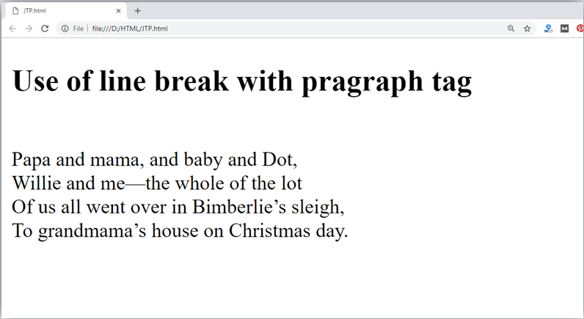

AnHTML<hr>tagisusedtoapplyahorizontallinebetweentwostatementsortwo paragraphs. Following is the example which is showing use of <hr> tag with paragraph.

Example:

<!DOCTYPEhtml>
<html>
<head>
</head>
<body>
<h2>Exampletoshowahorizontallinewithparagraphs</h2>
<p>AnHTML hrtagdrawahorizontallineandseparatetwoparagraphswiththat line.<hr>it will start a new paragraph.
</p>
</body>
</html>Output:

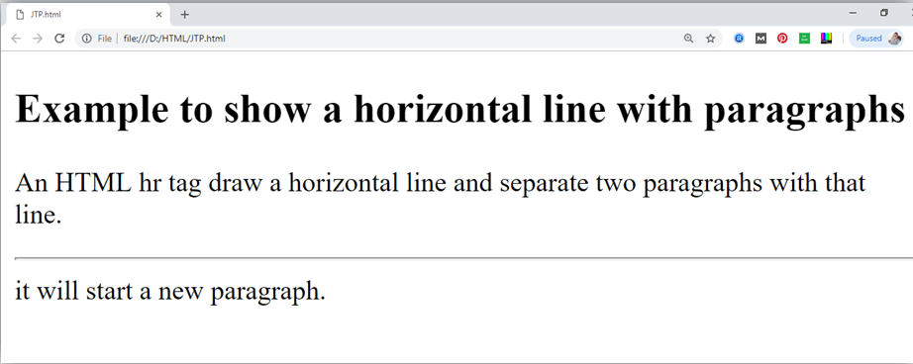

ChangingappearanceofText tags:

Formattingelementsweredesignedtodisplayspecialtypesof text:
- <b>-Bold text
- <strong>-Importanttext
- <i>-Italictext
- <em>-Emphasizedtext
- <mark>-Marked text
- <small>-Smallertext
- <del>-Deleted text
- <ins>-Inserted text
- <sub>-Subscript text
- <sup>-Superscripttext

HTML<b>and<strong>Elements
TheHTML<b>elementdefinesboldtext,withoutanyextraimportance.
Example
<b>Thistextisbold</b>

TheHTML<strong>elementdefinestextwithstrongimportance.Thecontentinsideistypically displayed in bold.

Example
<strong>Thistextis important!</strong>

HTML<i>and<em>Elements
TheHTML<i>element definesa partoftextinanalternatevoice ormood. Thecontentinsideis typically displayed in italic.
Tip:The<i>tagis oftenusedtoindicateatechnicalterm,a phrasefrom anotherlanguage,a thought, a ship name, etc.
Example
<i>Thistextisitalic</i>

TheHTML<em>elementdefinesemphasizedtext.Thecontentinsideistypicallydisplayedin italic.
Tip:Ascreenreaderwillpronouncethewordsin<em>withanemphasis,usingverbalstress.
Example
<em>Thistextisemphasized</em>

HTML<small>Element
TheHTML<small>elementdefinessmallertext:
Example
<small>This issomesmallertext.</small>

HTML<mark> Element

TheHTML<mark>elementdefinestextthatshouldbemarked orhighlighted:
Example
<p>Donotforgettobuy<mark>milk</mark>today.</p>

HTML<del>Element
TheHTML<del>element definestextthathasbeendeletedfroma document.Browserswill usually strike a line through deleted text:

Example
<p>Myfavoritecoloris<del>blue</del>red.</p>

HTML<ins>Element
TheHTML<ins>elementdefinesatextthathasbeeninsertedintoa document.Browserswill usually underline inserted text:
Example
<p>Myfavoritecoloris<del>blue</del><ins>red</ins>.</p>

HTML<sub>Element
TheHTML<sub>elementdefinessubscripttext.Subscripttextappears halfacharacterbelow the normal line, and is sometimes rendered in a smaller font. Subscript text can be used for chemical formulas, like H2O:
Example
<p>Thisis<sub>subscripted</sub>text.</p>

HTML<sup>Element
TheHTML<sup>elementdefinessuperscripttext.Superscripttextappearshalfacharacter abovethenormalline,andissometimesrendered ina smallerfont.Superscripttextcanbe used for footnotes, like WWW^{[1]}:
Example
<p>Thisis<sup>superscripted</sup>text.</p>

HTMLComments

HTMLcommentsarenotdisplayedinthebrowser,buttheycanhelpdocumentyourHTML source code.
HTMLCommentTag
Youcanadd commentstoyourHTMLsourcebyusingthefollowingsyntax:
<!--Writeyourcommentshere-->

Noticethatthereisanexclamationpoint(!)inthe starttag,butnotinthe endtag.

Note:Commentsarenot displayedbythebrowser,buttheycanhelpdocumentyourHTML source code.

AddComments
Withcommentsyoucanplace notificationsandremindersinyourHTMLcode:
Example
<!--Thisisacomment-->

<p>Thisisaparagraph.</p>

<!--Remembertoaddmoreinformationhere -->Hide Content
Commentscanbeusedtohidecontent.
Thiscan behelpfulifyouhidecontenttemporarily:
Example
<p>Thisisaparagraph.</p>

<!--<p>This isanotherparagraph</p>-->

<p>Thisisaparagraphtoo.</p>

Youcanalsohidemore thanoneline.Everything betweenthe <!--andthe-->willbehidden from the display.
BackgroundColor
Youcansetthebackgroundcolorfor HTMLelements:
HelloWorld

Backgroundcolorfeature

Example
<h1style="background-color:DodgerBlue;">HelloWorld</h1>
<pstyle="background-color:Tomato;">Loremipsum...</p>Text Color
Youcansetthecoloroftext: Hello World
WelcometoHTML How are you…
Example
<h1style="color:Tomato;">HelloWorld</h1>
<pstyle="color:DodgerBlue;">WelcometoHTML</p>
<pstyle="color:MediumSeaGreen;">Howareyou...</p>

Non-breakingSpace
AcommonlyusedentityinHTML isthenon-breakingspace:&nbsp;
Anon-breakingspaceisaspacethatwillnotbreakintoanewline.
Twowordsseparatedbyanon-breakingspacewillsticktogether(notbreak intoa newline). This is handy when breaking the words might be disruptive.
Examples:
- §10
- 10km/h
- 10PM
Anothercommonuseofthe non-breakingspaceistopreventbrowsersfromtruncatingspaces in HTML pages.
Ifyouwrite 10spacesinyourtext,thebrowserwillremove9ofthem.Toaddrealspacesto your text, you can use the &nbsp; character entity.

Tip:Thenon-breakinghyphen(&#8209;)is usedtodefineahyphencharacter(-)that doesnot break into a new line.

HTML <hr>Tag
Example
Usethe<hr>tagtodefinethematic changesinthecontent:
<h1>TheMainLanguagesoftheWeb</h1>

<p>HTML is the standard markup language for creating Web pages. HTML describes the structureofaWebpage,andconsistsofaseries ofelements.HTMLelementstellthe browser how to display the content.</p>

<hr>

<p>CSSisalanguagethatdescribeshowHTMLelementsaretobedisplayedonscreen,paper, or in other media. CSS saves a lot of work, because it can control the layout of multiple web pages all at once.</p>

<hr>

<p>JavaScriptistheprogramminglanguageofHTMLandtheWeb.JavaScriptcanchangeHTML content and attribute values. JavaScript can change CSS. JavaScript can hide and show HTML elements, and more.</p>
DefinitionandUsage

The<hr>tagdefinesathematicbreakinan HTML page(e.g.ashiftoftopic).
The<hr>elementismostoftendisplayedasahorizontalrule thatisusedtoseparatecontent (or define a change) in an HTML page.
Example
Aligna<hr>element(withCSS):
<hrstyle="width:50%;text-align:left;margin-left:0">
Example
Anoshaded<hr>(withCSS):

<hrstyle="height:2px;border-width:0;color:gray;background-color:gray">
Example
Settheheightofa<hr>element(with CSS):
<hrstyle="height:30px">
Example
Setthewidthofa<hr>element(withCSS):
<hrstyle="width:50%">

UNIT2

WorkingwithHTML

ListinHTML
- HTML Lists are used to specify lists of information.Alllistsmaycontainoneormore list elements. There are three different types of HTML lists:
- OrderedListorNumberedList(<ol>)
- UnorderedListorBulletedList(<ul>)
- DescriptionListorDefinitionList(<dl>)

OrderedList/NumberedList
- In the ordered HTML lists, all the list items are markedwithnumbersbydefault.Itisknownas numbered list also. The ordered list starts with
<ol>tagandthelistitemsstartwith<li>tag.
- <ol>
- <li>HTML</li>
- <li>CSS</li>
- <li>JS</li>
- <li>JAVA</li>
- </ol>

We can use ordered list to represent items either in numerical order format or alphabetical order format, or any format where an order is emphasized. There can be different types of numbered list:
- NumericNumber (1,2,3)
- CapitalRomanNumber(IIIIII)
- SmallRomanNumber(iiiiii)
- CapitalAlphabet(AB C)
- SmallAlphabet(abc)

To represent different ordered lists, there are 5 types of attributes in <ol> tag

Type | Description
Type"1" | Thisisthedefaulttype.Inthistype,the list items are numbered with numbers.
Type"I" | In this type, the list items arenumbered with upper case roman numbers.
Type"i" | In this type, the list items arenumbered with lower case roman numbers.
Type"A" | In this type, the list items are  numberedwithuppercaseletters.
Type"a" | In this type, the list items are numbered with lower case letters.

Examplei/pno/p

<!DOCTYPEhtml>
<html>
<body>
<ol>
<li>HTML</li>
<li>Java</li>
<li>JavaScript</li>
<li>SQL</li>
</ol>
</body>
</html>
- HTML
- Java
- JavaScript
- SQL

Otherattributes
StartAttribute:Thestartattributeisusedwith<ol> tag to specify from where to start the list items.
  - <oltype="1"start="5">:Itwillshownumeric values starting with "5".
  - <oltype="A"start="5">:Itwillshowcapital alphabets starting with "E".
  - <oltype="a"start="5">:Itwillshowlowercase alphabets starting with "e".
  - <oltype="I"start="5">:ItwillshowRoman upper case value starting with "V".

reversedAttribute:
ThisisaBooleanattributeofHTML<ol>tag,anditisnewinHTML5version. If you use the reversed attribute with tag then it will numbered the list in descending order (7, 6, 5, 4......1). Here is example:
<!DOCTYPEhtml>
<html>
<head>
</head>
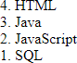
<body>
<olreversed>
<li>HTML</li>
<li>Java</li>
<li>JavaScript</li>
<li>SQL</li>
</ol>
</body>
</html>

UnorderedListorBulletedList
  - HTML Unordered List or Bulleted List displays elements in bulleted format . We can use unorderedlistwherewedonotneedtodisplay items in any particular order. The HTML<ul> tag is used for the unordered list. There can be 4 types of bulleted list:
  - disc
  - circle
  - square
  - none

  - Torepresentdifferentorderedlists,thereare4 types of attributes in <ul> tag.

Type | Description
Type"disc" | This is the default style. In this style,the list items are marked with bullets.
Type"circle" | In this style, the list items are marked with circles.
Type"square" | In this style, the list items are marked with squares.
Type"none" | Inthisstyle,thelistitemsarenot  marked.

Example:

<!DOCTYPEhtml>
<html>
<body>
<h1>Hereisanexampleof unordered list</h1>
<ul>
<li>HTML</li>
<li>Java</li>
<li>JavaScript</li>
<li>SQL</li>
</ul>
</body>
</html>
Output:
Hereisanexampleof unordered list
    - HTML
    - Java
    - JavaScript
    - SQL

Note:bydefaultunorderedlist type is disc.
Otheryoucantryusingtype attribute in <ul> tag

Descriptionlist/Definitionlist
    - HTML Description List or Definition List displays elements in definition form like in dictionary.The<dl>,<dt>and<dd>tagsare used to define description list.
    - The3HTMLdescriptionlisttagsaregiven below:
    - <dl>tagdefinesthedescription list.
    - <dt>tagdefinesdataterm.
    - <dd>tagdefinesdatadefinition(description).

Example
<!DOCTYPEhtml>
<html>
<body>
<p><b>HereisanexampleofDescription/DefinitionListinHTML</b></p>
<dl>
<dt>HTML</dt>
<dd>isamarkuplanguageanddevelpoedbyTimBernersleein1992</dd>
<dt>Java</dt>
<dd>isaprogramminglanguageandplatformIndependent</dd>
<dt>JavaScript</dt>
<dd>isascriptinglanguage</dd>
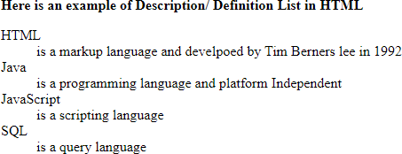
<dt>SQL</dt>
<dd>isaquerylanguage</dd>
</dl>
</body>
</html>

WorkingwithImage
- HTML <img> tag is used to display image on the web page. HTML <img> tag is an empty tag that containsattributesonly,closingtagsarenotused in HTML image element.
AttributesofHTMLimgtag
- ThesrcandaltareimportantattributesofHTML img tag. All attributes of HTML image tag are given in next slide:

src:Itisanecessaryattributethatdescribesthe
source or path of the image. It instructs the browserwheretolookfortheimageontheserver.
Thelocationofimagemaybeonthesame directory or another server.

alt:Thealtattributedefinesanalternatetextfor the image, if it can't be displayed.

ImageSize-WidthandHeight:usestyleattribute to specify the width and height of an image.
Example
<imgsrc="img_flower.jpg"alt=“Pink
Flower"style="width:500px;height:600px;">
Alternatively,thewidthandheightattributescan be used as given below:
Example
  - <imgsrc="img_flower.jpg"alt=“Pink Flower"width="500"height="600">
  - Thewidthandheightattributesalwaysdefine the width and height of the image in pixels.

- Otherattributesare:
- Border
- Hspace
- Vspace
- Align(left,center,right)

<!DOCTYPEhtml>
<html>
<body>
<p>UseimagetaginHTMLalongwithallthe attributes</p>

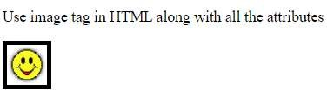
<img src="smiley.gif" alt="Smiley face" width="42"height="42"style="border:5pxsolid black">

</body>
</html>

WorkingwithLinks
- HTML anchor tag defines a hyperlink that links one page to another page. It can create hyperlink tootherwebpageaswellasfiles,location,orany URL. The "href" attribute is the most important attribute of the HTML <a> tag which links to destination page or URL.
href attribute: The href attribute is used to define theaddressofthefiletobelinked.Inotherwords, it points out the destination page.
ThesyntaxofHTMLanchortagisgivenbelow.
- <ahref="...........">LinkText</a>

- target attribute: By default, the linked page will be displayedinthecurrentbrowserwindow.Tochange this, you must specify another target for the link.
- Thetargetattributespecifieswheretoopenthelinked document.
- Thetargetattributecanhaveoneofthefollowing values:
_self:Default.Opensthedocumentinthesame window/tab as it was clicked
_blank:Opensthedocumentinanewwindowortab
_parent:Opensthedocumentintheparentframe
_top:Opensthedocumentinthefullbodyofthewindow

<!DOCTYPEhtml>
<html>
<body>
<h2>TheanchortagalongwithhrefandtargetAttribute</h2>

<ahref="https://www.youtube.com/"target="_blank">Visit youtube!</a>

<p>Iftarget="_blank",thelinkwillopeninanewbrowser window or tab.</p>

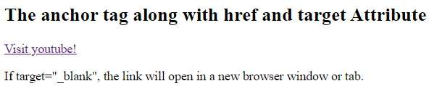
</body>
</html>

AbsoluteURLsvs.RelativeURLs
A local link (a link to a page within the same website) is specifiedwitharelativeURL(withoutthe"https://www"part):
Example:
- ExternalLinking
<h2>AbsoluteURLs</h2>
<p><ahref="https://www.w3.org/">W3C</a></p>
<p><ahref="https://www.google.com/">Google</a></p>
- InternalLinking
<h2>RelativeURLs</h2>
<p><ahref="html_images.asp">HTMLImages</a></p>
<p><ahref="/css/default.asp">CSSTutorial</a></p>

Unit 3

DesigningwithHTML

CreatingTables
- HTML table tag is used to display data in tabularform(row*column).Therecanbe many columns in a row.
- We can create a table to display data in tabularform,using<table>element,withthe help of <tr> , <td>, and <th> elements.
- In Each table, table row is defined by <tr> tag, tableheaderisdefinedby<th>,andtabledata is defined by <td> tags.

Tag | Description
<table> | Itdefinesatable.
<tr> | Itdefinesarowinatable.
<th> | Itdefinesaheadercellinatable.
<td> | It defines acellin atable.
<caption> | It defines thetable caption.
<tbody> | Itisusedtogroupthe body content inatable.
<thead> | Itisusedtogroupthe headercontent inatable.
<tfooter> | Itisusedtogroup the footercontentinatable.

Importanttabletags

<table>:Itdefinesatable.
<tr>:Itdefinesarowinatable.
<th>:Itdefinesaheadercellinatable.
<td>:Itdefinesacellinatable.
<caption>:Itdefinesthetablecaption.
<tbody>:Itisusedtogroupthebodycontentinatable.
<thead>:Itisusedtogrouptheheadercontentinatable.
<tfooter>:Itisusedtogroupthefootercontentina table.

HTMLTableexample
<!DOCTYPE>
<html>
<body>
<!--hereisstep1oftableformation-->
<table>
<caption><b>Student_Info</b></caption>
<tr><th>First_Name</th><th>Last_Name</th><th>Marks</th></tr>
<tr><td>Abay</td><td>Singh</td><td>95</td></tr>
<tr><td>Jatin</td><td>Singh</td><td>85</td></tr>
<tr><td>Ankush</td><td>Kumar</td><td>87</td></tr>
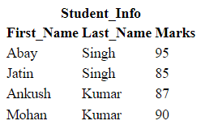
<tr><td>Mohan</td><td>Kumar</td><td>90</td></tr>
</table>
</body>
</html>

HTMLTablewithBorder

TherearetwowaystospecifyborderforHTMLtables.
- ByborderattributeoftableinHTML
- ByborderpropertyinCSS
  - HTML Border attribute: Use border attribute of tabletaginHTMLtospecifyborder.Butitisnot recommended now.
  - CSSBorderproperty:Itisnowrecommendedtouse border property of CSS to specify border in table.

<!DOCTYPE>
<html>
<body>
<!--Step2-->
<tableborder="1">
<caption><b>Student_Info</b></caption>
<tr><th>First_Name</th><th>Last_Name</th><th>Marks</th></tr>
<tr><td>Abay</td><td>Singh</td><td>95</td></tr>
<tr><td>Jatin</td><td>Singh</td><td>85</td></tr>
<tr><td>Ankush</td><td>Kumar</td><td>87</td></tr>
<tr><td>Mohan</td><td>Kumar</td><td>90</td></tr>
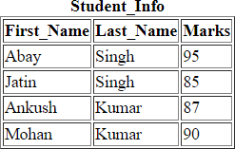
</table>
</body>
</html>

<!DOCTYPE>
<html>
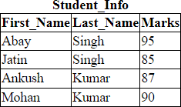
<head>
<style>table,th,td{
border: 1px solid black; border-collapse:collapse;
}
</style>
</head>
<body>
<table border="1">
<caption><b>Student_Info</b></caption>
<tr><th>First_Name</th><th>Last_Name</th><th>Marks</th></tr>
<tr><td>Abay</td><td>Singh</td><td>95</td></tr>
<tr><td>Jatin</td><td>Singh</td><td>85</td></tr>
<tr><td>Ankush</td><td>Kumar</td><td>87</td></tr>
<tr><td>Mohan</td><td>Kumar</td><td>90</td></tr>
</table>
</body>
</html>

HTMLCellPadding&Cell Spacing:
HTML tables can adjust the padding inside the cells, andalsothespacebetweenthecellsusingcellspacing and cellpadding attributes of <table> tag.

WithPadding
hello | hello | hello
hello | hello | hello
hello | hello | hello

WithSpacing
hello | hello | hello
hello | hello | hello
hello | hello | hello

Otherattributesof<table>tagaregivenbelow:
- Bordercolor
- Bgcolor
- Align
- Height
- Weight

rowspanandcolspan
HTMLtablescanhavecellsthatspanover multiple rows and/or columns.
colspan: To make a cell span over multiple columns,usethecolspanattribute.Thevalueof the colspan attribute represents the number of columns to span.
rowspan: To make a cell span over multiple rows, use the rowspan attribute. The value of therowspanattributerepresentsthenumberof rows to span.

<!DOCTYPEhtml>
<html>
<head>
<style> table,th,td{
border:1pxsolidblack;

Exampleofcolspan
<tr>
<td>Abay</td>
<td>Singh</td>
<td>47</td>
</tr>
<tr>

border-collapse:collapse;
}
</style>
</head>
<body>
<h2>Cellthatspanstwocolumns</h2>
<p>Tomakeacellspanmorethanonecolumn,
usethecolspanattribute.</p>
<tablestyle="width:100%">
<tr>
<thcolspan="2">Name</th>
<th>Age</th>
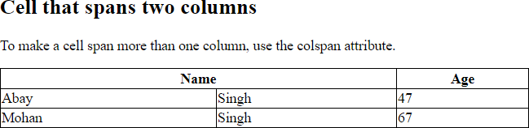
</tr>
<td>Mohan</td>
<td>Singh</td>
<td>67</td>
</tr>
</table>
</body>
</html>
Output:

<!DOCTYPEhtml>
<html>
<head>
<style>
table,th,td{

Exampleofrowspan
<tr>
<th>Name</th>
<td>Mohan</td>
</tr>
<tr>

border: 1px solid black; border-collapse:collapse;
}
</style>
</head>
<body>
<h2>Cell thatspanstworows</h2>
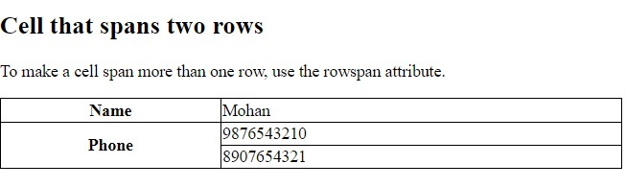
<p>Tomakeacellspanmorethanone row, use the rowspan attribute.</p>

<tablestyle="width:100%">
<throwspan="2">Phone</th>
<td>9876543210</td>
</tr>
<tr>
<td>8907654321</td>
</tr>
</table>
</body>
</html>

Workingwithframes
HTML frames are used to divide your browser window into multiple sections where each section can load a separate HTML document.
A collection of frames in the browser window is knownasaframeset.Thewindowisdivided into frames in a similar way the tables are organized: into rows and columns.

Touseframesonapageweuse<frameset>tag
insteadof<body>tag.
The <frameset> tag defines, how to divide the window into frames.
The rows attribute of <frameset> tag defines horizontal frames and cols attribute defines verticalframes.Eachframeisindicatedby
<frame> tag and it defines which HTML document shall open into the frame.

<!DOCTYPEhtml>
<html>
<head>
<title>HTML Frames</title>
</head>
<framesetrows="10%,80%,10%">
<!–attheplaceofrowswecanusecolsarewell…TrythisinLab-->
<framename="top"src="/html/top_frame.htm"/>
<framename="main"src="/html/main_frame.htm"/>
<framename="bottom"src="/html/bottom_frame.htm"/>
<noframes>
<body>Yourbrowserdoesnotsupportframes.</body>
</noframes>
</frameset>
</html>
Note:The<frame>tagdeprecatedinHTML5.Soinsteadofusing<frame>wecanuse the concept of <iframe >.

HTMLForm
HTMLformsarerequiredifyouwanttocollect some data from of the site visitor.
For example: If a user want to purchase some items on internet, want to fill the form, shipping addressandcredit/debitcarddetailssothatitem can be sent to the given address.

Tag | Description
<form> | It defines an HTMLform to enter inputs by the used side.
<input> | Itdefinesan inputcontrol.
<textarea> | It definesamulti-lineinputcontrol.
<label> | Itdefines alabel for an input element.
<legend> | Itdefinesacaption fora<fieldset>element.
<button> | It definesaclickablebutton.

- HTML<form>element
- The HTML <form> element provide a document section to take input from user. It provides various interactive controls for submitting information to web server such as text field, text area, password field, etc.
Note: The <form> element does not itself create a formbutitiscontainertocontainallrequiredform elements, such as <input>, <label>, etc.
Syntax:
<form>
//Formelements
</form>

HTML<input> element
- The HTML <input> element is fundamental form element. It is used to create form fields, to take input fromuser.Wecanapplydifferentinputfiledtogather different information form user. Following is the example to show the simple text input.
Example:
<body>
<form>
Enteryourname<br>
<inputtype="text"name="username">
</form>
</body>
An<input>elementcanbedisplayedinmanyways, dependingon the type attributegiven in next slide.

Type | Description
<inputtype="text"> | Displaysasingle-linetextinputfield
<inputtype="radio"> | Displaysaradiobutton(forselectingone of many choices)
<inputtype="checkbox"> | Displaysacheckbox(forselectingzeroor more of many choices)
<inputtype="submit"> | Displaysasubmitbutton(forsubmitting the form)
<inputtype="button"> | Displaysaclickable button

Otherpermissiblevaluesintypeattributearegiven below:
- <inputtype="color">
- <inputtype="date">
- <inputtype="email">
- <inputtype="file">
- <inputtype="number">
- <inputtype="password">
- <inputtype="search">
- <inputtype="time">
- <inputtype="url">
- <inputtype="week">

The<label> Element
- The <label> element is useful for screen-reader users, because the screen-reader will read out loud the label when the user focuses on the input element.
- The <label> element also helps users who have difficulty clicking on very small regions (such as radio buttons or checkboxes) - because when the user clicks the text within the <label> element, it toggles the radio button/checkbox.

- The for attribute of the <label>tag should be equal to the id attribute of the <input>element to bind them together.

<!DOCTYPEhtml>
<html>
<head>
<body>
<h2>UseHtmlformandcreateaformwithFirstNameandLastName</h2>
<p>Forthisuselabelninputtagsalongwithsuitableattributesandmakeaform more attractive. </p>

<form>
<labelfor="firstname">FirstName:</label>
<inputtype="text"id="firstname"name="firstname"/>
<br/>
<br/>
<labelfor="lastname">LastName:</label>
<inputtype="text"id="lastname"name="lastname"/><br/>
</form>
</body>
</html>

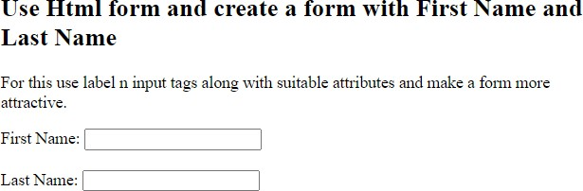

<!DOCTYPEhtml>
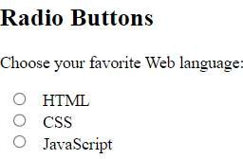
<html>
<body>
<h2>RadioButtons</h2>
<p>ChooseyourfavoriteWeblanguage:</p>
<form>
<inputtype="radio"id="html"name="fav_language"value="HTML">
<labelfor="html">HTML</label><br>
<inputtype="radio"id="css"name="fav_language"value="CSS">
<labelfor="css">CSS</label><br>
<inputtype="radio"id="javascript"name="fav_language"value="JavaScript">
<labelfor="javascript">JavaScript</label>
</form>
</body>
</html>
Note:TrycheckboxesinLab

UNIT4

Whatis JavaScript?
JavaScript (JS) is a light-weight object-oriented programming language which is used by several websites for scripting the webpages. It is an interpreted, full-fledged programming language that enables dynamic interactivity on websites when applied to an HTML document.
It was introduced in the year 1995 for adding programs to the webpages in the Netscape Navigator browser. Since then, it has been adopted by all other graphical web browsers. With JavaScript, users can build modern web applications to interact directly without reloading the page every time.
Although,JavaScripthasnoconnectivitywithJavaprogramminglanguage.Thenamewas suggested and provided in the times when Java was gaining popularity in the market.
AnotherpopularuseofJS:Inadditiontowebbrowsers,databasessuchasCouchDBand Mongo DB use JavaScript as their scripting and query language.

FeaturesofJavaScript
TherearefollowingfeaturesofJavaScript:

- AllpopularwebbrowserssupportJavaScriptastheyprovide environments.
built-inexecution
- JavaScript follows the syntax and structure of the C programming language. Thus, it is a structured programming language.
- JavaScriptis aweaklytypedlanguage,wherecertaintypes are on the operation).
implicitlycast(depending

- JavaScriptisan
object-orientedprogramming
usingclassesforinheritance.
light-weightedandinterpreted
- Itisa
languagethat usesprototypesratherthan

language.

- Itisa language.
case-sensitive
- JavaScriptissupportableinseveraloperatingsystemsincluding,Windows,macOS,etc.
- Itprovidesgoodcontroltothe usersovertheweb browsers.
JavaScriptHistory

JavaScriptwasinventedbyBrendanEichin 1995.
Itwasdevelopedfor Netscape2,andbecametheECMA-262standardin1997.
AfterNetscapehandedJavaScript overtoECMA,theMozillafoundationcontinuedtodevelop JavaScript for the Firefox browser. Mozilla's latest version was 1.8.5. (Identical to ES5).
InternetExplorer(IE4)wasthefirstbrowsertosupportECMA-262Edition1(ES1).

Year | ECMA | Browser
1995 |  | JavaScriptwasinventedbyBrendanEich
1997 |  | JavaScriptbecameanECMAstandard(ECMA-262)
1997 | ES1 | ECMAScript1wasreleased

1998 | ES2 | ECMAScript2wasreleased
2009 | ES5 | ECMAScript5wasreleased
2015 | ES6 | ECMAScript6wasreleased
2017 | ES6 | FullsupportforES6inFirefox54
2017 | ES6 | FullsupportforES6 inEdge15
2018 | ES6 | FullsupportforES6inallbrowsers**

Themaindifferencebetweenclient-sideandserver-sidescriptingisgivenbelow.

Basis | Client-sideScripting | Server-sideScripting
Primary Function | Theprimaryfunctionofclient-sidescripting is to provide the requested output to the end-user | Theprimaryfunctionofserver-sidescripting is to manipulate and give access to the required database as per request.
Uses | The client side is used as the front end, wheretheusergetstoseewhatwehave browsed. | Theserversideisusedasabackendwhere data is processed and is not visible to the client user.
Codeallowance | On the client side, the user is allowed to accessthecodewrittenafterverifyingthe user’s need. | Server-side scripting allows the back-end developertohidethesourcecodefromthe user.
Processing | Theclient-sidedoesnotneedany interaction with the server. | Server-sidescriptingontheotherhandisall about communicating with the servers.
Function | Usedforthevisibilityandgettingoutthe required data from servers’ database | Usedforthecustomizationormodificationof the data to change the website dynamically.
Dependability | Client-sidescriptingdependsuponthe  user’sbrowserversion. | Serve-sidedoesnotdependontheclient.

Basis | Client-sideScripting | Server-sideScripting
Security | This way of scripting is less secure than Server-side scripting because of the accessibilityofcodeprovidedtotheclient. | Server-side scripting is considered a more securewayofworkingonawebapplication
Connectivity | Theclient-sidedoesnotconnecttothe database at the webserver. | The server side helps connect with the database,whichisalreadystoredinthe server database.
FileAccess | It does have any access to the files present onthewebservers.Butwehavetheoption to upload files from the front end | Ithastotalaccesstothefileswhicharestored in the web database server.
Occurrence | It occurs when the browser processes all thecodes,andthenitreactsaccordingto the client’s query. | Itonlyactsaftertheclientinitiatesthe browsing request.
Running | Itrunsonthe end-user’s system. | Itrunsonthe webserver.
Languages | HTML,JavaScript,andCSSareusedto  displaythe request | PHP,Python,Ruby,Nodejsaresomeof the  programminglanguagesusedonserver-side

PhasesofwebDevelopment

WebDevelopmentreferstoa termthat includes allthe processesinvolvedin developinga webproject or website. It contains the various phases such as planning, designing, Implementation& testing, and launching of the web project. The web development process requires a team of expertsresponsibleforimplementingthedifferenttasksneededtocreateawebsite.
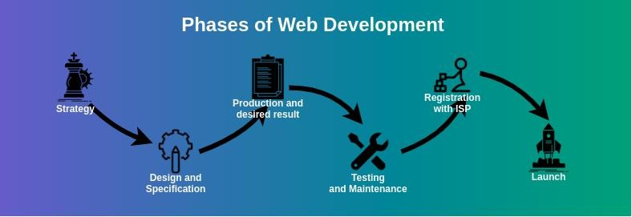
Thevariousstagesthatareneededinordertodevelopa webprojectinwebdevelopmentare as following:
Strategy:Thefirststepinthewebdevelopmentprocessforadeveloperistomakeastrategy for developing awebpage orwebsite. Inthe strategy phase,webdeveloper has todone the following:
- Decidinggoalsandobjectives
- Developingteam

- Maketheappropriateanalysisassociatedwithproblemandreviewtheanalysis
- Formulatealistoftasks
- Proposalofprojecttowebteamfordeveloping

Specification and Design:After the strategy-making, the next step in the web development process is to develop a planned work. Web developer has to determine the schedule and the specifications. The tasks in this phase are as follows.
- Developingapproach
- Selectionoffrontend(clientside)orbackend(serverside)programminglanguages
- Planningofcontentsneededforuse
- Makingofroughdesignforproject
- Making of final design from rough design, if there is no considerable modification in rough design.
- Frameaprototype(dummywebsite)ofprojectfor developing
- Testthe prototype
If prototypeisaccomplish,then go tonext phase phase-3 otherwise repeat the phase 2 untilprototype is accomplish.

Production of desired result:In this phase of the web development process the actual functional site is built. After the proper testing of the prototype, the developer has to work on developing the actual live web project. The actual live web project is built according to the requirements of the client. Web developer has to consider all the situations from the design phase to create all the features in the web project.
This phase involves both front end development and back end development of the website. Front end development comprises of the writing codes with the basic technologies like HTML,CSS, JavaScript etc. according to the web standards. It generally starts by developing the home page first and then other pages.
Back end development is also completed in this phase by installing and configuring the contentmanagement systems, databases, and frameworks using PHP, Python, Ruby, SQL etc.
Aftercompleting all the steps that were finalized inthe strategy and designphase by whichthe original website becomes functional, it is tested in the next phase.

Testing and Maintenance:Testing is an important phase in the web development process. Testing is performed by the developers and testers to ensure the client’s requirements aftercompletion of the web project.

Registration with ISP:After completion of the Testing and Maintenance and removing all the bugsfromthe project,thenextsteporphase istoregisterthewebproject withthe regionalISP to make the web project legal.
The client has to select and decide the ISP which provides domain name registration and web hosting services.

Launch:This is thelast phaseofthewebdevelopmentprocess. Project is launchedaftergetting registered with ISP. After launching, web project is publicly accessed by the users of the particular domain. The tasks performed in the launch phase are as follows.
- Migrationofdata
- Launchingofserver
- Mergingofcode
- Redirectingdomainname

ApplicationofJavaScript
JavaScriptisusedtocreate interactivewebsites.Itismainlyusedfor:

  - Client-sidevalidation,
  - Dynamicdrop-downmenus,
  - Displayingdateand time,
  - Displayingpop-upwindowsanddialogboxes(like analertdialog box,confirm dialogbox and prompt dialog box),
  - Displayingclocksetc.
NOTE:Javascriptexample iseasytocode.JavaScriptprovides3placestoputtheJavaScript code:
  - withinbodytag
  - withinheadtag
  - externalJavaScriptfile(.js file)

Example1(withinbodyTag)
<html>
<head><title>MyfirstJSprogram</title></head>
<body>
<h2>WelcometoJavaScript</h2>
<script>
document.write("JavaScriptisasimple languagefor learners");
</script>
</body>
</html>

Output:
WelcometoJavaScript

JavaScriptisasimplelanguagefor learners

HighlightsofExample1:
Thedocument.write()functionis usedtodisplay dynamiccontentthroughJavaScript.Wewill learn about document object in detail later.

Example2:withinhead section
<html>
<head>
<script>functionmsg()
{
alert("HelloJavatpoint");
}
</script>
</head>
<body>
<p>WelcometoJavascript</p>
<form>
<inputtype="button"value="click"onclick="msg()"/>
</form>
</body>
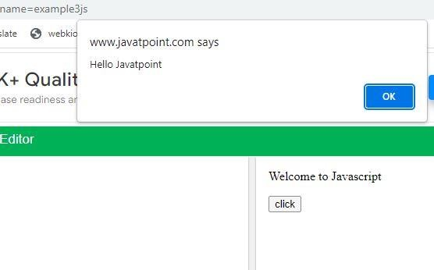
</html> Output:

How to add comments in JS: TheJavaScriptcommentsare meaningfulway todelivermessage. It is used to add information about the code, warnings or suggestions so that end user caneasily interpret the code.

TheJavaScriptcomment isignoredbytheJavaScriptenginei.e.embeddedinthebrowser.

AdvantagesofJavaScriptcomments:
TherearemainlytwoadvantagesofJavaScriptcomments.
Tomakecodeeasytounderstand:Itcanbeused toelaboratethecodesothatend usercan easily understand the code.
To avoid the unnecessary code: It can also be used to avoid the code being executed. Sometimes,weaddthecodetoperformsomeaction.But aftersometime,theremaybeneed to disable the code. In such case, it is better to use comments.

TypesofJavaScriptComments
TherearetwotypesofcommentsinJavaScript. Single-line Comment
Multi-lineComment

JavaScriptSinglelineComment
Itisrepresentedbydoubleforwardslashes(//).Itcanbeusedbeforeandafterthestatement.

Let’sseetheexampleofsingle-linecommenti.e.addedbeforethestatement.

<script>
// It is single line comment document.write("hellojavascript");

</script>

JavaScriptMultilineComment
Itcanbeusedtoaddsingleaswellasmultilinecomments.So,itismore convenient.
Itisrepresentedbyforwardslashwithasteriskthenasteriskwithforwardslashatthe end. For example:
/*yourcodehere*/
Itcanbeusedbefore,afterandmiddleof the statement.

<script>
/*Itismultilinecomment.
Itwillnotbedisplayed*/
document.write("exampleofjavascriptmultilinecomment");

</script>

JavaScriptVariable:
AJavaScriptvariableissimplyanameofstoragelocation. Therearetwotypesofvariables in JavaScript : local variable and global variable.
TherearesomeruleswhiledeclaringaJavaScript variable(alsoknownasidentifiers).
- Namemuststartwithaletter(atozorAtoZ),underscore(_),ordollar($)sign.

- Afterfirstletterwecan usedigits(0to9),forexample value1.
- JavaScriptvariablesarecasesensitive,forexamplexandXaredifferentvariables.

Example:

<html>
<head><title>VariableinJSprogram</title></head>
<body>
<script>varx=10; vary=20; varz=x+y;
document.write(z);
</script>
</body>
</html>Output:30

OperatorsinJavaScript:

TherearefollowingtypesofoperatorsinJavaScript.
  - ArithmeticOperators
  - Comparison(Relational)Operators
  - BitwiseOperators
  - LogicalOperators
  - Assignment Operators
  - Special Operators JavaScriptArithmeticOperators
Arithmeticoperators areusedtoperformarithmeticoperations on theoperands. Thefollowing operators are known as JavaScript arithmetic operators.

Operator | Description | Example
+ | Addition | 10+20=30
- | Subtraction | 20-10=10
* | Multiplication | 10*20=200
/ | Division | 20/10=2

% | Modulus(Remainder) | 20%10=0
++ | Increment | vara=10;a++;Nowa= 11
-- | Decrement | vara=10;a--; Nowa=9

JavaScriptComparisonOperators
TheJavaScriptcomparisonoperatorcomparesthetwooperands.Thecomparisonoperatorsare as follows:

Operator | Description | Example
== | Isequal to | 10==20= false
!= | Notequal to | 10!=20=true
!== | NotIdentical | 20!==20=false
> | Greaterthan | 20>10=true
>= | Greaterthanorequal to | 20>=10= true
< | Less than | 20<10=false
<= | Lessthanorequal to | 20<=10= false
JavaScriptBitwiseOperators
The bitwise operators perform bitwise operations on operands. The bitwise operators are asfollows:

Operator | Description | Example
& | BitwiseAND | (10==20&20==33)= false
| | BitwiseOR | (10==20|20==33)= false
~ | BitwiseNOT | (~10)=-10

JavaScriptLogicalOperators
ThefollowingoperatorsareknownasJavaScript logical operators.

Operator | Description | Example
&& | LogicalAND | (10==20&&20==33)=false
|| | LogicalOR | (10==20||20==33)= false
! | LogicalNot | !(10==20)=true

JavaScriptAssignmentOperators
ThefollowingoperatorsareknownasJavaScriptassignmentoperators.

Operator | Description | Example
= | Assign | 10+10=20
+= | Addand assign | vara=10;a+=20; Nowa=30
-= | Subtractandassign | vara=20;a-=10;Nowa=10
*= | Multiplyandassign | vara=10;a*=20; Nowa=200
/= | Divideandassign | vara=10;a/=2; Nowa=5
%= | Modulusandassign | vara=10;a%=2;Nowa=0
JavaScriptSpecialOperators
ThefollowingoperatorsareknownasJavaScriptspecial operators.

Operator | Description
(?:) | ConditionalOperatorreturnsvalue basedonthecondition.Itislikeif-else.
, | CommaOperatorallowsmultipleexpressionstobeevaluatedassinglestatement.
delete | DeleteOperatordeletesapropertyfromthe object.
in | InOperatorchecksifobjecthasthegivenproperty
new | createsaninstance(object)
typeof | checksthetypeofobject.

void | itdiscardstheexpression'sreturnvalue.

Ex1:
Programofaddition,subtraction,multiply,anddivisioninJavaScript
<!doctypehtml>
<html>
<body>
<script>
varnumOne=12,numTwo=10,res; res = numOne + numTwo;
document.write("Add="+res+"<br/>"); res = numOne - numTwo;
document.write("Subtract="+res+"<br/>"); res = numOne * numTwo; document.write("Multiply="+res+"<br/>"); res = numOne/numTwo; document.write("Divide = " + res + "<br/>");
</script>
</body>
</html>

Output:
Add=22
Subtract=2
Multiply=120
Divide=1.2

DifferentwaystodeclareVariablesin JavaScript:
- Usingvar
- Usinglet

- Usingconst
- Usingnothing
<!DOCTYPEhtml>
<html>
<body>
<h2>JavaScriptVariables</h2>
<p>Inthisexample,x,y,andzarevariables.</p>
<pid="demo"></p>
<script>letx=5; lety=6;
letz=x+y;
document.getElementById("demo").innerHTML="Thevalueofzis:"+z; document.write("The value of z is:" + z);
</script>
</body>
</html>
JavaScriptVariables
Inthisexample,x,y,andzarevariables. The value of z is: 11
Thevalue ofz1is:11

WhentoUseJavaScript var?
AlwaysdeclareJavaScriptvariableswithvar,let,orconst.
ThevarkeywordisusedinallJavaScriptcodefrom1995to2015. The let and const keywords were added to JavaScript in 2015.
Ifyouwantyour codetorun in olderbrowsers,youmustusevar.

WhentoUseJavaScriptconst?
Ifyouwantageneralrule:alwaysdeclarevariableswithconst. If you think the value of the variable can change, use let.
Inthisexample, price1,price2,andtotal,arevariables:

Example
constprice1=5; constprice2=6;
lettotal=price1+price2;

Thetwovariablesprice1andprice2aredeclaredwiththeconstkeyword. These are constant values and cannot be changed.
Thevariabletotalisdeclaredwiththe letkeyword. This is a value that can be changed.

DifferentKindsofLoops

JavaScriptsupportsdifferentkindsofloops:
- for-loopsthroughablockofcodeanumber oftimes
- while-loopsthrougha blockofcode whileaspecifiedconditionistrue
- do/while-alsoloopsthroughablock ofcodewhileaspecifiedconditionistrue The For Loop
Theforstatementcreatesaloopwith3optionalexpressions:
for(expression1;expression2;expression3)
{
//codeblocktobeexecuted
}
Expression1(Initialization)isexecuted(onetime)beforetheexecutionofthecodeblock.
Expression2(Condition)definestheconditionforexecutingthecode block.
Expression3(Increment/Decrement)isexecuted(everytime)afterthecodeblockhasbeen executed.
<!DOCTYPEhtml>
<html>
<body>
<h2>JavaScriptForLoop</h2>

<pid="demo"></p>

<script>
lettext="";
for(let i=0;i<5; i++)
{
text+="Thenumber is"+i+"<br>";
}
document.getElementById("demo").innerHTML=text;
</script>
</body>
</html>
Fromtheexample above,youcan read:
Expression1setsavariable beforetheloopstarts(leti=0).
Expression2definestheconditionforthelooptorun(imustbelessthan 5).
Expression3increasesavalue(i++)eachtimethe codeblock inthe loophas beenexecuted. Another Example:
<!DOCTYPEhtml>
<html>
<body>
<h2>JavaScriptForLoop</h2>

<pid="demo"></p>

<script>
constp_lang=["html","css","javascript","java","c","c++"];

lettext="";
for(leti=0;i<p_lang.length;i++){ text += p_lang[i] + "<br>";
}
document.getElementById("demo").innerHTML=text;
</script>
</body>
</html>

JavaScriptWhileLoop

Loopscanexecuteablockofcodeaslongasaspecifiedconditionistrue.
TheWhileLoop:Thewhile looploopsthroughablockofcodeas longasaspecifiedconditionis true.
Syntax
while(condition){
//codeblocktobeexecuted
}
Example

Inthefollowingexample,the code intheloopwillrun,overandoveragain,aslongasa variable (i) is less than 10:
<!DOCTYPEhtml>
<html>
<body>

<h2>JavaScriptWhileLoop</h2>

<pid="demo"></p>
<script>
lettext=""; let i = 0;
while(i< 10){
text+="<br>Thenumberis"+i; i++;
}
document.getElementById("demo").innerHTML=text;
</script>
</body>
</html>

JavaScriptWhileLoop
Thenumberis0 Thenumberis1 Thenumberis2 Thenumberis3 Thenumberis4

Thenumberis5 Thenumberis6 Thenumberis7 Thenumberis8 Thenumberis9

Ifyouforgettoincreasethevariableused inthe condition,the loopwillnever end.Thiswillcrash your browser.

TheDoWhile Loop
Thedo whileloop is a variant of the while loop. This loop will execute the code block once, before checking if the condition is true, then it will repeat the loop as long as the condition is true.
Syntax do {
//codeblocktobeexecuted
}
while(condition); Example
The example below uses adowhile loop. The loopwillalways be executedat least once,evenif the condition is false, because the code block is executed before the condition is tested:
<!DOCTYPEhtml>
<html>
<body>

<h2>JavaScriptDoWhileLoop</h2>
<pid="demo"></p>
<script>
lettext="" let i = 0;

do{
text+="<br>Thenumberis"+i; i++;
}

while(i<10);

document.getElementById("demo").innerHTML=text;
</script>

</body>
</html>

Output:

JavaScriptDoWhile Loop
Thenumberis0 Thenumberis1 Thenumberis2 Thenumberis3 Thenumberis4 Thenumberis5 Thenumberis6 Thenumberis7 Thenumberis8 Thenumberis9
JavaScriptFunctions

WhyFunctions?
CodeReusability:Withfunctionsyoucan reusecodeandwecan calla functionseveraltimesso it saves coding.
Youcanwritecodethatcanbeusedmanytimes.
Youcanusethesamecodewithdifferentarguments(inputvalues),toproducedifferentresults.
LessCoding:Itmakesourprogramcompact.Wedon’tneedtowritemanylinesofcode each time to perform a common task.
AJavaScriptfunctionis ablockofcodedesignedtoperformaparticulartask.
AJavaScriptfunctionisexecutedwhen"something"invokesit(callsit).

JavaScriptFunctionSyntax
AJavaScriptfunctionisdefinedwiththe function keyword,followedbyaname,followedby parentheses ().
Functionnamescancontainletters,digits,underscores,anddollarsigns(samerulesas variables).
Theparenthesesmayincludearguments/parameternamesseparatedbycommas:
(parameter1,parameter2,...)
Thecodetobe executed,bythefunction,isplacedinsidecurlybrackets:{}
functionname(parameter1,parameter2,parameter3)
{
//codetobe executed
}
Function parameters are listed inside the parentheses () in the function definition. Functionargumentsarethevaluesreceivedbythefunctionwhenitisinvoked/call. Inside the function, the arguments (the parameters) behave as local variables.

Example:

<!DOCTYPEhtml>
<html>
<body>
<h1>JavaScriptFunctions</h1>

<p>Callafunctionwhichperformsacalculationandreturnstheresult:</p>

<pid="demo"></p>
<script>
functionmyFunction(p1,p2){ return p1 * p2;
}
let n1=+prompt("Enter n1"); let n2=+prompt("Enter n2"); letresult=myFunction(n1,n2);
document.getElementById("demo").innerHTML=result;
</script>

</body>
</html>

Output:

JavaScriptFunctions

Callafunctionwhichperformsacalculationandreturnstheresult: 24
FunctionInvocation
Thecodeinsidethefunctionwillexecutewhen"something"invokes(calls)thefunction:
- Whenan eventoccurs(whenauserclicksabutton)
- Whenitisinvoked(called)fromJavaScript code
- Automatically(selfinvoked) Function Return
WhenJavaScriptreachesa returnstatement,thefunctionwillstop executing.
Ifthefunctionwasinvokedfromastatement,JavaScriptwill"return"toexecutethecodeafter the invoking statement.
Functionsoftencomputeareturnvalue.Thereturnvalue is"returned"backtothe"caller":

The()Operator
The()operatorinvokes(calls)thefunction:
<!DOCTYPEhtml>
<html>
<body>
<h1>JavaScriptFunctions</h1>

<p>Invoke(call)afunctionthatconvertsfromFahrenheittoCelsius:</p>
<pid="demo"></p>

<script>
functionFahToCelsius(f) //FahToCelsius(77)
{

return(5/9)*(f-32);
}
letn1=+prompt("Enterthevalueofn1infah"); let value = FahToCelsius(n1); //fun calling
document.getElementById("demo").innerHTML=value;
</script>

</body>
</html>
Accessingafunctionwithincorrectparameterscanreturnanincorrectanswer: Suppose 77 is not passed here then it will return NaN
Accessingafunctionwithout()returnsthefunctionandnotthefunction result:
<!DOCTYPEhtml>
<html>
<body>
<h1>JavaScriptFunctions</h1>

<p>Accessingafunctionwithout()returnsthefunctionandnotthefunctionresult:</p>
<pid="demo"></p>

<script>
functiontoCelsius(f){ return(5/9)*(f-32);
}
let value = toCelsius; document.getElementById("demo").innerHTML=value;
</script>

</body>
</html> OutPut:

JavaScriptFunctions

Accessingafunctionwithout()returnsthefunctionandnotthefunction result: function toCelsius(f) { return (5/9) * (f-32); }

Unit-5
TheHTMLDOM(DocumentObjectModel)

Whenaweb pageisloaded,thebrowsercreatesa DocumentObjectModelofthepage. The HTML DOM model is constructed as a tree of Objects:
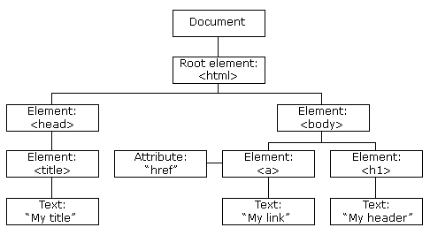
TheHTMLDOMTreeofObjects
Withtheobjectmodel,JavaScriptgetsallthepoweritneedstocreatedynamicHTML:
- JavaScriptcan changealltheHTMLelementsinthepage
- JavaScriptcan changealltheHTMLattributesinthepage
- JavaScriptcan changealltheCSSstylesinthepage
- JavaScriptcanremoveexistingHTMLelementsandattributes
- JavaScriptcanaddnewHTMLelementsandattributes What is the DOM?
TheDOMisaW3C(WorldWideWebConsortium)standard. The DOM defines a standard for accessing documents:
"The W3C Document Object Model (DOM) is a platform and language-neutral interface that allowsprogramsandscriptstodynamicallyaccessandupdatethecontent,structure,andstyle of a document."

TheW3CDOMstandardisseparatedinto3differentparts:
- CoreDOM-standardmodelforalldocumenttypes
- XMLDOM-standardmodel for XMLdocuments
- HTMLDOM-standardmodelforHTMLdocuments What is the HTML DOM?
TheHTMLDOMisastandardobjectmodeland programminginterface forHTML.Itdefines:
- TheHTMLelementsasobjects
- ThepropertiesofallHTML elements
- ThemethodstoaccessallHTMLelements
- TheeventsforallHTMLelements

Inotherwords:TheHTMLDOMisastandardforhowtoget,change,add,ordeleteHTML elements.

Methodsofdocument object
Wecanaccessandchangethecontentsofdocumentbyitsmethods. The important methods of document object are as follows:
Method | Description
write("string") | writesthegivenstringonthedoucment.
writeln("string") | writes the given string onthedoucmentwithnewline character at the end.
getElementById() | returnstheelementhavingthegivenidvalue.
getElementsByName() | returnsalltheelementshavingthegivennamevalue.
getElementsByTagName() | returnsalltheelementshavingthegiventag name.
getElementsByClassName() | returnsalltheelementshavingthegivenclass name.

ExampleofgetElementsById() method:
<!DOCTYPEhtml>
<html>
<body>

<h2>JavaScriptHTMLDOM</h2>
<pid="intro">FindingHTMLElementsbyId</p>
<p>Thisexampledemonstratesthe<b>getElementsById</b>method.</p>
<pid="demo"></p>

<script>
constelement=document.getElementById("intro");

document.getElementById("demo").innerHTML=
"Thetextfromthe introparagraphis:"+element.innerHTML;
</script>
</body>
</html>

UsinggetElementsByTagName()method:
<!DOCTYPEhtml>
<html>
<body>

<h2>JavaScriptHTMLDOM</h2>
<p>FindingHTMLElementsbyTagName.</p>
<p>Thisexampledemonstratesthe<b>getElementsByTagName</b>method.</p>
<pid="demo"></p>

<script>
constelement=document.getElementsByTagName("p");

document.getElementById("demo").innerHTML='Thetextinfirstparagraph(index 0)is:'+ element[0].innerHTML;
</script>

</body>
</html>

Trymore CSSpropertiesandchangeimage,padding,border,andmargin

