PRESENTATION ON
ELECTRICAL AND ELECTRONICS ENGINEERING MATERIALS BRANCH- ELECTRICAL ENGINEERING SEMESTER - III

INTRODUCTION

Electrical and Electronics Engineering Materials is one of the core Engineering subject. A diploma holder or Electrical Engineer will be involved in maintenance, repair and production of electrical equipment and systems. In addition, he may be required to inspect and test electrical and electronics engineering materials. Knowledge of various types of materials will be needed in order to execute above mentioned functions. The perfect knowledge of this subject is very useful in almost every field of Engineering. As the various types of materials are required for the manufacturing of various engineering goods, so each and every materials has different properties and hence serve specific functions. For the selection of an Electrical and Electronics Engineering material we should know its physical, chemical, mechanical and electrical properties.

Unit-1
Classification of Materials

Classification of Electrical and Electronics
Engineering Materials
Materials used in the field of Electrical and Electronics Engineering are called Electrical and Electronics Engineering Materials. Based on properties and area of applications, Electrical Engineering Materials are classified as below:
- Conductors
- Semiconductors
- Insulators
- Magnetic material

Engineering Materials
Semiconducting
Material
Silicon, Germanium
Iron, Nickel, Steel
Rubber, Wood, Glass,
Mica
Gold, Silver, Copper,
Aluminium

Magnetic Materials

Insulating Materials

Conducting Material

- Conducting materials- Those materials in which the electric current can easily
flow. E.g. copper, aluminum, silver and gold.
- Insulating materials- Those materials which do not allow the passage of electric current. The resistivity of these materials is very high. E.g. Rubber, wood, glass, ceramic, mica
- Semiconducting materials-Those materials whose resistivity is less than insulators but more than conductors. The conductivity of these materials is less than conductors but more than insulators. These materials are used in manufacturing of semiconductor devices e.g. diode, transistor etc. The most well known used semiconducting materials are silicon, germanium etc.
- Magnetic materials-Those materials which can be magnetized and which are attracted towards the magnet. Such materials create a magnetic field on the surrounding space. E.g. iron, nickel and cobalt

THE MODERN ATOMIC THEORY

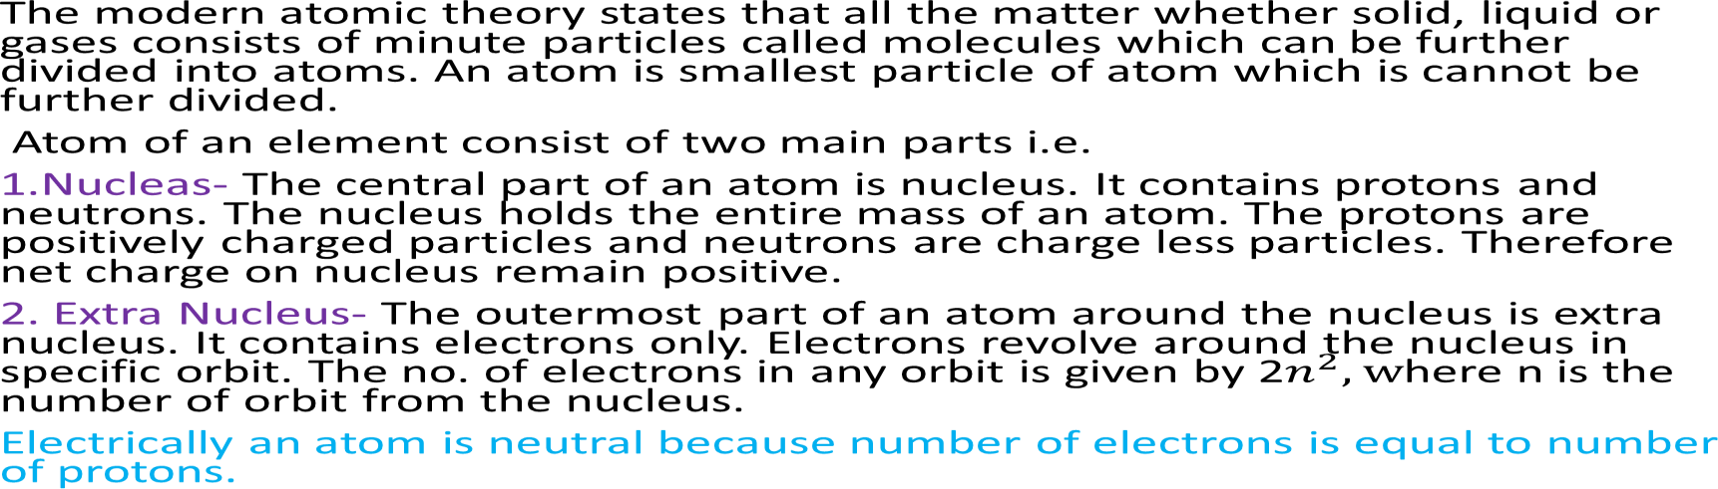

Classification of Conductor, Insulator and Semiconductor on the basis of Atomic Structure
The outer shell of an atom, called the valence shell, contains valence electrons that determines if a substance is a conductor, an insulator or a semiconductor.

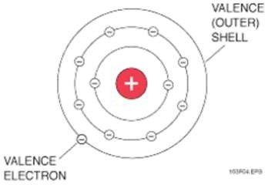

Conductors contain 1 to 3 valence electrons in its outer shell. Semiconductors contain 4 valence electrons in its outer shell. Whereas insulators contains more than four electrons i.e. generally 7 to 8 electrons in outer shell.

Energy Band Theory:-
In a single isolated atom, the electrons in each orbit have definite energy associated with it. But in case of solids all the atoms are close to each other, so the energy levels of outermost orbit electrons are affected by the neighboring atoms. When two single or isolated atoms are bring close to each other then the outermost orbit electrons of two atoms are interact or shared with each other. i.e., the electrons in the outermost orbit of one atom experience a attractive force from the nearest or neighboring atomic nucleus. Due to this the energies of the electrons will not be in same level, the energy levels of electrons are changed to a value which is higher or lower than that of the original energy level of the electron.
The electrons in same orbit exhibits different energy levels. The grouping of this different energy levels is called energy band.
However, the energy levels of inner orbit electrons are not much affected by the presence of neighboring atoms.

Important Energy Bands in Solids:
- There are number of energy bands in solids but three of them are very important. These three energy bands are important to understand the behavior of solids. These energy bands are
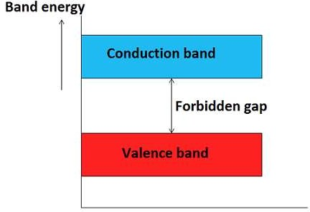
- Valence band
- Conduction band
- Forbidden band or forbidden gap

Valence band
The energy band which is formed by grouping the range of energy levels of the valence electrons or outermost orbit electrons is called as valence band. Valence band is present below the conduction band as shown in figure above. Electrons in the valence band have lower energy than the electrons in conduction band. The electrons present in the valence band are loosely bound to the nucleus of atom.

Conduction band
The energy band which is formed by grouping the range of energy levels of the free electrons is called as conduction band. Generally, the conduction band is empty but when external energy is applied the electrons in the valence band jumps in to the conduction band and becomes free electrons. Electrons in the conduction band have higher energy than the electrons in valence band. The conduction band electrons are not bound to the nucleus of atom.

Forbidden gap
The energy gap which is present between the valence band and conduction band by
separating these two energy bands is called as forbidden band or forbidden gap.

Classification of Conductors, Semiconductors and Insulators on the basis of Energy Band Diagram:-

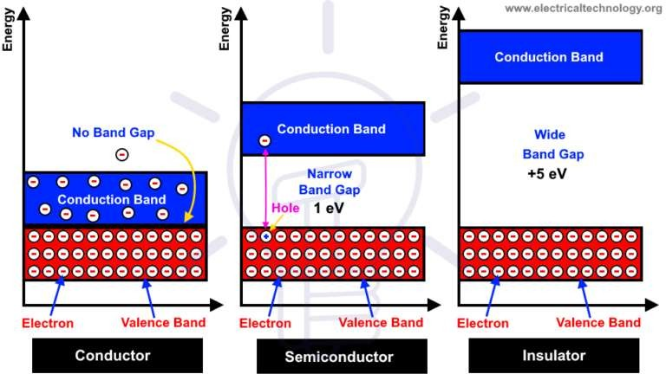
15eV

- Conductors:-
In conductors , conduction band is overlapped with valence band. So , large number of electrons can jump from valence band to conduction band with the application of small potential difference. The energy band diagram is shown in the figure above.

Semiconductors:-
In these materials , valence band is full of electrons while conduction band is empty. In this case, energy gap is very small (1 eV).With the application of small potential difference, electrons can jump from valence band to conduction band. The semiconductor behaves as an insulator at room temperature or low temperature. As the temperature increases, more electrons pass through valance band to conduction band resulting conductivity increases. Energy band diagram for semiconductor shown above.

Insulators:-
In insulators , conduction band remain is empty, while valence band has many electrons. The forbidden energy gap between valence ban d and conduction band is quite large (15 eV). So it is not easy to conduct electric current through them. The electrons of the valance band require very high electric field in order to cross it and move in the conduction band. The electrons of the valance band do not have enough energy to cross and move towards conduction band therefore the conductivity of the insulator is almost zero.

Unit-2
Conducting Materials

Conducting Materials:
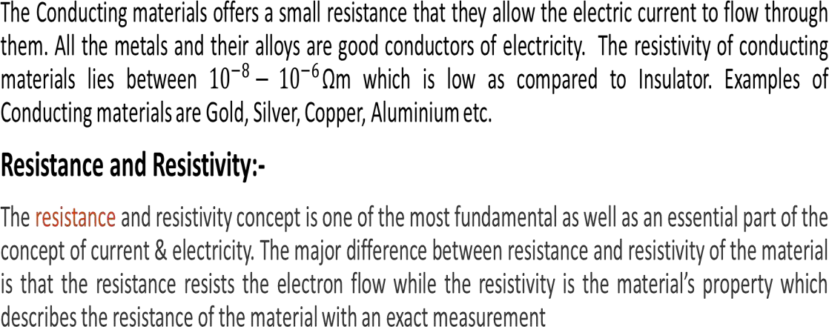

Resistance:-
The opposition offered to the flow of current is called Resistance. It is material property which makes an obstruction within the current flow. It’s symbol is

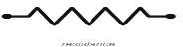
It’s unit is Ω(Ohm).
Factors Affecting Resistance:

Where l is length of conductor in meters. a is area of cross section of wire. ρ is resistivity of material

R = ρ x l / a

The wire resistance mainly depends on the following factors:
- When the length of the wire increases then automatically resistance of the wire will be increased
- The conductor’s cross-section area is inversely proportional to the resistance.
- It depends on the object of the wire.
- The resistance of the object mainly relies on its temperature.

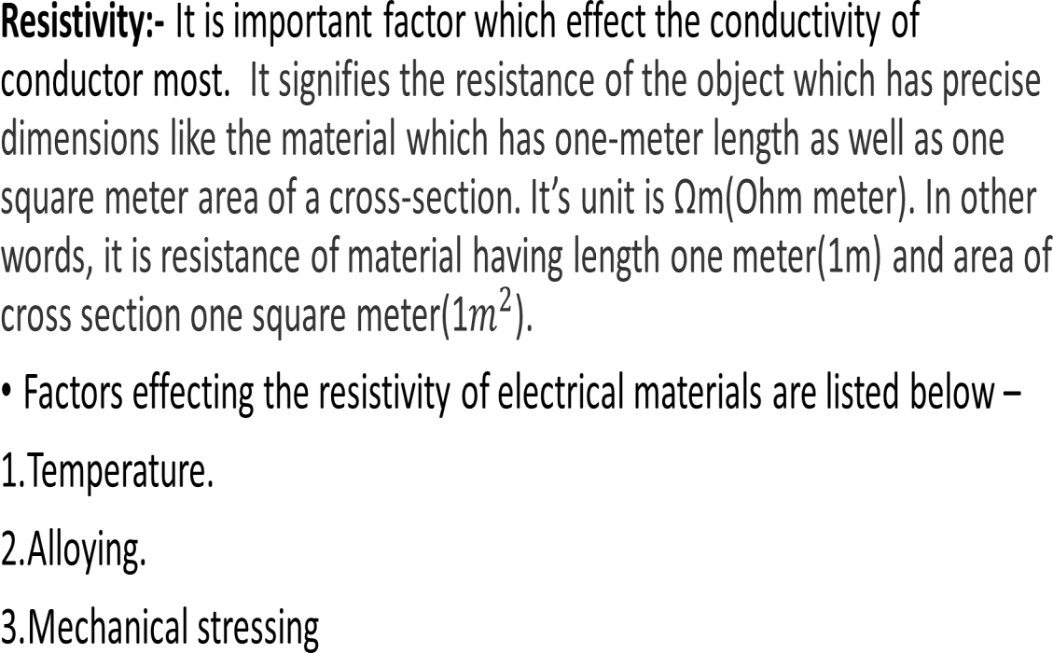

Temperature:
The resistivity of materials changes with temperature. Resistivity of most of the metals increase with temperature. Means the metals are having positive temperature coefficient of resistance. Several metals exhibit the zero resistivity at temperature near to absolute zero. This phenomenon is “called the superconductivity”. The resistivity of semiconductors and insulators decrease with increase in temperature. Means the semiconductors and insulators are having negative temperature coefficient of resistance.

Alloying:
Alloying is a solid solution of two or more metals. Alloying of metals is used to achieve some mechanical and electrical properties. The atomic structure of a solid solution is irregular as compared to pure metals. Due to which the electrical resistivity of the solid solution increases more rapidly with increase of alloy content. A small content of impurity may increase the resistivity metal considerably. Even the impurity of low resistivity increases the resistivity of base metal considerably. For example the impurity of silver (having lowest resistivity among all metals) in copper increase the resistivity of copper.

Mechanical Stressing:-
Mechanical stressing of the crystal structure of material develops the localized strains in the material crystal structure. These localized stains disturb the movement of free electrons through the material. Which results in an increase in resistivity of the material. Subsequently, annealing, of metal reduces the resistivity of metal. Annealing of metal, relieve the mechanical stressing of material due to which the localized stains got removed from the crystal structure of the metal. Due to which the resistivity of metal decrease. For example, the resistivity of hard drawn copper is more as compared to annealed copper.

Few Important terms related to Conductivity:

Temperature Coefficient of Resistance:
- It is the measure of change in electrical resistance of any substance per degree of temperature change.
- A positive coefficient for a material means that its resistance increases with an increase in temperature. Pure metals typically have positive temperature coefficients of resistance. Coefficients approaching zero can be obtained by alloying certain metals.
- A negative coefficient for a material means that its resistance decreases with an increase in temperature. Semiconductor materials (carbon, silicon, germanium) typically have negative temperature coefficients of resistance.

Ductility:
The process by which metal can be drawn into thin wire is called Ductility.

- Solderability and Contact Resistance:
Conducting materials are required to be joined very often. The joint should offer minimum contact resistance. Thus solderability is also considered as a required property.
- Hard Drawn Wire and Annealed Wire:
Annealed and hard drawn basically refers to the softness or hardness of a metal.
- If a wire is annealed, this means it has been heat treated whilst being drawn through a die. After being heated and drawn, it is then left to cool slowly in order to soften it. An annealed wire is generally very easy to bend and shape due to its softness, making it a malleable and ductile material, however it can also become hard if it is over worked.
- A hard drawn wire is heated and then cooled very rapidly. These wires are very brittle and can snap easily if they are overworked. If you were to take the paperclip mentioned in the previous example, and bend it over and over again in the same place, it will become harder and eventually snap.

Classification of Conducting Materials:-
- LOW RESISTIVITY MATERIALS
- HIGH RESISTIVITY MATERIALS

Low Resistivity Materials:-
These are those materials which have low value of resistivity. Silver, Gold, Copper and
aluminum are the examples of low resistivity materials.

Properties of Low Resistivity Materials:
- LOW RESISTANCE TEMPERATURE CO-EFFICIENT: It means that the change of resistance with the change in temperature should be low. This is necessary to avoid variation on resistance which is responsible for variation in voltage drop and power loss. To keep these losses low, the conducting materials should have low resistance temperature co-efficient.
- SUFFICIENT MECHANICAL STRENGTH:- These materials must possess high mechanical strength. As line conductors used for transmission and distribution of electrical power, winding used on motors , generators or transformers should have sufficient mechanical strength.

- DUCTILITY:
The process by which a metal can be drawn into thin wires is called ductility. The conducting
material should be ductile enough to enable it to be drawn into different sizes and shapes.
- SOLDERABILITY AND CONTACT RESISTANCE:
Conducting materials are required to be joined very often. The joint should offer minimum
contact resistance. Thus solder ability is also considered as a required property.
- RESISTANCE TO CORROSION :
The conducting material should not be easily corroded.

DENSITY:
Low resistivity materials must possess low density so that actual weight of the system
where they are used should be less.

APPLICATIONS OF LOW RESISTIVITY MATERIALS:-
Low resistivity materials are used in house wiring, as a conductor for power transmission and distribution, on the winding of electrical machines such as generators, motors and transformers. Low resistivity materials are used where the power loss and voltage drop should be low. Copper and aluminium are examples of low resistivity materials.

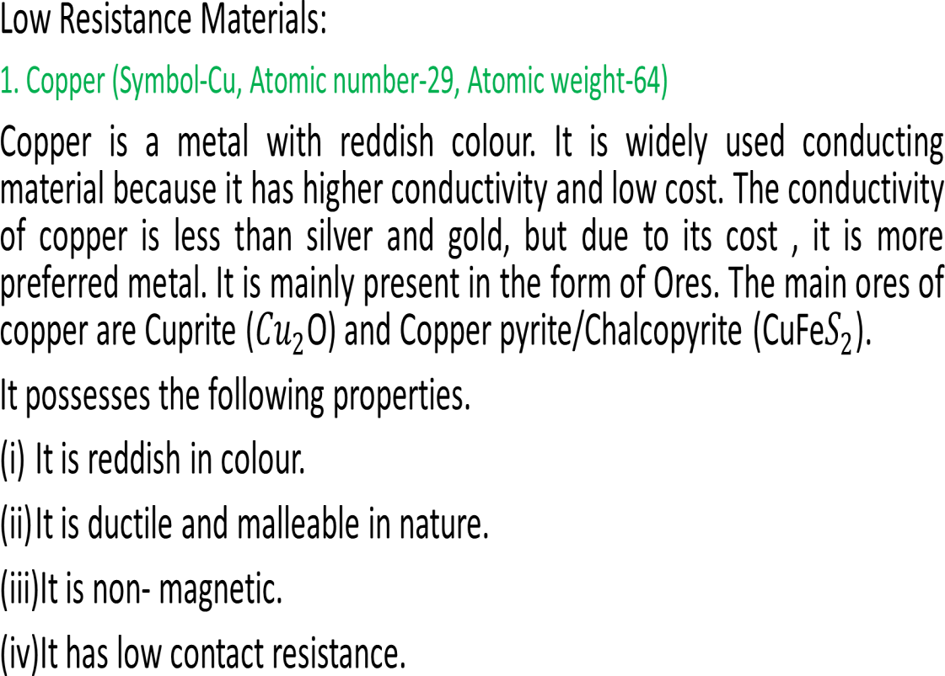

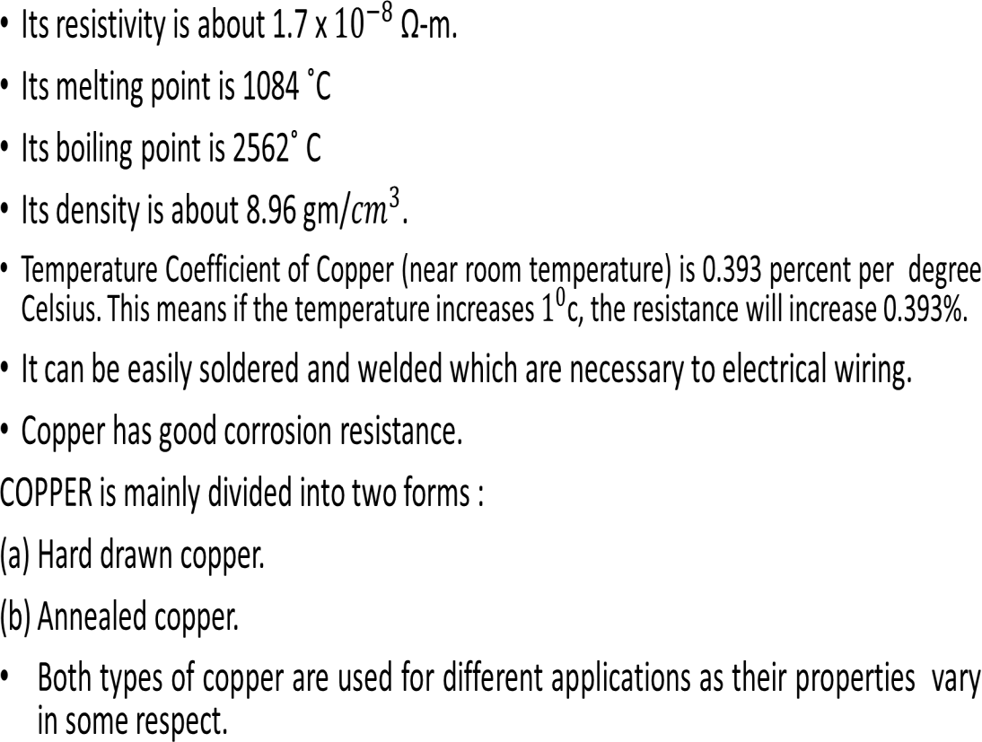

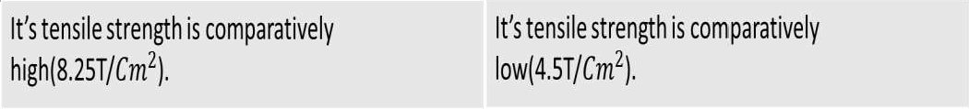

Difference Between Hard Drawn and Annealed Copper

HARD DRAWN COPPER | ANNEALED COPPER
It is made by drawing copper bars in cold  conditions. | It is made by raising the temperature of hard drawn copper and then allowed to cool at room temperature.
It is Hard | It is Soft.
Being Hard, It is less flexible. | Being Soft, It is more flexible.

Applications of Copper:
- Hard Drawn Copper:- It is used for high voltage underground cable, bus bars and conductors because of its high mechanical strength.
- Annealed Copper:- It is soft Copper. It is used for insulated conductor in low voltage cables, winding wires for electrical machines and transformers, flexible wires and in making coils for any purpose.

ALUMINIUM (Symbol –Al, Atomic number-13, Atomic weight-27)
Aluminium is a white colored metal, most commonly and universally used conducting material. It is used in the field of electrical engineering. Its conductivity is next to copper.
It possesses the following electrical, physical and chemical properties:
- It is silver white in colour.
- It is malleable and ductile and can be drawn into thin wires.
- It offers high resistance to corrosion due to oxide layer formed on its surface when exposed to atmosphere. But aluminium oxide layer had higher resistivity and act as an insulator.
- Its melting point is 655 ˚C.
- Its boiling point is 2057 ˚C.

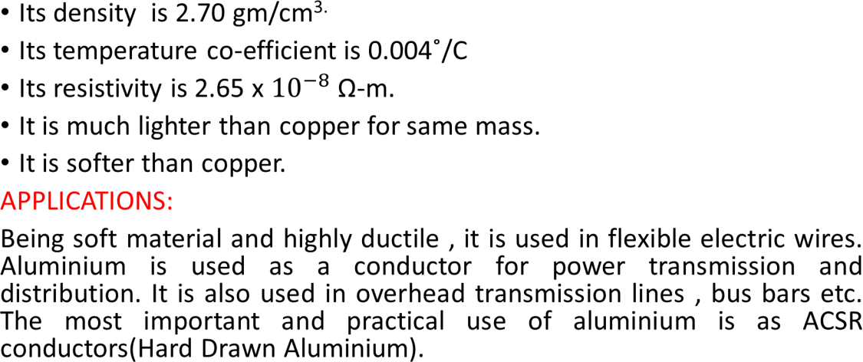

Steel:-
Steel is an alloy of iron and carbon with a small percentage of other metals such as nickel, chromium, aluminium, cobalt, manganese, tungsten etc. Steel is a hard ductile and malleable solid and is probably the most solid material.

Types of Steel:-
Steel are basically classified on the basis of type of metal used and the percentage content of
the metal in the particular type of Steel.
  - High Carbon Steel:
Simply composed of iron and carbon with a more percentage of carbon in it than iron. The presence of excess carbon makes this type of steel is softer than the other types of steel, Mostly used in the making of wood cutting tools, making of axes, swords, scissors and other cutting tools.
  - Mild Carbon Steel:
Simply composed of iron and carbon but has a very low carbon content in it. Widely used in
making of vehicle frames, panels, boxes, cases and sheet metals for roofs.
  - Stainless Steel:
It is most resistant and commonly used steel of all the types. It apart from carbon contains 11% chromium some amount of nickel. This is used in making of crockery, wrist watches, kitchen utensils, surgical equipment's.

Properties of Steel:
  - It is a shiny metal with a very attractive finish.
  - It transfers heat and electricity.
  - Malleability:- It can be rolled into thin sheets, rod, bar or beams or forged into different shapes.
  - Ductility: It can be stretched and drawn out into thin wires or pressed into different shapes.
  - It is very strong and resistant to fracture.
  - Durability: It is long lasting material (rail lines, bridges) Cold Rolled Grain Oriented (CRGO) Silicon steel:
The addition of silicon (Si) in Iron in right proportions with the help of certain manufacturing process significantly improves the magnetic and electric properties of iron. It is also known as Electrical Steel.

Properties of Silicon Steel/ CRGO Steel/ Electrical Steel:
- High Permeability- Increased capacity to support magnetic field.
- Low Magnetostriction- Low tendency to expand or contract in magnetic fields
- High Electrical Resistivity:- Reduces the core loss by reducing the eddy current component.
- Decreased hysteresis Loss:- Low hysteresis loss means less wasted energy in the form of heat from alternating magnetising force.

Application of Steel in the field of Electrical Engineering:-
Silicon steel is widely used in Electrical vehicle driving motors, Alternating current (AC) motors, Intermittent service motors, Power and distribution transformers, Reactors and magnetic amplifiers, Welding transformers, Audio transformers, Current transformers, Magnetic switches and relays, Electrical Ballast.

  - Bundle Conductors:
Bundle conductors are those conductors which form from two or more stranded conductors, bundled together to get more current carrying capacity. For voltages greater than 220 kV it is preferable to use more than one conductor per phase which is known as Bundle conductor.
Here, we use two or more stranded conductors per phase. Also, to increase the current carrying capacity of the system, a bundle conductor also contributes various facilities to the electrical transmission system.
Advantages:
- By using bundle conductors, we can reduce the reactance of lines.
- Bundle conductors reduce the voltage gradient.
- Bundle conductor reduce the corona loss.
- It reduce radio interference.
- It reduces surge impedance.

Application of Bundle Conductors:-
It is used for transmission purpose as it helps in obtaining better voltage regulation and efficiency by reducing the inductance and skin effect present in the power lines .

LOW RESITIVITY COPPER ALLOYS
BRASS – it is an alloy of copper and zinc containing 60% of copper and 40% zinc.
  - PROPERTIES –
  - Its tensile strength is high .
  - Its conductivity is lower than copper .
  - It can attain any shape if pressed .
  - It can be easily drawn into wires .
  - Its melting point is about 890 C .
  - Its specific gravity is 3.3 . APPLICATION –
It is used as a current carrying material on plug point , socket outlets , switches , lamp holders .

BRONZE
Its color is radish yellow in color and it is alloy of copper and tin . It contain 84% copper and 8 to 16% of tin.
PROPERTIES –
- It is found in two types i.e. cadmium bronze and silicon bronze.
- It has good conductivity but less than copper
- It is free from corrosion . APPLICATION –
It is used for conducting commutator or segments .

Beryllium copper
It is an alloy of copper and beryllium having 97% copper and 3% beryllium. PROPERTIES –
  - It is modulus of elasticity depend upon the extent of the heat treatment of alloy .
  - It is highly resistant to corrosion .
  - It electrical resistivity changes with heat treatment .
  - It is weld able , machinable . APPLICATION –
It is used in making co-axial connector coil springs , in electrical equipment like switches relay blades control bearings ,electronic connector switches
.

Special Metals
- Silver ( Symbol Ag, Atomic number- 47, Atomic weight-107)
Silver is at the top among all good conducting materials. It has high electrical
conductivity and corrosion resistance.
It possesses the following physical, electrical and chemical properties. :
- It is highly ductile and malleable.
- It has highest electrical and thermal conductivity.
- Its atomic number is 47 and atomic weight is 10⁷
- Its melting point is 960 ˚C.
- It has low resistivity of the order of 1.5 x 10⁻⁸ Ωm.

  - Its density is 10.5 gm/cc
  - It has better resistance to oxidation as compared to copper.
  - It has a low surface contact resistance.
  - It has a high value of thermal conductivity.
APPLICATIONS:
  - Silver is widely used in making the contact of relays, generator cut-outs,
thermal
  - overload devices. It can be used in making high rupturing devices such
as HRC
  - fuses. It may be used for making radio frequency conducting bodies as
well as
  - component leads.

- GOLD ( Symbol-Au, Atomic number-79, Atomic weight-197)
- Gold is at the second position in the list of top good conducting materials. It possesses the following physical, electrical and chemical properties:
- It is highly ductile and malleable.
- It has low resistivity of the order of 2.2 x 10⁻⁸ Ωm..
- It is very soft and low mechanical strength and it is always alloyed with some
impurities in order to improve its hardness and strength.
- It offers high resistance to corrosion.

- Its melting point is 1063 ˚C
- Its boiling point is 2970 ˚C
- It is very light metal having specific weight of 19.32 x 10³kg/m²

APPLICATIONS :-
- It is used for making contact of highly sensitive devices and of integrated circuits. Due to its high cost, its use is quite limited.

- PLATINUM (Symbol-Pt, Atomic number – 78)
Platinum is among the most stable metals with high resistivity.
It has the following physical and electrical properties:
- It is a grayish white metal .
- Its electrical resistivity is about 10.8 x10⁻⁸Ω-m.
- It is malleable and ductile.
- It is highly corrosion resistant .
- It possesses a high tensile strength.
- It is a very heavy metal with specific gravity of 21.4 gm/cc.
- It has a high melting point of about 1775 ˚C

APPLICATIONS :
Being hard and quite stable , it is used as a heating element in ovens and furnaces. It is also used as a contact material where making and breaking is quite frequent due to high resistance touching. It is used in appliances used for measuring high temperatures such as pyrometers and thermocouples.

HIGH RESISTIVITY CONDUCTING MATERIALS
The conducting materials which have high resistivity are called high resistivity conducting
materials. The resistivity of such materials ranges from 10⁻⁶ to 10⁻³Ωm.
These materials possesses some important physical and electrical properties which are as
under :
- High Resistivity: These materials possess resistivity ranging from 10-6 to 10-3 ohm-m.
- Low temperature co-efficient of resistance: High resistivity conducting materials must have low
temperature co-efficient of resistance.
- High melting point : high resistivity conducting materials must have high melting point. Almost all high resistivity conducting materials operate at high temperature such as resistance for motor starters, heaters etc.
- Highly ductile : High resistivity conducting materials must be highly ductile. Since they are used as heating elements, they must possess the property of being drawn into thin wires.
- Corrosion resistant : High resistivity conducting materials must be corrosion resistance.
- High mechanical strength : High resistivity conducting materials are used in heaters and heating elements. These materials should have high mechanical strength, so that while drawing into thin wires of required size, they should not breakdown.

APPLICATIONS OF HIGH RESISTIVITY CONDUCTING MATERIALS

High resistivity conducting materials are mostly used for making resistance elements of heating devices. They find a significant place in appliances like filaments of heaters, electric bulbs, electric iron, electric kettles etc. Use of high resistivity materials in above applications reduces the cost and size of the appliances as the length of wire required to produce the same effect is quite less in high resistivity materials as compared to that of low resistivity materials.

ALLOYS OF HIGH RESISTIVITY CONDUCTING MATERIAL
  - MANGANIN
It is a copper alloy containing about 85% copper ,13% manganese and 2% nickel . PROPERTIES –
- Its melting point is 1025 C .
- Its specific gravity is 8.2.
- It temp. co-efficient of resistance is low .
- It is a ductile alloy and can be drawn into wires .
- It offers high resistance to oxidation . APPLICATION –
It is used in making standard resistance because of very low temp. co-efficient of resistance .,making coils ,shunt of measuring instrument , in electric heating element .

2.CONSTANTAN
  - It is an alloy of copper containing about 60% of copper and rest 40% nickel
.
PROPERTIES –
- It is shiny allow having white silver like appearance .
- Its specific gravity about 8.92 g/cc.
- Its melting point is 1300 C .
- It is highly corrosion resistant .
- Its working temp. around 500 C . APPLICATION –
It is used for making different type of rheostats, resistance wires , resistance boxes , thermocouples ,arc lamps .

- NICHROME – As the name indicates it is an alloy of Nickel and chromium
. It contains 70 to 80 % nickel and 20 to 25 % chromium & about 3% of manganese 2% iron .
PROPERTY –
- Its melting point is 1350 C .
- Its specific gravity is 8.24g/cc.
- It is high ductile alloy i.e. drawn into thin wires .
- It offers high resistance to oxidation .
- It is silvery white in appearance . APPLICATION –
It is used as heating element in soldering irons ,tubular heaters .

- MERCURY
Mercury is silvery white metal .
PROPERTIES –
- Its specific gravity is 13.55 g/cc .
- It remain in liquid state at room temperature
- Its boiling point is 358 C .
- it is highly poisonous metal .
- It is heavy white silver metal .
- oxidation takes place beyond 300 C in contact with air . APPLICATION –
It is used in thermometers , fluorescent tubes , mercury arc rectifier .

- CARBON (Symbol-C, Atomic number-6)
Carbon is formed by the homogeneous mixture of powdered carbon and binders.
These are then extruded and molded to bake up to 900 C of temperature.
Carbon is available in two forms i.e. Amorphous and Crystalline. Charcoal, coke and carbon black are the forms of amorphous carbon whereas, diamond and graphite are the crystalline forms of carbon.
Carbon exhibits the following physical and electrical properties:
- Its resistivity is quite high 5000 x 10⁻⁶ Ω-m.
- It has negative temperature co-efficient of resistance.
- It has high melting point of about 3500 ˚C
- Its specific gravity is about 3.2 gm/cc.
- Its density is about 2x 10³ kg/m³
APPLICATIONS:
Carbon is used in making welding electrodes and as carbon brushes in electrical machines. It is also used in some high quality switchgears important in diaphragms as thin membranes in modern communication system. It is also used as positive terminal of dry cells. Carbon is also used in high quality switchgears

- TUNGSTEN (Symbol –W, Atomic number-74)
Tungsten is a hard material with high melting point. It is quite dense and slow wearing material.
Tungsten has the following physical, chemical and electrical properties:
- Tungsten has a high resistivity of 5.5 x 10⁻⁸ Ω-m.
- It is a hard material and has got high tensile strength.
- Its working temperature is about 2000 ˚C
- Its specific gravity is about 3.2 gm/cc.
- Its melting point is 3300 C which is highest among metals.
- It is a ductile material and can be easily drawn into wires.
- It can safely withstand various destructive corrosive arcing forces.
APPLICATIONS:
Being hard and of high tensile strength along with high resistivity , it is used as filaments of electric lamps,
fluorescent tubes and heating elements of electron tubes.

Super Conductors:
SUPER CONDUCTORS : Those materials which show zero resistance at a particular temperature. TRANSITION TEMPERATURE : The temperature at which this phenomenon occurs is called superconducting transition temperature.
SUPER CONDUCTIVITY: It is the phenomenon in which any conducting material attains the property
of superconductivity i.e. its resistivity becomes zero.
The few important points those can be concluded are as follows:
- Most of the metals which have only one electron in the valence shell i.e. monovalent does not show
superconductivity.
- All ferromagnetic materials are superconductors i.e. Steel, Iron, Cobalt etc.
- Good conductors such as Gold, Silver are not superconductors at room temperature.

Transition temperature of few super conducting materials:-

S.No. | Metals | Transition Temperature, Tc (K)
1.  2.  3.  4.  5.  6. | Aluminium(Al) Cadmium (Cd) Copper Sulphite Mercury(Hg) Lead(Pb) Zinc(Zn) | 1.14  0.6  1.6  4.16  7.26  0.78

MATERIALS USED FOR TRANSMISSION LINES
COPPER is used for transmission lines because of its high conductivity and low resistivity. Moreover copper has high tensile strength. Since copper material is very costly these days, therefore aluminium is being used in transmission lines especially with steel core for high voltage lines.
The selection of material depends upon following factors:
- COST OF MATERIAL.
- MECHANICAL STRENGTH
- ELECTRICAL PROPERTIES
- THE REQUIRED LOCAL CONDITIONS
OTHER MATERIALS WHICH CAN BE USED FOR TRANSMISSION LINES ARE :
- GALVANISED STEEL MATERIALS
- GALVANISED IRON
- COPPER WELD MATERIALS
- STEEL CORE COPPER
- STEEL CORED ALUMINIUM MATERIALS.(A.C.S.R.)

UNIT-3
Semi Conducting Materials

SEMICONDUCTING MATERIALS
Semiconductor materials are those which possess the conductivity higher than insulators but lesser than conductors and are used for manufacturing most of the active components. Their conductivity is largely dependent upon the electric fields and impurities etc. Some examples of semiconductor materials are silicon, germanium.
ACCORDING TO ENERGY BAND STRUCTURE :
Semiconductor are materials which have normally empty conduction band at 0 ˚C and partially filled valence band. The forbidden energy gap between the two is of the order of 1 eV. Since the energy gap is very small, it can be overcome by increasing the temperature or supplying energy by any other external manner to the electron in the valence band. The electrons after receiving the energy jump to the conduction band and are free to take part in conduction.

SEMICONDUCTORS ARE OF TWO TYPES:
  - INTRINSIC SEMICONDUCTORS
  - EXTRINSIC SEMICONDUCTORS
INTRINSIC SEMICONDUCTORS
These semiconductors are in the purest form .The intrinsic semiconductors have little conductivity .Their conductivity is uncontrolled i.e. it depends only upon the temperature. Thus, they are of least practical significance.
EXTRINSIC SEMICONDUCTORS
When we add a certain amount of impurity in intrinsic semiconductor it becomes extrinsic semiconductor. By adding impurity , the conductivity of semiconductor increases and the conductivity will depend upon the amount of doping.
The impurity atoms are added from Group III or Group V of the periodic table.

TYPES OF EXTRINSIC SEMICONDUCTORS :-
    - P TYPE SEMICONDUCTOR: When we add trivalent impurity from Group III such as
boron , the resulting semiconductor is p-type semiconductor.
    - N TYPE SEMICONDUCTOR: When we add pentavalent impurity from Group V, such
as antimony, the resulting semiconductor is n-type semiconductor.

DIFFERENCE BETWEEN N- TYPE AND P- TYPE SEMICONDUCTORS.

N- TYPE SEMICONDUCTOR | P-TYPE SEMICONDUCTOR
- It is an extrinsic semiconductor obtained by doping  of pentavalent atom like P, Bi, As etc.  - Impurity atoms added provide extra electrons in  the structure and are called as donor atoms.  - Electrons are majority carriers and holes are  minority carriers.  - Electron density is more than hole density. | - It is an extrinsic semiconductor obtained by doping  of trivalent atoms like B, In, Al etc.  - Impurity atoms added provide extra holes in the  structure and are called as acceptor atoms.  - Holes are majority carriers and electrons are  minority carriers.  - Hole density is more than electron density.

CRYSTAL STRUCTURE OF SEMICONDUCTORS:-
In a crystal the atoms are bonded together in a cohesive manner. The semiconductor atoms have 4 electrons in the outermost shell. To fill the outermost shell each atom acquires four more electrons by sharing one electron each from the 4 adjacent atoms and hence form a crystal. Fig. shows simplified two dimensional crystalline structure of intrinsic semiconductor (Ge).In the figure, the core represents the nucleus and all other electrons as valence electrons. The valence electrons take part in forming covalent bonds with 4 neighboring atoms. At absolute zero, all 4 covalent bonds are intact and no electron is free to conduct.

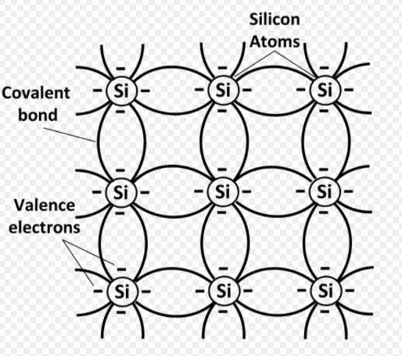

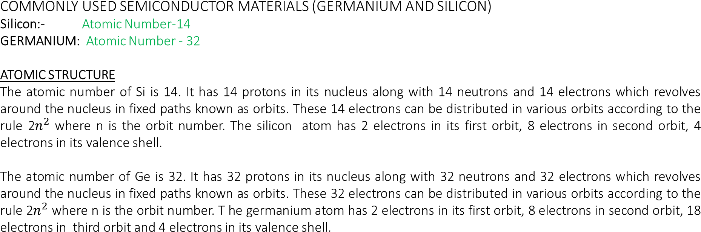

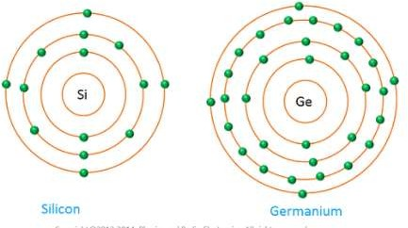
Germanium
Silicon
Valence
Shell

ATOMIC STRUCTURE OF SILICON AND GERMENIUM

CONCEPT OF ELECTRON AND HOLE
At absolute zero , the valence band in intrinsic semiconductor is totally filled and the conduction band is empty. Since there are four covalent bonds, each bond is not so strong. When the temperature is increased the electrons get sufficient energy to break the covalent bond.e.g. the room temperature may be sufficient to make a valence electron to move away from the influence of its nucleus. When this happens the electrons becomes free to conduct and hence appears in the conduction band.

THERMAL GENERATION :
When an electron moves away to the conduction band, a vacancy is created in the valence band. This vacancy is called hole. Whenever agree electron is generated, a hole is created simultaneously. This type of generation is called thermal generation.

COVALENT BOND :
A covalent bond, also called a molecular bond, is a chemical bond that involves the sharing of electron pairs between atoms. These electron pairs are known as shared pairs or bonding pairs, and the stable balance of attractive and repulsive forces between atoms, when they share electrons, is known as covalent bonding

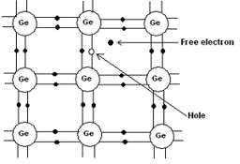

Material used for making some electronic component

- DIODE – A semiconductor diode is a device made of P- type and N- type semiconductor.
- TRANSISTOR – It is formed by two P-N junction in either P-N-P or N-P- N configuration.
- THYRISTOR – It is combination of two transistor PNP and NPN .
- RESISTOR- The resistive element is made from a mixture of finely powdered carbon and an insulating material, usually ceramic. A resin holds the mixture together

Unit-4 Insulating Materials (General Properties)

Insulating Materials:-
The materials which have very high resistivity i.e. offers a very high resistance to the flow of electric current. Insulating materials plays an important part in various electrical and electronic circuits. In domestic wiring insulating material protect us from shock and prevent leakage current.

Factor Affecting Selection of an Insulating Material:
  - Operating condition: Before selecting an insulating material for a particular application the selection should be made on the basis of operating temperature, pressure and magnitude of voltage and current.
  - Easy in shaping: Shape and size is also important factor.
  - Cost: Cost is also important factor.
  - Availability of material: The material should be easily available.

Insulating Materials ‘General Properties’
The properties can be classified as :
    - Electrical Properties
    - Thermal Properties
    - Chemical Properties
    - Physical/ Mechanical Properties

ELECTRICAL PROPERTIES OF INSULATING MATERIALS
      - Insulation Resistance:
The Resistance offered to the flow of electric current through the material is called Insulation Resistance.
Insulation Resistance is of two types:
  - Volume insulation resistance
  - Surface insulation resistance

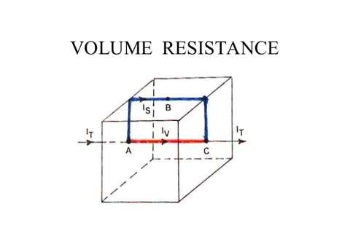

Surface Insulation Resistance:
The resistance offered to current which flows over the surface of insulation material is called Insulation resistance. As from A to B and then B to C.
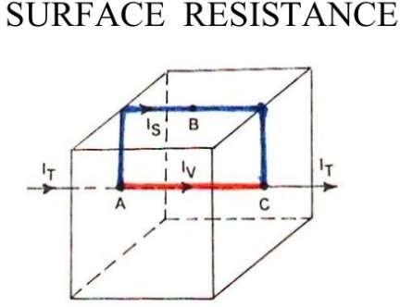

Factors Affecting Insulation Resistance:

  - TEMPERATURE
As the temperature of the insulating material rises its insulation resistance keeps on falling.
  - MOISTURE
Insulation resistance is reduced if the material absorbs moisture, so insulation material should be non hygroscopic.
  - APPLIED VOLTAGE
Applied voltage also affects insulation resistance.
  - AGEING
Ageing reduces the insulation resistance. As age of insulation material is increased the insulation resistance decreases.

Dielectric Strength
Dielectric strength is the minimum voltage which when applied to an insulating material will result in the destruction of its insulating properties. Electrical appliances/apparatus is designed to operate within a defined range of voltage.
If the operating voltage is increased gradually at some value of voltage, the breakdown of the insulating materials will occur. The property which attributes to such type of break down is called the dielectric strength.
In other words dielectric strength of an insulating material is the maximum potential
gradient that the material can withstand without rupture
e.g. dielectric strength of mica is 80k V/mm. It means if the voltage applied across 1mm thick sheet of mica becomes 80kV mica will lose its insulating properties and current will start passing through mica sheet.

Dielectric Constant
The ratio of capacity of storing the electric charge by an insulating material to
that of air is called dielectric constant of the material.
Every insulating material has the property of storing electric charge 'Q' , when a
voltage V is applied across it. The charge is proportional to the voltage applied i.e.
Q𝘢V and we get Q= CV
Where C is the capacitance of the capacitor which was formed by placing the material between the conductors across which voltage is applied.
The capacitance of the capacitor will change if the air between the plates of a capacitor is replaced by an insulating material acting as a dielectric. The property of insulating materials that causes the difference in the value of capacitance, physical dimensions remaining same, is called the dielectric constant or permittivity.

Dielectric Loss:
Electrical energy absorbed by the insulating material and dissipated in the form of heat when an alternating voltage is applied across it is called dielectric loss. When a perfect insulation is subjected to alternating voltage it is like applying like alternating voltage to a perfect capacitor. In such a case there is no consumption of power. Only vacuum and purified gases approach this perfection. In such a case the charging current would lead the applied voltage by 90 degree exactly. This would mean that there is no power loss in the insulation. In most of the insulating materials, that is not the case. There is a definite amount of dissipation of energy when an insulator is subjected to alternating voltage. This dissipation of energy is called dielectric loss .

Thermal Properties:
        - HEAT RESISTANCE
This is general property of insulating material to withstand temperature variation within desirable limits, without damaging its other important properties. If an insulator has favorable properties at ambient temperature but, if it is not able to retain these, it is not a good insulator.
The insulator which is capable of withstanding temperature higher without deterioration of its other properties can be used for operation for such higher temperature.

Classification of Insulating Materials on the basis of operating temperature:
CLASS 'Y' INSULATION
Material if un-impregnated fall in this category with operating temperature up to 90⁰C. e.g. paper, cardboard, cotton, poly vinyl chloride etc.
CLASS 'A' INSULATION
Insulators of class Y when impregnated fall in class A with operating temperature of
about 105⁰ C.
CLASS 'E' INSULATION
Insulation of this class has operating temperature of 120⁰C. Insulators used for enameling of wires fall in this category. e.g. p.v.c. etc.
CLASS 'B' INSULATION
Impregnated materials fall in class B insulation category with operating temperatures of about 130⁰C. e.g. impregnated mica, asbestos, fiber glass etc.

CLASS 'F' INSULATION
Impregnated materials, impregnated or with better varnishes e.g. glued polyurethane, epoxides etc. fall in this category with operating temperature of about 150⁰C.
CLASS 'H' INSULATION
Insulating materials either impregnated or not, operating at 180⁰C fall in this category. e.g. fiber glass, mica, asbestos, silicon rubber etc.
CLASS 'C' INSULATION
which have operating Insulators temperatures more than 180⁰C fall in class C insulation category. e.g. glass, ceramics, poly tera fluoro ethylene, mica etc.

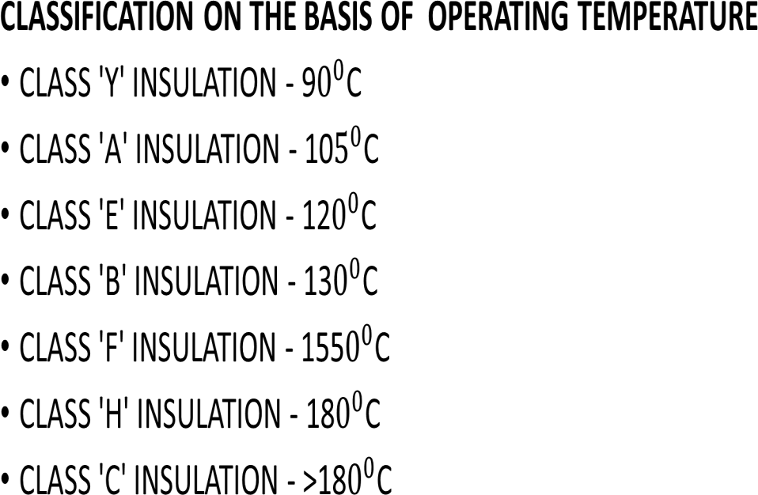

        - PERMISSIBLE TEMPERATURE RISE:
There is always some recommended operating temperature for an insulator. The operating temperature has a bearing on the life of the concerned apparatus. A thumb rule suggested by many experts is that life of insulator is halved for 8-10 degree centigrade rise above the recommended operating temperature for a given apparatus
        - EFFECT OF OVERLOADING ON THE LIFE OF AN ELECTRICAL APPLIANCE
Insulators can withstand overloading within permissible limits for short period of time. Continuous overloading ultimately results in the breakdown of the insulating materials. Consider an underground cable under operation. This cable is recommended for operation with certain limitation of voltage and current. Suppose voltage is increased. If the involved insulating material is able to withstand the higher voltage stress, the change will cause increase of dielectric losses that will increase heat generation. So, the temperature of the insulation will further increase. If the applied overvoltage is withdrawn, the damage may not be permanent and the cable will cool down with time and start operating normally. If overvoltage is not removed, the cycle of temperature rise goes on and ultimately the insulator starts losing its insulating properties, ultimately breakdown of the insulating material will occur and the cable will be permanently damaged. Secondly if load current in the cable is increased IR losses will increase, resulting once again in increased heat generation. And if overloading maintained, will ultimately result in breakdown of the insulating material.

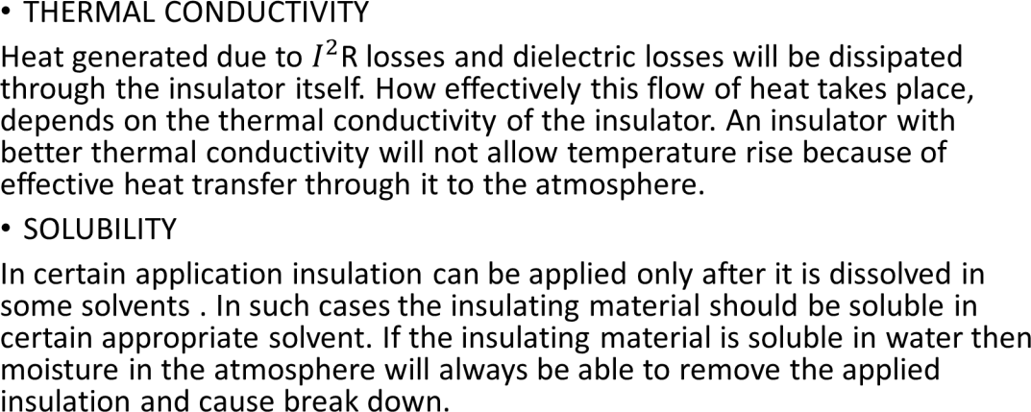

Chemical Properties:
- CHEMICAL RESISTANCE:
Presence of gases, water, acids , alkalis and salts affects different insulators differently. Chemically a material is a better insulator if it resist chemical action. Certain plastic are found approaching this condition. Consequently their use is very much increase.

WEATHERABILITY
Insulators come in contact with atmosphere both during manufacture or operation. The contact of insulation with atmosphere is often so complete that even the less chemically aggressive atmosphere can prove a threat to the smooth running of apparatus.

Hygroscopicity:
The property of insulating material by virtue of which it absorbs moisture. The insulating material should be non-hygroscopic. The absorption of moisture reduces the resistivity of the insulator.
MECHANICAL PROPERTIES

MECHANICAL STRENGTH
The insulating material should have high mechanical strength to bear the mechanical stresses and strains during operation. Temperature and humidity are the main factors which reduce the mechanical strength of insulating materials.

POROSITY
A material having very small holes in it is called a porous material. Insulator absorbs moisture if it is porous, which reduces its resistivity as will as mechanical strength. Porous material are impregnated with varnishes or resins to fill their pores which makes them non-porous thus better insulating materials.

DENSITY
The insulating material should have low density to reduce the weight of equipment in which insulating material is being used.

BRITTLENESS
The insulating material should not be brittle. Otherwise insulators may fracture easily due to stresses.

Unit – 5
Insulating Material and Their Application

PLASTICS
Plastics are basically hydrocarbons i.e. they contain hydrogen and carbon as their essential components.
Plastics are found in nature are called Natural Plastics. While man made plastics are called Synthetic Plastics and they are classified accordingly.

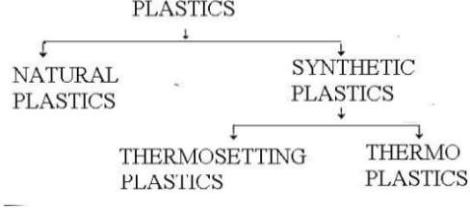

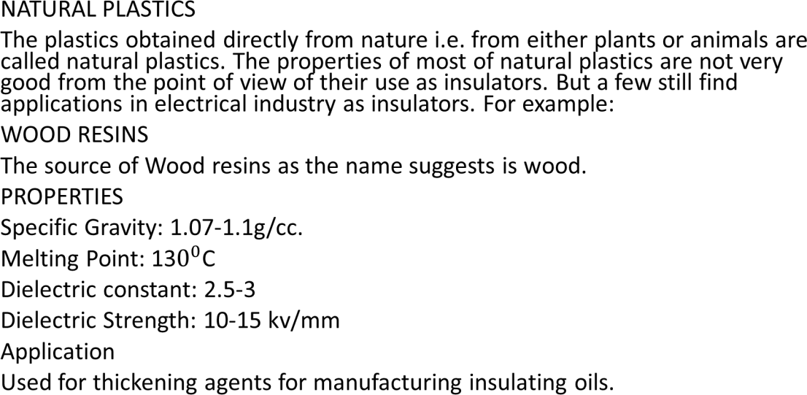

SYNTHETIC PLASTICS
The plastics obtained by a chemical process called polymerization, are called synthetic plastics. It is of two types.
- THERMOSETTING PLASTICS
The plastics which lose their properties when cooled after melting and cannot be reshaped are called thermosetting plastics.
PROPERTIES
- Made by Condensation Polymerization.
- Cross linked chains of molecules.
- Hard and Rigid.
- Higher molecular weight.
- Low hygroscopicity.
- Good dielectric Strength.
Application of Thermosetting Plastic:
Used in Industrial Moldings, Reflectors, Radio/TV Cabinets, Adhesives Varnishes, Wire and
Cable insulators.

- THERMOPLASTICS
The plastics which retain their properties even when cooled after melting and can be reshaped are called thermosetting plastics.
PROPERTIES
  - Made by Additional system of Polymerization
  - No Cross linked chains of molecules.
  - Less Flexible but Mechanically stronger.
  - Low molecular weight.
  - Highly Hygroscopic.
  - Poor Dielectric Properties.
APPLICATIONS
Mostly used for Wire and Cable insulation

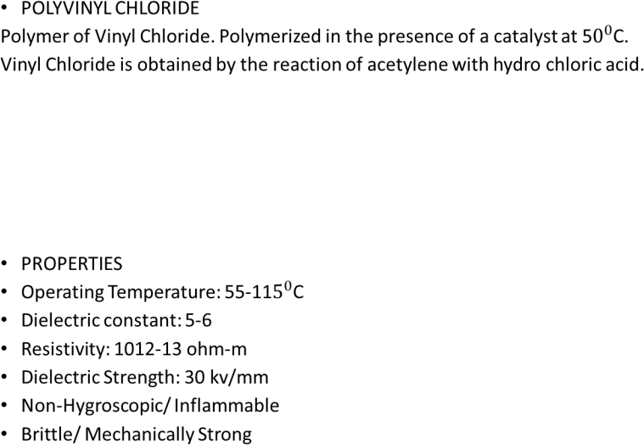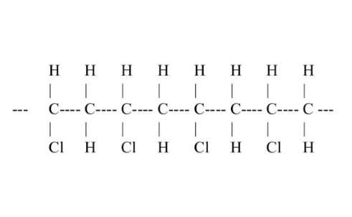

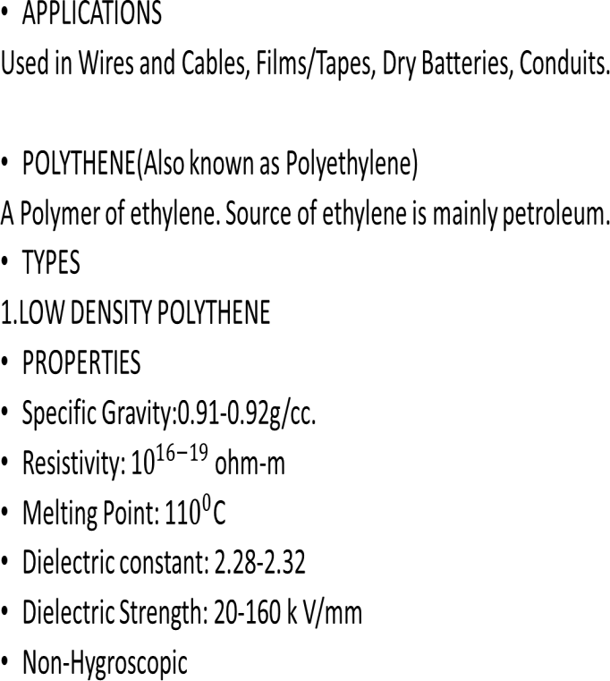

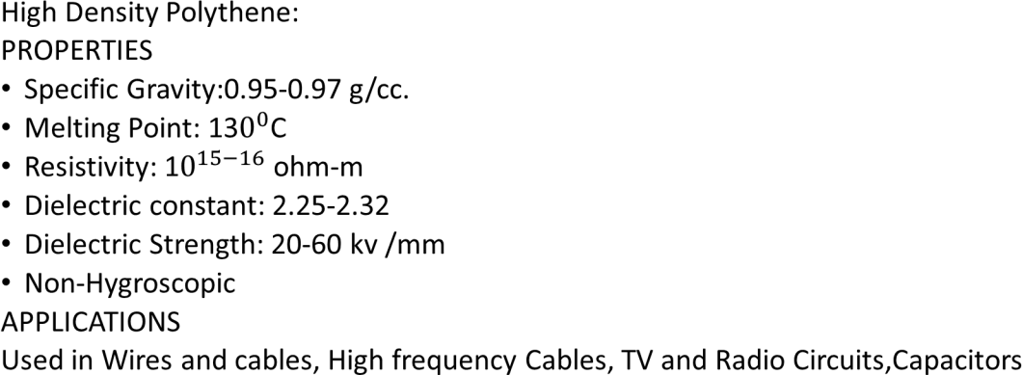

Natural Insulating Materials:

MICA AND MICA PRODUCTS
Mica is an inorganic mineral . It is one of the best natural insulating materials available. It is one of the oldest insulating material of out-standing performance. India fortunately claims the biggest reserves of mica in world. About 80% of total World requirement of mica for electrical industry is furnished by India.
Chief sources of supply are China, Russia, Finland, India, and U.S.A. In India, it is mainly found in Andhra Pradesh, Jharkhand, Bihar and Rajasthan.

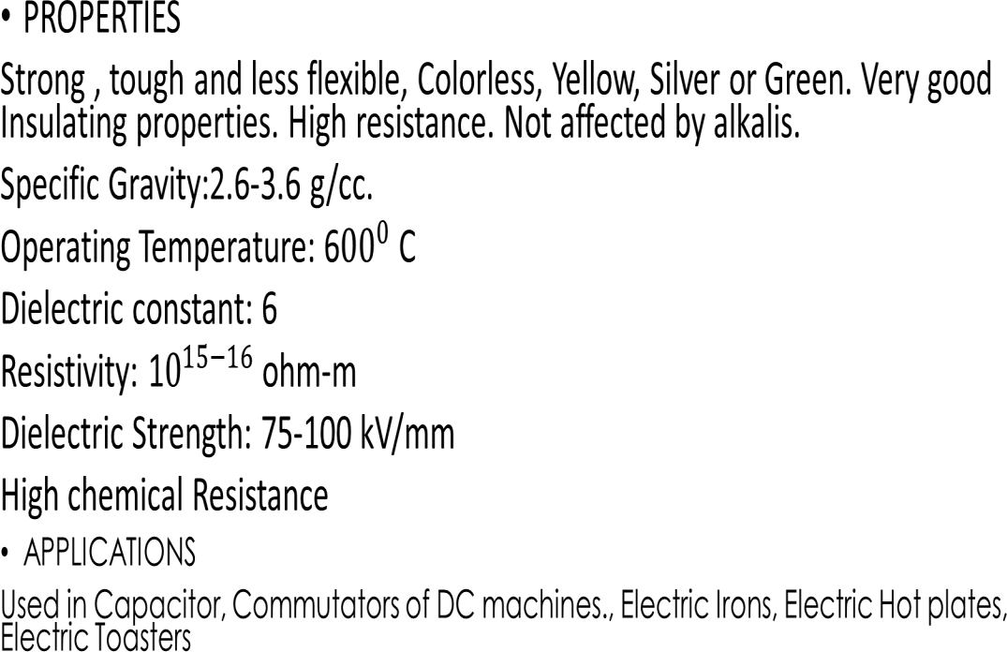

- Mica Products:
- GLASS BONDED MICA
Ground mica and powdered glass when molded makes glass bonded mica.
The ratio of mica and glass is 40:60 to 60:40 range.
APPLICATIONS
The material finds its use in high humidity and high ambient temperature atmospheres.

- MANUFACTURED MICA
When mica flakes are held together with adhesive the product is called mica plate. The binding material is about 20%. The binding materials are shellac, epoxy and silicon resins etc.
APPLICATIONS
Used in Commutators of DC motors and generators, Insulation for armature and field coils, Heating appliances, Transformers.

- MICANITE
Very thin mica sheet bound together with adhesives are called micanites.
APPLICATIONS
Used in Commutators of DC motors and generators.

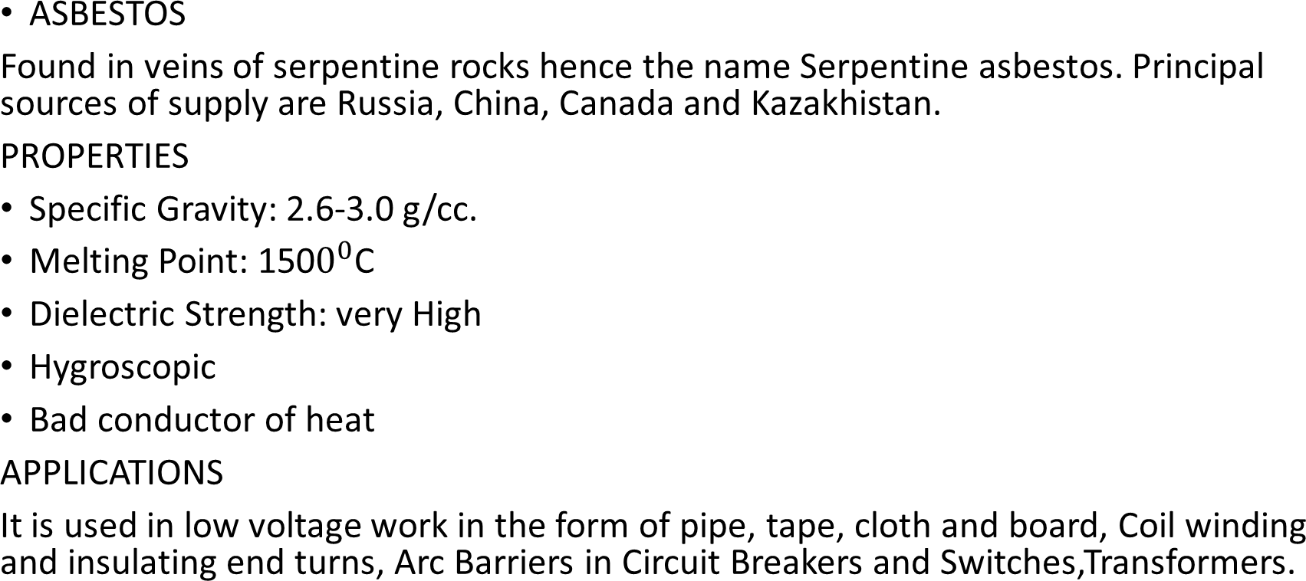

Asbestos Products:
- ASBESTOS ROVING
Asbestos fibers reinforced with cotton or synthetic organic fibers makes asbestos roving.
APPLICATIONS
It finds use in insulation of cables and conductors and in heating devices.
- ASBESTOS CEMENT
About 20% asbestos fiber and 80% Portland cement are the main constituents of asbestos
cement. Impregnated asbestos cement products are used to overcome its hygroscopic nature.
PROPERTIES
- Good mechanical strength.
- High thermal stability.
- Excellent resistance to electrical
- arcing
- Hygroscopic
APPLICATIONS
These cements find their use in switch panel construction and in arcing devices.

CERAMICS MATERIALS
Ceramics are materials made by high temperature firing treatment of natural clay and certain organic matters. Structurally ceramics are crystals bonded together. Other materials used with clay in different type of ceramics are Quartz, Talc, Magnetite etc.
PROPERTIES
  - Hard, strong and dense.
  - Not affected by chemical action Stronger in compression than tension
  - Stability at high temperatures
  - Excellent dielectric properties.
APPLICATIONS
Used in manufacturing Porcelain insulators, Line insulators.

- PORCELAIN
Porcelain are basically clays and quartz embedded in glass matrix. When used as insulators glazing is done i.e. a thin layer of glass is glazed over the insulator.
PROPERTIES
- Specific Gravity:2.35-5 g/cc.
- Operating Temperature: 1200 C
- Dielectric constant: 5-7
- Resistivity: 1011-14 ohm-m
- Low-Hygroscopicity
- High chemical Resistance
- High tensile strength.
APPLICATIONS
Transformer bushings, Line Insulators( Low frequency application as dielectric loss is
high), Switches/ Plugs/ sockets/ Fuse Holders

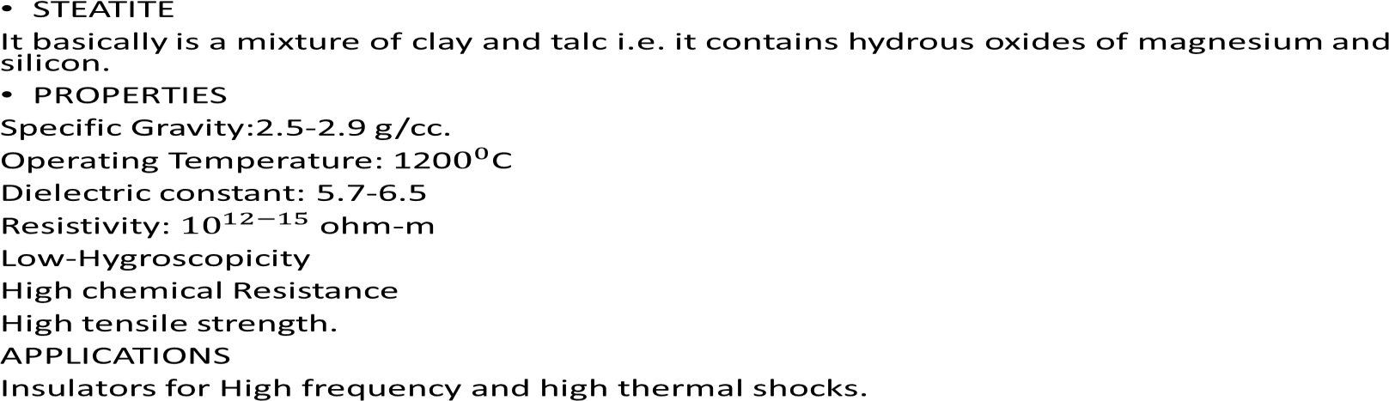

GLASS
It is normally transparent , brittle and hard. It is insoluble in water and the usual organic solvents. Glass find its use in electrical industry because of its low dielectric loss, slow aging and good mechanical strength. Glass has its limitations because it is not easy to manufacture and is dense and heavy.
APPLICATION
Used in Molded devices such as electrical bushings, fuse bodies, insulators, Capacitor, Radio and television tubes, Laminated boards, Lamps/ Fluorescent Tubes.

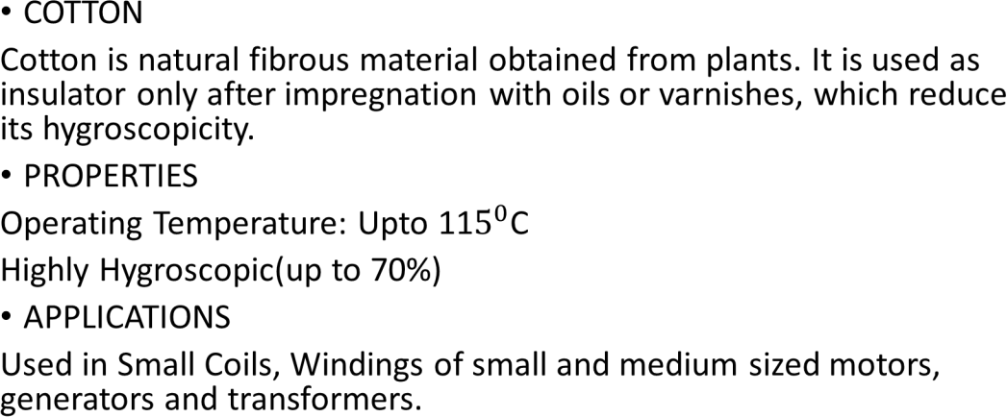

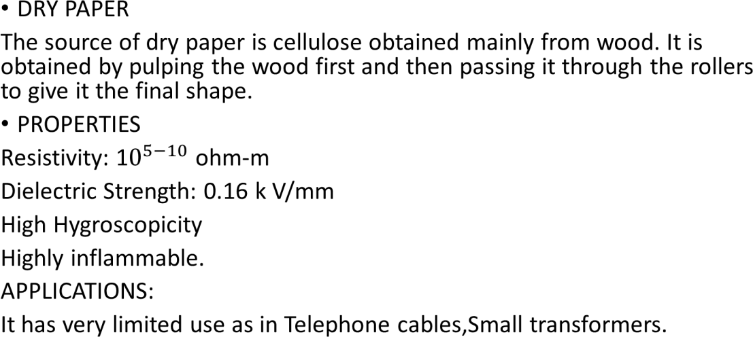

- IMPREGNATED PAPER
To improve the properties of dry paper it is impregnated with oils or varnishes.
PROPERTIES
It has better properties then the dry paper in terms of mechanical strength, chemical resistance, dielectric constant, operating temperature, hygroscopicity and dielectric loss.
APPLICATIONS
Used in Underground Cables (200-400V), Capacitors.

  - RUBBER
Natural rubber is obtained from the milky sap of trees. It finds limited applications in the field of engineering. The reasons are Rubber is a material which is stretchable to more than twice its original length without deformation.
  - NATURAL RUBBER
Natural rubber is extracted from the milky sap from a rubber trees.
APPLICATIONS
It finds limited use in covering wires, conductors etc. for low voltage operations.Used in manufacturing of Gloves, Rubber Shoes.

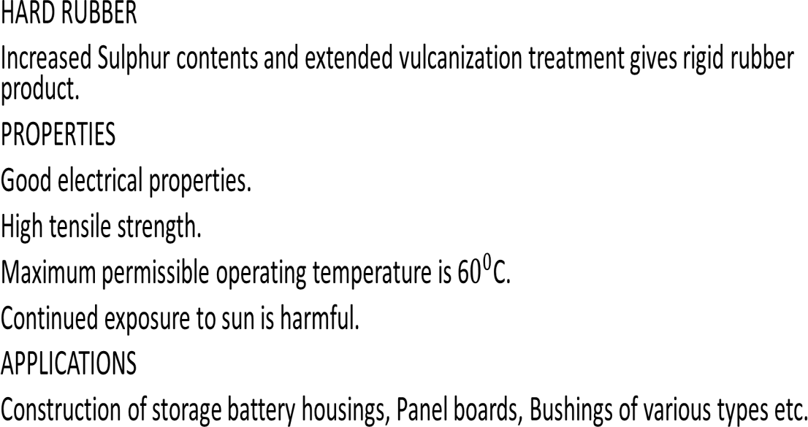

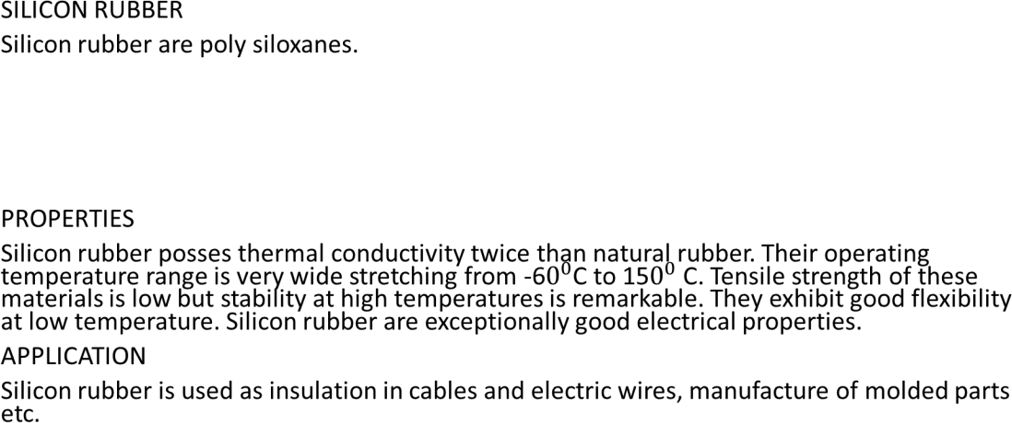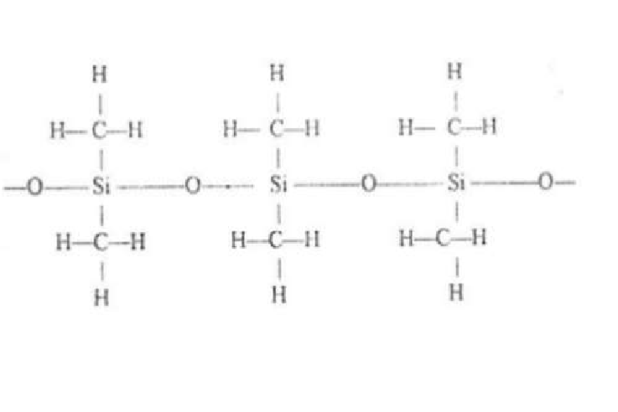

- VARNISHES
Varnishes are obtained by dissolving the materials in oil or alcohol. They are
used mainly for impregnation, surface coating and as adhesives.
PROPERTIES
Transparent
Non-Hygroscopic
APPLICATIONS
Surface coating on windings Impregnation of paper, cotton.

Gaseous Insulating Materials:
  - AIR
Like other insulating gases , the dielectric constant of the air increases linearly with increasing gas pressure. Air acts as an insulation in many electrical applications in addition to the solid or liquid insulating materials provided. Common examples are overhead transmission lines, air condensers, plugs, switches, various electrical machines and apparatus etc.
  - HYDROGEN
Hydrogen is rarely used as an insulator. It is used for cooling purposes in electrical machines. Common examples are overhead transmission lines, air condensers, plugs, switches, various electrical machines and apparatus etc.

  - NITROGEN
Nitrogen is commonly used as an insulator in electrical equipment. In many applications it is for both electrical and chemical purposes. In many high voltages applications air is replaced by nitrogen to prevent oxidation of the other insulating materials
  - SULFUR HEXAFLUORIDE
When sulfur is burnt in atmosphere of fluorine, sulfur hexafluoride is formed.
PROPERTIES
Remarkably high dielectric strength.
Non inflammable .
Cooling property is superior to those of air and nitrogen. At increase pressure its dielectric strength increases and may even become equal to that of transformer oil.

Disadvantages
To have high dielectric strength this gas must be used under high pressure which needs a scaled tank construction capable of withstanding the pressure over the whole temperature range of its commercial use. The presence of sulfur in the molecule under some condition involve corrosion of the contacting surfaces.

APPLICATIONS:
Used in Electric switches, Circuit Breakers.

Unit-6
Magnetic Materials

Magnetic Material:
Magnetic Materials are those materials in which a state of magnetization can be induced. Such materials when magnetized create a magnetic field in the surrounding space.
Classification :
- Ferromagnetic
- Paramagnetic
- Diamagnetic
- Magnetically Soft material
- Magnetically Hard material

- Ferromagnetic :
A type of material that is highly attracted to magnets and can become permanently magnetized is called as ferromagnetic. The relative permeability is much greater than unity and are dependent on the field strength. These have high susceptibility.

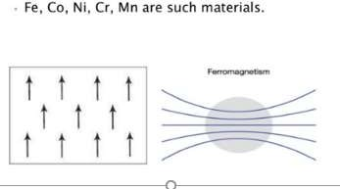

- Paramagnetic :
It is a substance or body which very weakly attracted by the poles of a magnet, but not retaining any permanent magnetism. These have relative permeability slightly greater than unity and are magnetized slightly. They attract the lines of forces weakly.
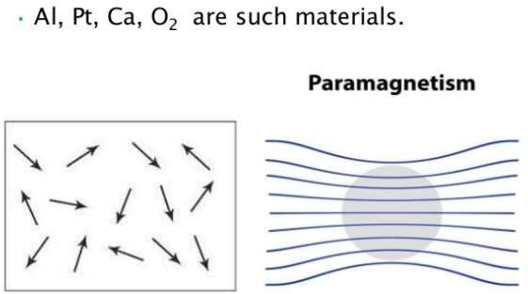

Diamagnetic :
It is a substance which create a magnetic field in opposite to an externally applied field. Susceptibility is negative. These have relative permeability slightly less than unity. They repel the lines of force slightly.

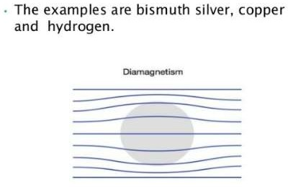

Magnetically Soft Material :
Characteristics :
  - They have high permeability.
  - The magnetic energy stored is not high.
  - They have negligible coercive force.
  - They have low remanence.
  - Hysteresis loop is narrow. Examples :
  - pure or ingot iron, cast iron, carbon steel, manganese & nickel steel, etc.

Magnetically Hard Material :
Characteristics :
- They possess high value of BH product.
- High retentivity.
- High coercivity.
- Strong magnetic reluctance.
- Hysteresis loop is more rectangular in shape. Examples :
- Tungsten steel, cobalt steel, chromium steel, etc.

Applications of Magnetic Material:
Ferromagnetic materials are used in magnetic
  - recording devices, such as for cassette tapes
  - floppy discs for computers, and the magnetic
  - stripe on the back of credit cards.
Diamagnetic materials
These are used for magnetic levitation, where an object will be made to float in above a strong magnet.
Magnetic soft materials
These are used in making Electromagnets and these electromagnets are used in telephone receiver, bells, loudspeakers etc.
Magnetic hard materials
These are used in making permanent magnets.

Unit- 7 Special Materials

Thermocouple:
The thermocouple is a temperature measuring device. It uses for measuring the temperature at one particular point. In other words, it is a type of sensor used for measuring the temperature in the form of an electric current or the EMF. The thermocouple consists two wires of different metals which are welded together at the ends. The welded portion was creating the junction where the temperature is used to be measured. The variation in temperature of the wire induces the voltages
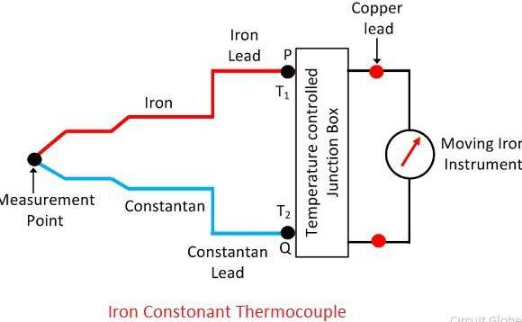

Working Principle of Thermocouple
The working principle of the thermocouple depends on the three effects:
- See back Effect– It is a phenomenon in which the temperature difference between the two different metals induces the potential differences between them. The See beck effect produces small voltages for per Kelvin of temperature.

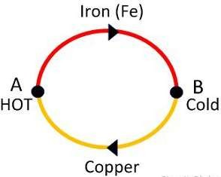

- Peltier Effect –
The Peltier effect is the inverse of the Seebeck effect. The Peltier effect state that the temperature difference can be created between any two different conductors by applying the potential difference between them.
- Thompson Effect – The Thompson effect state that when two dissimilar metals join together and if they create two junctions then the voltage induces the entire length of the conductor because of the temperature gradient. The temperature gradient is a physical term which shows the direction and rate of change of temperature at a particular location.

Advantages of Thermocouple
The following are the advantages of the thermocouples.
- The thermocouple is cheaper than the other temperature measuring devices.
- The thermocouple has the fast response time. 3.It has a wide temperature range.

Disadvantages of the Thermocouples
- The thermocouple has low accuracy.
- The recalibration of the thermocouple is difficult.

Allow used for making Thermocouple:
Nickel-alloy, Platinum/rhodium alloy, Tungsten/Rhenium-alloy, Chromel-gold,
Iron-alloy are the name of the alloys used for making the thermocouple.

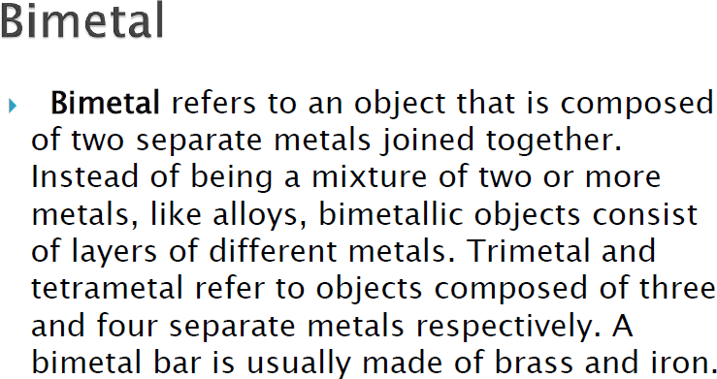

Bimetal is consists of two strips of two different metals having different Coefficient of linear thermal expansion, welded together lengthwise. A bimetal at normal temperature is shown in figure below.

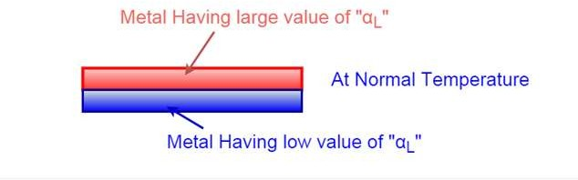

On heating, the expansions in the length of both metal strips are different. Due to which the bimetallic element bends and form an arc in such a way that the metal with higher Coefficient of linear thermal expansion is outer at side of the arc and metal with lower Coefficient of linear thermal expansion is at inner side of the arc as shown in figure below.

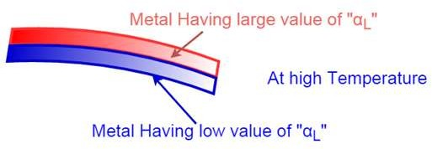

On cooling, bimetal element bends and form an arc in such a way that the metal with lower Coefficient of linear thermal expansion is at outer side of the arc & metal with higher Coefficient of linear thermal expansion is at inner side of the arc as shown in figure below.

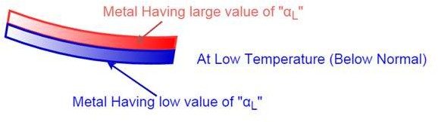
The above phenomenon can used to produce a useful device for detecting and measuring change in temperature.

- Commonly Used Combinations for Making Bimetallic Strips Many combinations of metals with different Coefficient of linear thermal expansion can be used to form the bimetals. Some of the commonly used combinations for making bimetallic strips are listed below-
- Iron, nickel, constantan (high “Coefficient of linear thermal expansion”)
- Alloy of iron and nickel (low “Coefficient of linear thermal expansion”)
Bimetals are very much useful to make the bimetallic thermostat for automatic switching of circuit to control the temperate of certain appliance such as, Electric heater, Electric irons, refrigerators, electric ovens etc. In some circuits, the current passed through the thermostat itself produce the heat for operation of thermostat

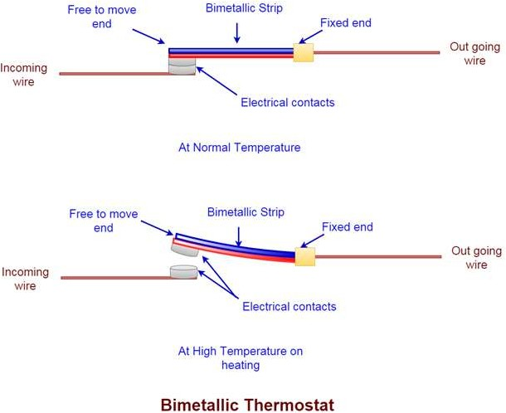

Fuse:-
A fuse is a part of the circuit which consists of a conductor which melts easily and breaks the connection when current exceeds the predetermined value. An electrical fuse is the weakest part of an electrical circuit which breaks when more than predetermined current flows through it.
The function of fuse wire is to carry the normal current without excessive heating but more than normal current when passes through fuse wire, it rapidly heats up and melts.
The materials used for fuse wires are mainly tin, lead, zinc, silver, antimony, copper, aluminum etc.

Some Important terms related to Fuse:

Minimum Fusing Current
It is minimum value of current due to which fuse melts.

Current Rating of Fuse
It is maximum value of current due to which fuse does not get melt.

Fusing Factor
This is the ratio of minimum fusing current and current rating of fuse. The value of fusing factor is always more than 1.

Prospective Current in Fuse
Before melting, the fuse element has to carry the short circuit current through it. The prospective current is defined as the value of current which would flow through the fuse immediately after a short circuit occurs in the network.

Types of Fuses:
  - Rewireable or Kit Kat Fuse:
Rewireable or Kit Kat Fuse Unit is most commonly used fuse in our day to day life. This fuse has mainly two parts. The unit in which the incoming and outgoing line or phase wire connected permanently is known as fuse base. The removable part which holds the fuse wire and fits into the base is known as fuse carrier. The fuse carrier is also known as cutout.

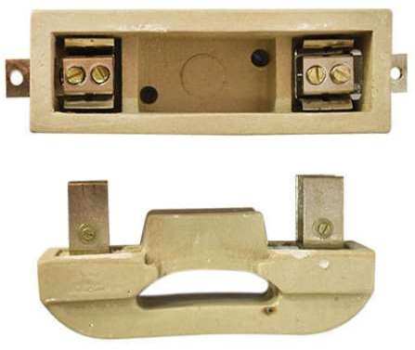

Cartridge Fuse
In cartridge fuse the fuse wire is enclosed in a transparent glass tube or bulb, the whole unit is sealed off. In case the fuse blows, it is to be replaced by new one as the cartridge fuse can not be rewired due to its sealing.
They are available up to 600A and 600V AC and widely used in industries, commercial as well as home distribution panels.

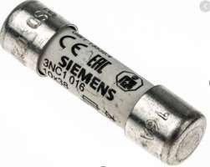

HRC Fuse (High Rupturing Capacity Fuse)
This type of fuse contains a fuse wire in it, which carries the short circuit current safely for a given time period. During this period, if fault is removed, then it does not blow off otherwise it will melt and remove the circuit from electrical supply hence, the circuit remains safe. The common material, which is used to make an HRC fuse is glass, but this is not always the case. Other chemical compounds are also used in HRC fuse manufacturing and construction based on different factors.
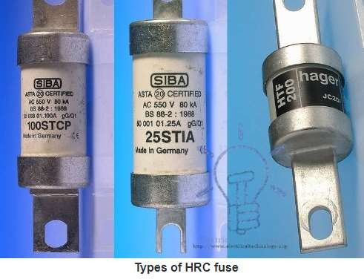

Unit-8
Electric Machines(Constructional Parts)

Motor:
An electric motor can be defined as; it is one kind of machine used to convert the energy from electrical and mechanical.
Principle of motor: A motor works on the principle that when a rectangular coil is placed in a magnetic field and current is passed through it. A force acts on the coil which rotates it continuously.

Construction of Electric Motor

The construction of an electric motor is shown below. This motor can be built with different components like rotor, stator, air gap, windings, and commutator.

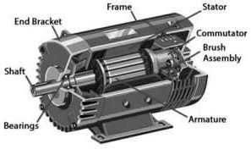

- Rotor
It is a moving part in an electromagnetic system of motor, generator otherwise alternator. The rotor in a motor plays the main role in rotating the shaft to produce mechanical energy.
- Bearings
The bearings play an essential role within the motor by providing the support for the rotor to turn on its axis.

- Stator
This is an inactive part of a rotary system in the motor. It is available in generators, biological rotors, mud motors, and sirens.

- Air Gap
The gap between the rotor and the stator in the motor is known as the air gap.

5).Windings
Windings are nothing but wires that are placed within the coils. Winding is made up of Copper.
- Commutator
A commutator is one kind of rotating electrical switch and it reverses the direction of current flow among the rotor & the exterior circuit.

Types of Electric Motor
The classification of the electric motor can be done based on different considerations like the type of power source, construction, and application. In addition to AC types and DC types of motors, there are some more types of motors available like brushed, brushless, 1-phase, 2-phase, or 3-phase, air- cooled/liquid-cooled. General electric motors that have typical dimensions, as well as characteristics, give suitable mechanical power to use in industries.
  - AC Motors
  - DC Motors

AC Motors
The main function of the AC motor is to change the current from alternating to mechanical with the help of electromagnetic induction. This motor works with alternating current and the main parts of this motor are the rotor & stator.

DC Motors
A DC motor is a kind of rotary electrical machine, used to convert the energy from DC to mechanical. Most of the motors depending on the generated forces from the magnetic field.

Advantages and Disadvantages
The advantages of the electric motor are
- These motors cost is reasonable compared with other engines like fossil fuels. However, the horsepower (HP) rating is similar to both.
- The lifespan of electric motors is longer.

- The capacity is up to 30,000 hrs but it needs little maintenance

- These are very efficient & its controlling capability allows automatic start and stops functions.
- They don’t use fuel or battery service.

The disadvantages of the electric motor are
- Large motors are not simply movable & consideration must be made for the precise current and voltage supply.
- It has a more efficient performance.

Applications of Electrical Motor
Electrical motors are used in various applications which include the following. These motors are used in
1. fans 2. blowers 3. pumps 4. ships 5. tools used in machines 6.movers 7. rolling mills,
- compressors, and 9. paper mills.

Generator: The AC generator is a machine that converts mechanical energy into
electrical energy in the form of alternative emf.
A simple AC generator works on the principle of Faraday’s Law of Electromagnetic
Induction.

Working Principle

AC generator working principle is, these are commonly referred to as alternators which work on the principle of Faraday’s Law of Electromagnetic Induction. The movement of a conductor in a uniform magnetic field changes the magnetic flux linked with the coil, thus inducing an emf.

The various components of an AC generator are:
  - Field
  - Armature
  - Prime Mover
  - Rotor
  - Stator
  - Slip Rings

Field
The field consists of coils of conductors that receive a voltage from the source and produce magnetic flux.

Armature
The part of an AC generator in which the voltage is produced is known as an armature.

Prime Mover
The component used to drive the AC generator is known as a prime mover.

Rotor
The rotating component of the generator is known as a rotor. The generator’s prime mover drives the rotor.

Stator

The stator of an AC generator is the stationary part. As the rotor, this component may be the armature or the field, depending on the type of generator.

Slip Rings

Slip rings are electrical connections that are used to transfer power to and fro from
the rotor of an AC generator.

Working

When the armature rotates between the poles of the magnet upon an axis perpendicular to the magnetic field, the flux linkage of the armature changes continuously. Due to this, an emf is induced in the armature. This produces an electric current that flows through the galvanometer and the slip rings and brushes.

The direction of the induced current can be identified using Fleming’s Right Hand Rule.

Advantages of Generators

Following are a few advantages of generators:

  - AC generators can be easily stepped up and stepped down through transformers.
  - Transmission link size might be thinner because of the step-up feature
  - Losses are relatively lesser than DC machine
  - Size of the AC generators are relatively smaller than DC generators

Transformer: A transformer is a device which converts magnetic energy into electrical
energy. It consists of two electrical coils called as a primary winding and secondary winding.

The single-phase transformer works on the principle of Faraday`s law of Electromagnetic Induction .

Construction of Single Phase Transformer

A simple single-phase transformer has each winding being wound cylindrically on a soft iron limb separately to provide a necessary magnetic circuit, which is commonly referred to as “transformer core”. It offers a path for the flow of the magnetic field to induce voltage between two windings.

Core-type Transformer

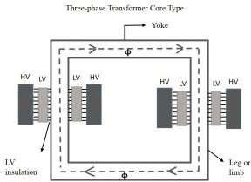
In this type of construction, only half of the windings are wound cylindrically around each leg of a transformer to enhance magnetic coupling as shown in the figure below.

Shell-type Transformer
In this type of transformer construction, the primary and secondary windings are positioned cylindrically on the centre limb resulting in twice the cross-sectional area than the outer limbs. There are two closed magnetic paths in this type of construction and the outer limb has the magnetic flux ɸ/2 flowing. Shell type transformer overcomes leakage flux, reduces core losses and increases efficiency.
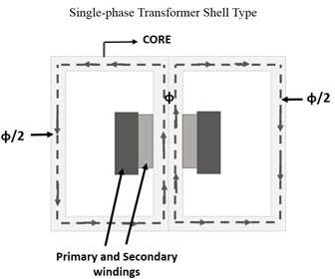

Applications
The applications of a single-phase transformer are mentioned below.
- To step-down long-distance signals to support both residential and light-commercial electronic devices
- In television sets for voltage regulation
- To step-up power in home inverters
- To supply power to non-urban areas
- To isolate two circuits electrically as primary and secondary are placed far from each other

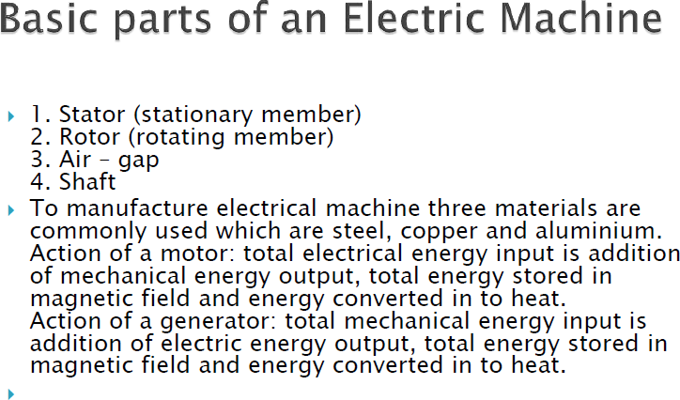

References:
- Google
- SlideShare
- Wikipedia
- Textbooks

